# **Course Overview**

## **Course Overview**

Hi everyone. My name is Stacia Varga and welcome to my course, Getting Started with Power BI. I'm a business intelligence consultant and instructor at Data Inspirations, a company I started back in 2006 to help people understand what their data is telling them. Speaking of understanding your data, Power BI is a fantastic tool from Microsoft that helps you do just that with interactive, easy to use visualizations that make it easier to see patterns and relationships.

In this course we're going to explore the main features of Power BI so that you can get an idea of what it can do for you and learn how to work with its various components, even if you've never used a reporting tool before. Some of the major topics that we'll cover include mashing together data from different sources, fixing up data to make it easy to explore, building reports and dashboards, and keeping your data up to date. By the end of this course you'll know enough about Power BI to your own simple data mashups and reports. You don't need to be a programmer or have any special skills to work with Power BI. If you've ever built a simple spreadsheet that uses formulas, you're definitely ready to experience the power of Power BI.

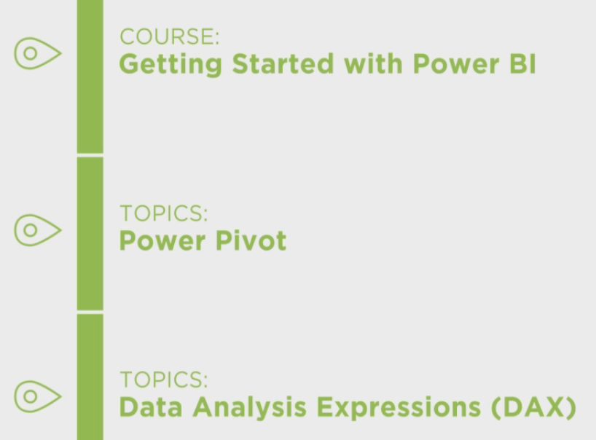

From here you should feel comfortable diving into courses that include Power Pivot or Data Analysis Expressions, the language known as DAX. I hope you'll join me on this journey to learn Power BI basics with the Getting Started with Power BI course at Pluralsight.

# **Introducing Power BI**

## **Introducing Power BI**

Hi, I'm Stacia Varga and welcome to Introducing Power BI, the first module in the Getting Started with Power BI course, which is designed for the business professional who knows a thing or two about working with data, but wants to use Power BI to explore and use that data more effectively.   
In this module I'll start by showing you Power BI using the data set and interactive reports that you build in later modules so that you can see what's possible and what you can learn to build in this course. And then I'll explain the various tools that are part of the Power BI family, so that you can choose which development tool is right for you.

**Getting Acquainted with Power BI**

In case you're brand new to Power BI, let me start by explaining what it is. It's a cloud-based service from Microsoft. Many features of the service are available for free while other features require a monthly subscription.

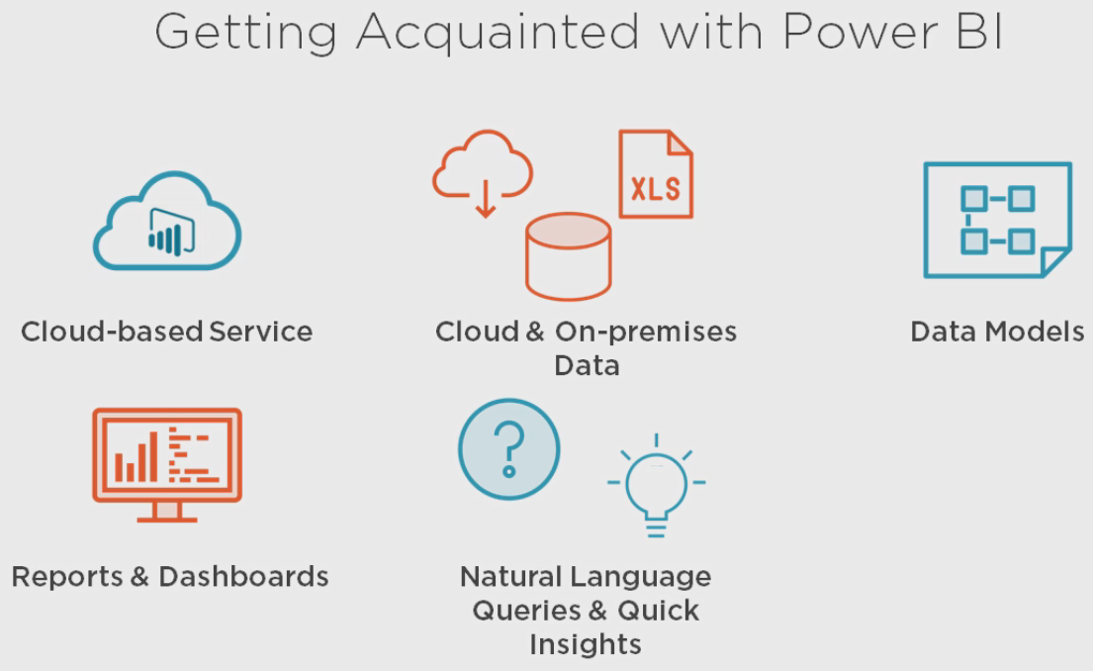

Now this service lets you combine a variety of data sources coming from the cloud or from your on-premises databases or files. And you use these to create data models that you can enhance with calculations to answer analytical questions. And you can refine it to enable easy exploration of the data.   
You can create dashboards that provide information at a glance from the data models that you build or build interactive reports with interrelated visualizations that help you understand your data more effectively.   
  
You can even ask questions of your data just by typing in a question just as you would ask a question of another person, no special query language required, and you can use a feature called Quick Insights to start exploring your data if you have no idea where to start.   
  
And wherever you are, you can get to your dashboards and reports from mobile devices using apps made specifically for Windows, iOS or Android.

**Creating Datasets from Data Models and Data Files**

The key to using the Power BI service is “data sets”. Whether you create a data model or import data into the service. You learn how to create a data model in module 2, but for now let's assume that someone's created a file for you. What can you use with Power BI?

Well someone ‘can create a data model and give it to as a PBIX file’. This type of file comes from the main development tool that you learn how to use throughout this course.  
Or they can store a data model in an XLSX file, which comes from Excel 2007 or higher, as long as the file is under 1 GB in size. I'll explain more about this approach later when I describe your options for development tools.   
Either way, you can upload these file types into the Power BI service.

Another option is to get data from Excel. This could be data formatted as a table in a workbook, saved as an XLSX file and it can even be data that comes from a connection to an external data source.   
You can also use data saved in an XLSM file. Or you can use data from a CSV file. Regardless of which method you use, your upload becomes a data set in the Power BI service.

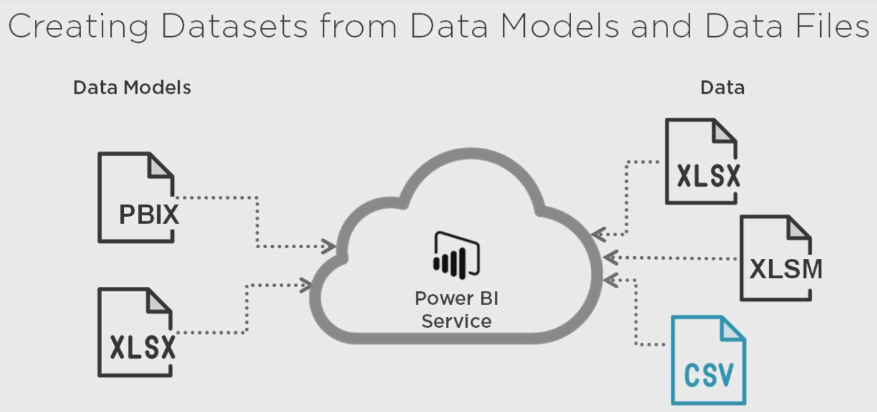

**Imp :** One thing to keep in mind is that a “report can only include data from a single data set”.  
If you need to combine data from multiple sources, you should “create a data model first”.   
If you upload a workbook with data or upload a CSV file, you cannot later make changes to the structure in Power BI.

**Demo: Getting Started with Power BI**

Before I go much further, let's see how to access the powerbi.com service. And then I'll show you how to upload data sets from files that are already completed so that you can later see how to use these features. Now Power BI is updated quite frequently so it's possible that what I show you now in this demonstration will look different in the future. Functionality should not go away, but the look and feel could be different when you try out these steps. So don't be alarmed if my screen looks a lot different from your screen.

The first step is to open your browser and go to powerbi.com. If this is your first time using Power BI, you'll need to sign up for a new account, just click this Get started free button here. Then you can choose to download the Power BI desktop for Windows application. But you can always do this later. The signup process begins when you click this signup button. You need to provide an email address for your business. This cannot be a generic email like gmail or hotmail, and once you've put in this address click the sign up button. Just like it says here, go check your email to complete the sign up process. So after you click the button in your welcome email, you come in and put in your name and password. We'll skip the part about inviting more people, and it's important to note that if you were to invite more people they'll have to have email addresses at the same company as you. So now if you already have a Power BI workbook you can upload it like this. Click the Get button in the Files tile and then you point to the location of the file. For this module I've included a completed data model for you to upload and try yourself, go to the location where you've extracted the files for this module and in the getting-started-power-bi-data folder, you should find a Customer Analysis file. This is a Power BI Desktop document with a PBIX extension. We'll select this and now it's being imported into the Power BI service.

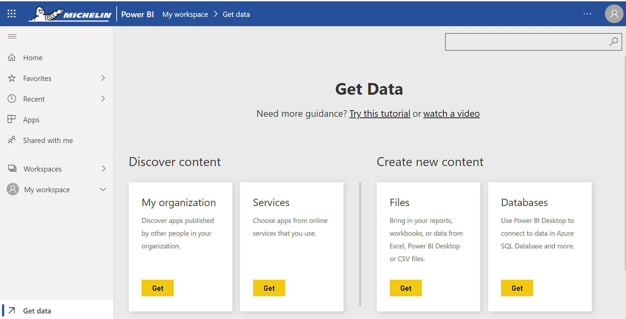

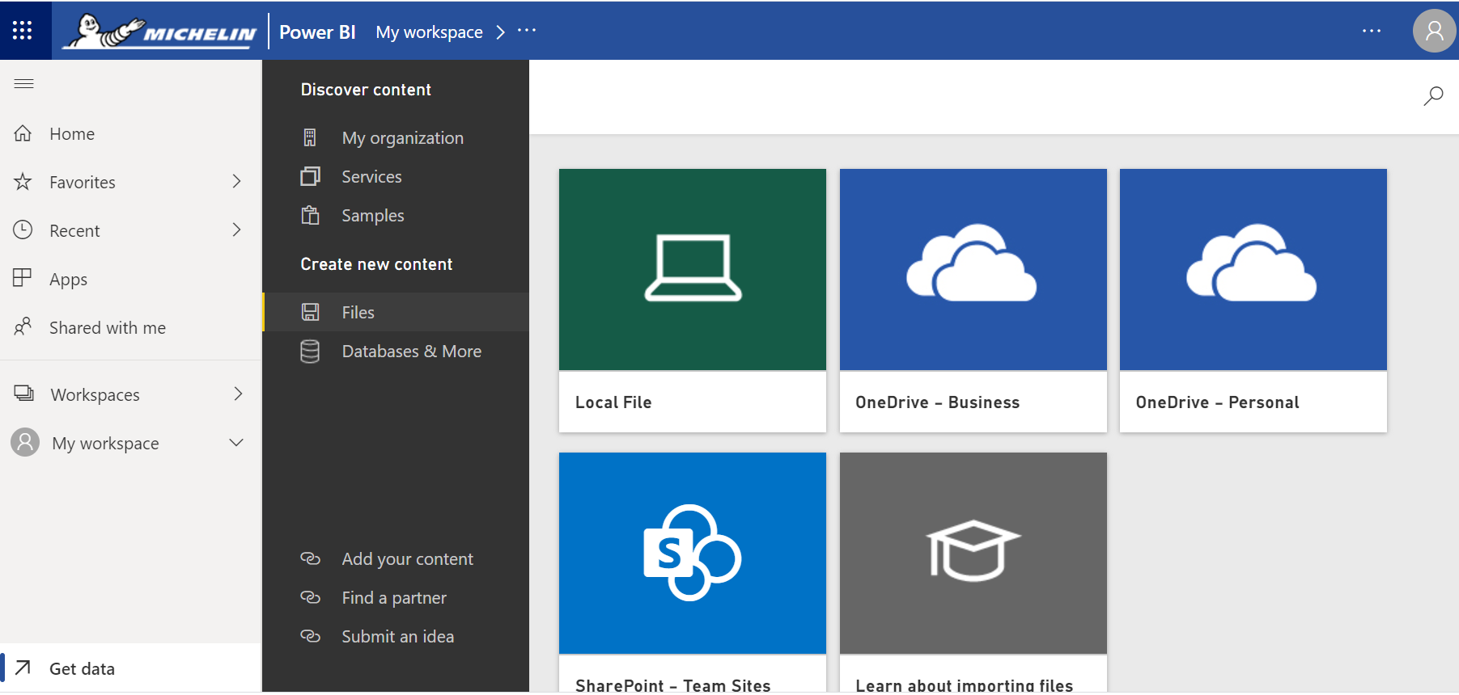

Click “Local File”

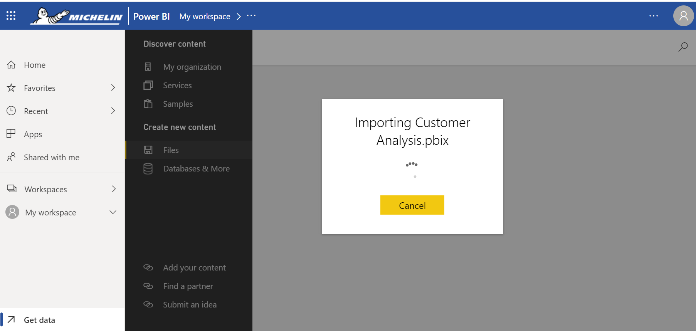

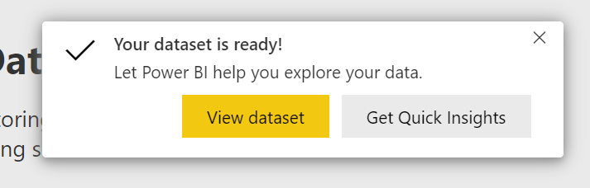

**Using Quick Insights to Explore a Dataset**

When you upload a data set or a data model from a Power BI desktop file, one of the first things you might try is the Quick Insights feature to begin your exploration of the data. There are up to eight different types of insights that are automatically generated as visualizations about your data that highlight some potentially interesting points in your data.

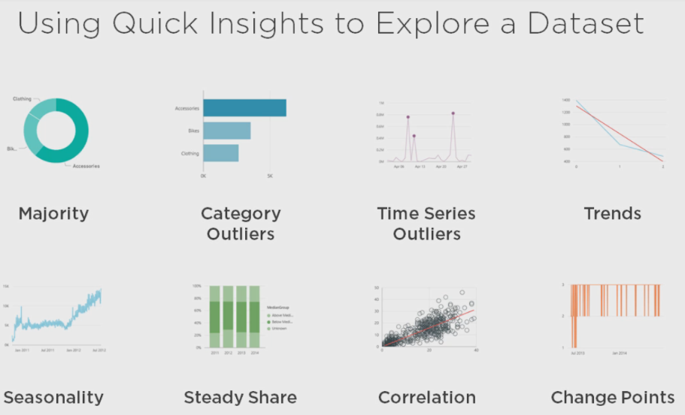With Majority insights we see a graphic that shows us where a majority of a total value can be attributed to a single factor when broken down by another variable.

* Then we have Category Outliers and this highlights where when we have a given measure in the model we have one or two categories that have much larger values than other categories.
* Then there are Time Series Outliers, which shows us data across a time series and detects when there are specific dates or times that have values that are significantly different than the other dates and times.
* Then we have Trend insights, which detects upward or downward trends whenever we have time series data.
* Then there's Seasonality that also provides insights into time series data. It's looking for periodic patterns in our data such as weekly, monthly or yearly seasonality.
* Then we have Steady Share insights and this highlights cases where there's a parent child correlation between the share of a particular child value in relation to the overall value of a parent across a continuous variable.
* And then we have Correlation. This detects cases where we have multiple values showing a correlation between each other when plotted against a particular category in our data set.
* And then we have Change Points insights and this shows us where there might be significant changes in trends when we have a time series of data.

**Demo: Using Quick Insights**

Let's take a closer look at this feature, but first let me explain the scenario for this data set. Imagine I'm a marketing analyst for a fictitious company called Adventure Works and I want to explore my customer base for the West Coast of the United States to determine a good target market some high end bicycles that Adventure Works sells. So the purpose of this PBIX file is to help me do that. After I upload the PBIX file, I get a message that encourages me to explore the Quick Insights, but if I come back later there's another way to get to the same place.

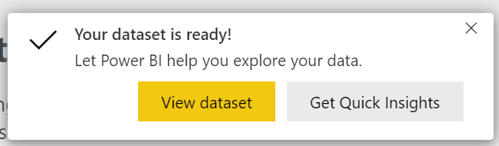And that is to go to the left side of your screen and show the Navigation pane and then down where it says Data Sets, we can open a menu here and select the option Quick Insights.

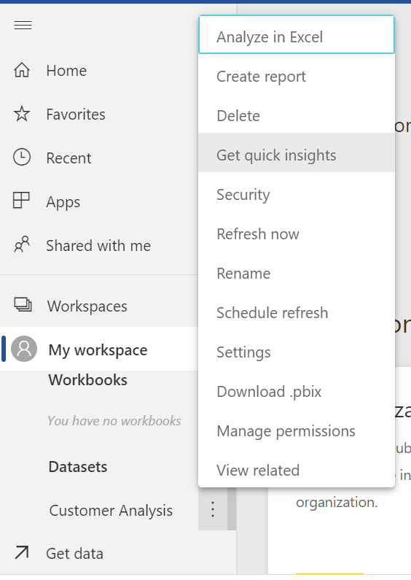Now it'll take a minute or two to generate these insights for us, but you'll see the status displayed in this message box. As soon as it's ready click View Insights.

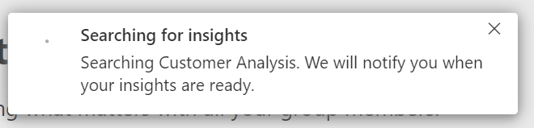

Now even though there are eight categories of insights the structure and the contents of our data determine which insights that Power BI generates for us automatically.

Here we can see an example of Category Outliers and it tells us that for a value called Distinct Customers Purchasing that there are more customers buying accessories than there are customers buying bikes or clothing. And in particular, accessories has noticeably more customers purchasing this category of product. We can scroll down and view other kinds of insights, such as a Majority insight where we can see, again, accessories accounts for the majority of sales if we're just counting the number of sales as opposed to the number of customers. So it's similar information, but from a slightly different perspective.

In addition, Power BI found a correlation between the distinct number of customers that are purchasing products and the number of children that each customer has at home. Now this may or may not have true significance, but Quick Insight's job is to bring to our attention certain bits of information that we can explore.

Now here's an example of where an insight doesn't necessarily make sense. Normally the Trend insight should work with time series data. What this is showing us is that the email promotion flag, which is set to 1 or 2, that this changes over those values, and this doesn't necessarily make sense that the number of children at home gets lower depending on our email promotion flag. So sometimes Power BI doesn't know enough about your data to fine tune these Quick Insights. As we scroll down and look at Total Sales, we can see that we sell more in California than we do in Washington and Oregon, and if we hover over a particular data point, we can see the actual value of Total Sales.

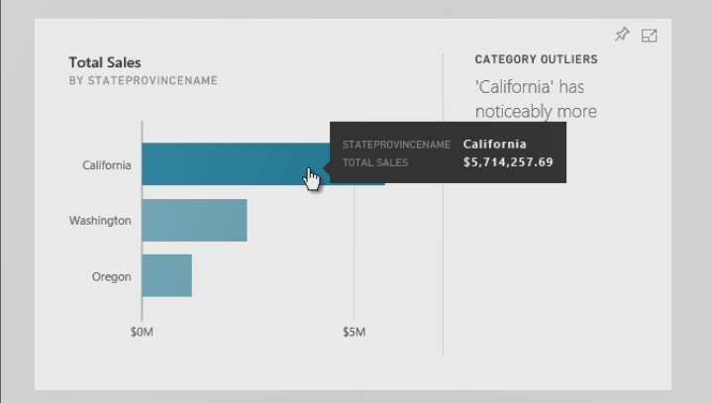And if we like this graphic we can do a couple of things, number one we could go to Focus mode where all we see is this particular visualization. We can continue to get more insights related to this particular visualization, such as the minimum value and the maximum value and total sales, and additional insights that are related to just this particular piece of information.

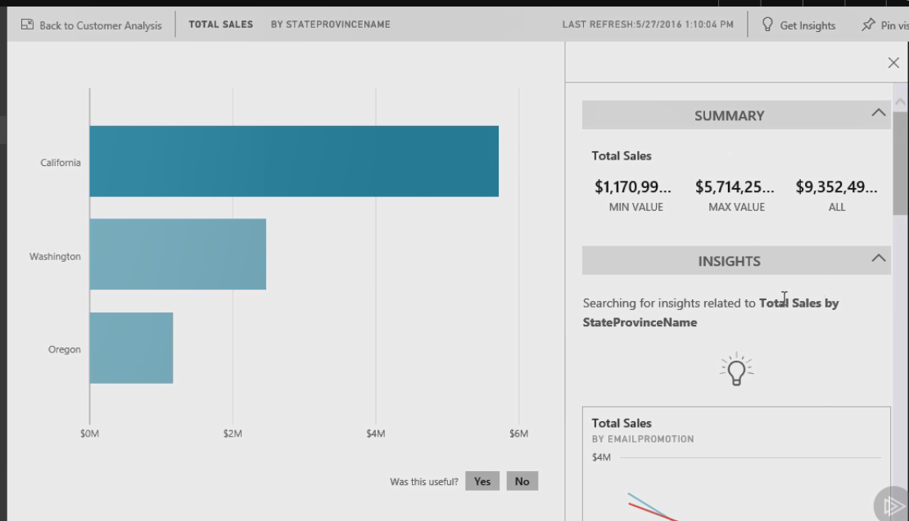

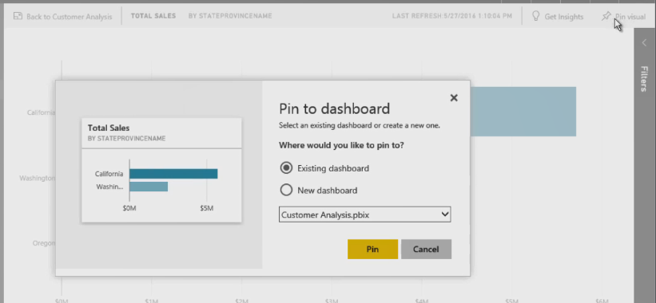And if we like this visual, we can save it to a dashboard by using the Pin visual button here.

So we can create a new dashboard, we'll call this West Coast Customers, and click the Pin button. Now you can see that in our Workspace panel on the left we have a Dashboards group and if we click West Coast Customers, we can see that it includes that visualization that was generated from Quick Insights.

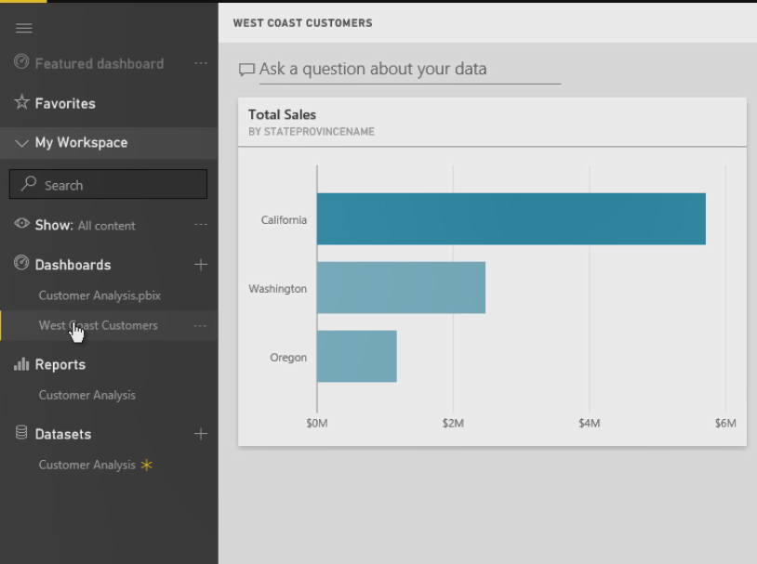

**Viewing Reports**

You can also explore a data set that you've uploaded by creating a report or you can view reports that are saved in Power BI or upload it from an Excel or Power BI desktop file.

A report can contain one or more visualizations, such as charts, tables, or a map. It might have slicers that you can use as one way to filter the data in the report and as you'll see in the demonstration you can click items in the report to have a special type of filter called a highlight, and a report can have multiple pages.

Imp : One thing to remember about a report is that all the data from any page has to come from the same data set.

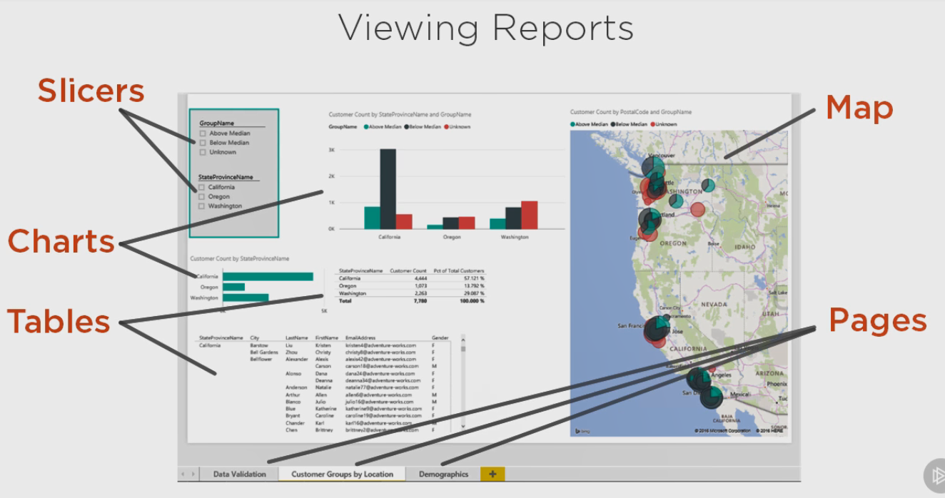

**Demo: Viewing Reports in Power BI**

Now let's take a look at working with reports. The Power BI desktop file that I uploaded in an earlier demonstration not only uploaded a data set, but also a report.

Let's open this report. It has two tabs, one for Sales and Customer Groups by Location.

I have a chart here at the top that counts my customers by state and in fact it's filtered right now with what we call a slicer, it's showing me only those customers for whom their yearly income is above the median income reported by the US Census Bureau for where they live. I can clear this selection and see my customers for all states and I can see it categorized by color the count of customers above the median, below the median and for an unknown income relative to the median for each state.

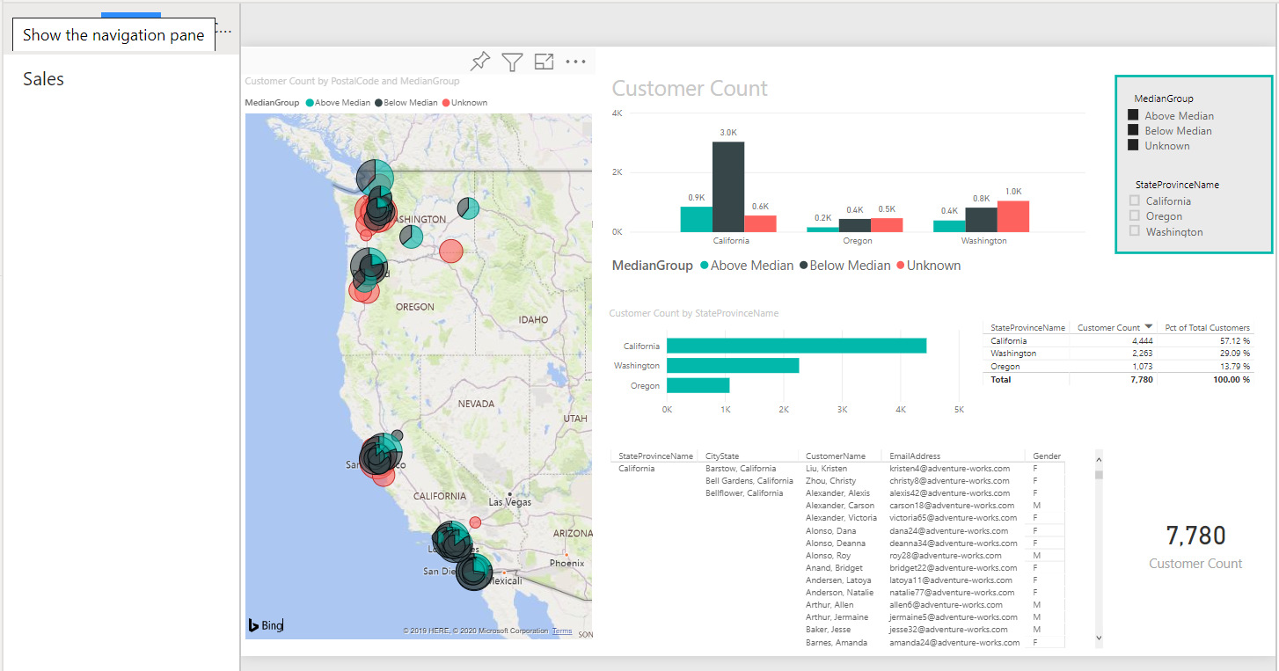

On the left I have a map that gives me similar information by zip code and if I point to a particular zip code I can see how those values break down. I can also see all customers broken down by state in chart form and in table form, and below I have a list of particular customers organized by state, city, the customer name, with an email address and their gender, and an overall customer count. Now this report is set up so that I can drill down to see all of my data by city and state and I scroll through this or I can drill down and look at a particular state, so if I enable the drill down feature and then I click on Washington, I can see all of the city states within Washington. Or I can select just Bellingham Washington and see that breakdown by occupation. If I highlight a data element on a map or on a chart, it highlights that data in the related charts. So for example, the 98225 zip code represents a very small slice of Washington above the median here, a specific data point that I had highlighted. And in each of the charts we see the relative percentage that selection represents. And our tables have also been filtered to show me just the information related to that data element and what's really handy about this is when I make my selection, not only can I filter this data but I can export this data and get a list that I can use for other purposes. To clear the selection I just click on the same data element that I selected in the first place.

And then when I go to the Sales tab I can see different data related to sales about those customers as well and I have a KPI here that shows me overall sales are down from the prior year. So when we look at 2014 information we can see total sales is $2. 87 million, but the prior year sales, that is the 2013 information is 3. 1 million and so we can see this trend where we can see the comparison of the current year sales to the prior year sales has been increasing year or year, but then in 2014 all of the sudden we're not exceeding the prior year sales. And our slicers again can help us analyze this information and see how this changes by looking at different groups of customers or looking in different places. So this is how we explore our data and at any point in time if there is a visual that we like we can pin that to our dashboard. We can create new dashboards or associate a visual with an existing dashboard.

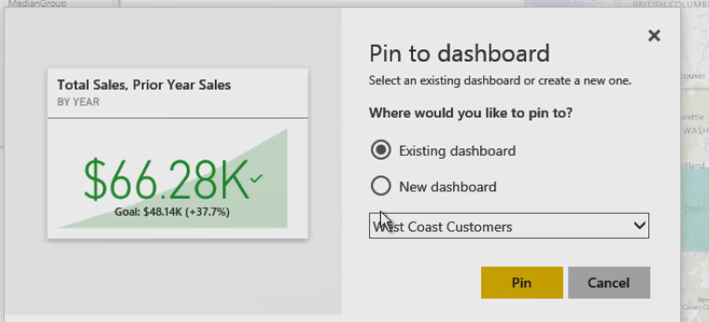

Furthermore we can pin a live page to our existing dashboard. So this tells us that when we use a live page, any changes we make to the reports will also appear in the dashboard tile when we refresh the dashboard page.

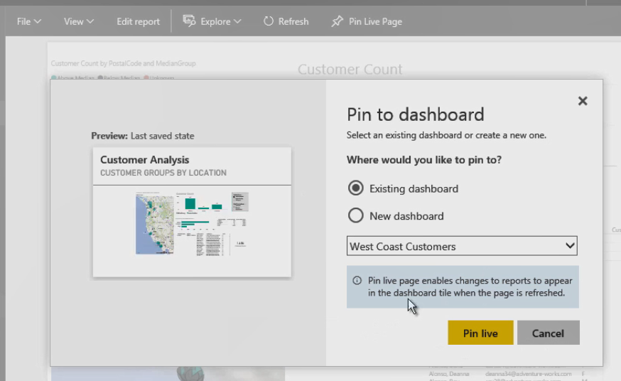

**Exploring a Dashboard**

A dashboard is the other major component in Power BI. A dashboard consists of multiple tiles. A tile can be a report, as you saw earlier in this module whereas a report can show data from only one data set, we can use a dashboard to bring together items from multiple reports.

It can also be some other type of content such as web content or even a SQL Server reporting services report if you have that running in your organization. It can be an image, a text box or a video.

Not only can you view data in your dashboard, but you can also type in a question using a natural language query such as which customers are in a particular location? There's no particular rule to how you ask the question, which means I could ask this question in multiple ways to get the same result, such as show customers in Bellingham Washington. The format of the result depends on the type of data that results for the question.

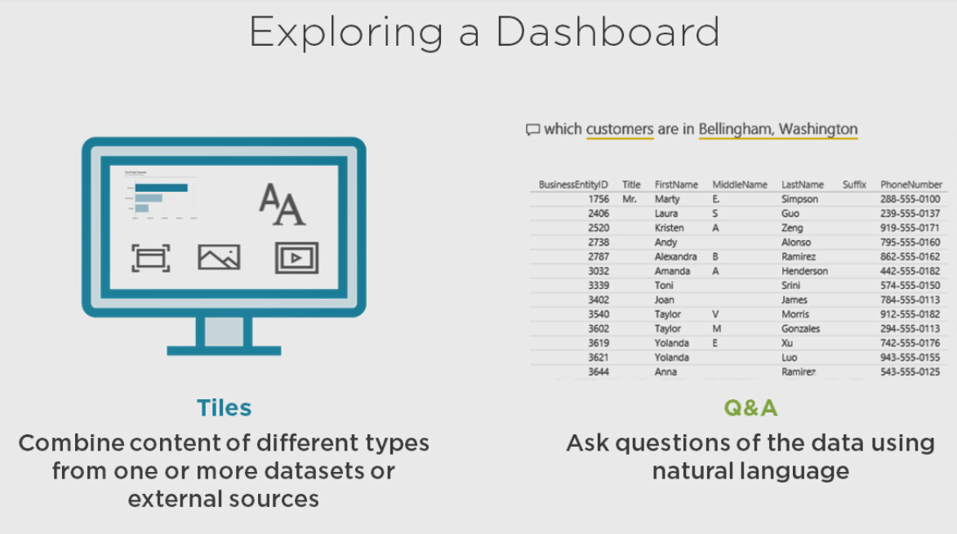

**Demo: Exploring a Dashboard**

So now let's take a look at our dashboard, we'll click the West Coast Customers in the dashboard page and we can see various tiles in this dashboard.   
The first tile comes from the Quick Insights that we reviewed in an earlier demonstration.

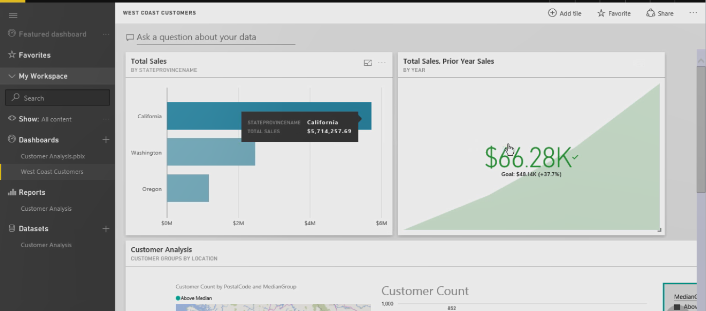

The second tile here comes from the KPI visualization in the report and then down below we have the customer analysis, this is the live page from the customer groups by location in our report.

Now notice that the “default view of the report is what is visible” here, where we have the selection of above median and so forth, and that's not what we saw when we first left the customer analysis report, and that's because the portion that gets saved is what was in the report. So the default view of the report, anything that I changed, even though I had cleared the median group selection and did the Pin Live Page, it didn't save what I saw on the report, it saved the default view.

If I want it to save what I was looking at, I would need to edit the report and then save the report with this new view that has cleared out the median group.

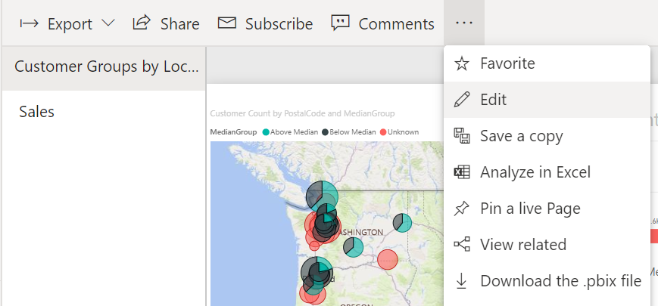

And now if I go back to my dashboard, we'll see that it has refreshed to show the current view that has been saved in the report.

And then we get the same level of interactivity that we had in the report, we can change the slicer selections, we can select an item in an chart to have it filter everything else on this tile as well, just as we do in the report.

Now the selections that we make in a given tile do not affect the other items in the dashboard.

Things that you can do in the dashboard is you can pop out any particular tile so that you can see a larger view of this. Here is for Oregon above median customers, so we might want to make this more clear.

We can edit the tile details and we can add other details as well. Maybe the last refresh time and if we wanted to create a drill through from our dashboard, maybe we have a report or additional information that we want to link to, we can set a custom link in this area as well.

And we can add a new tile, we have the option of adding in web content, which would require us to provide title and subtitle optionally as well as the URL that we would want to use or if we wanted an image here, then also we would provide a URL for image.

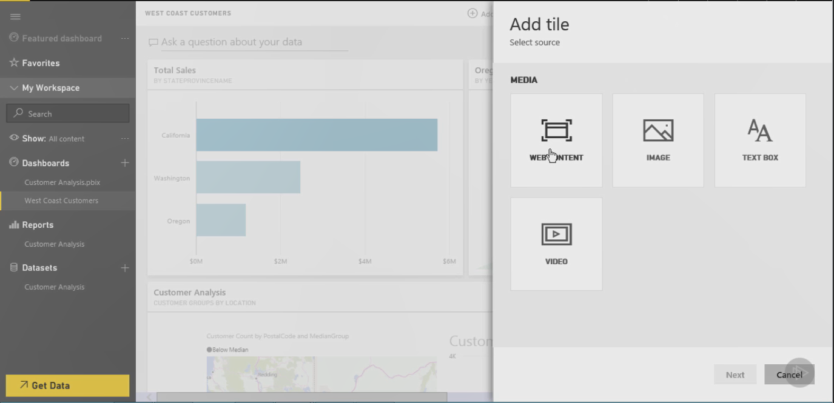

A text box allows us to type in anything that we like here, and we have some editing as well as the ability to include links. And then last we have the option to specify a video where we would include a URL for this as well.

So we can customize this dashboard, we can resize elements, we can rearrange them. As you can see, there's only so much that we can do with the resizing.

And then if you ever want to remove a tile then you would delete the tile here.

You can also export data and open related insights for your selected visualization.

**History of Power BI**

Power BI is a suite of tools that has evolved over several years to the online service that we're exploring in this course, and it exists in various forms which can make it confusing to understand what you need to make it work.

Let's take a quick look at the history of Power BI.

The very first Power BI tool was PowerPivot, which was introduced as a free downloadable add-in for Excel 2010. PowerPivot is the component that you use to model your data in preparation for reports.

Then in SQL Server 2012 Power View was introduced as part of reporting services in SharePoint integrated mode, meaning you can only use it inside of SharePoint. In this version you use Power View to connect to a Power Pivot model that you upload to SharePoint or to a SQL Server analysis tabular model and then you create visualizations much like the ones you saw in the previous demonstration in this module.

In Excel 2013 Power Query is a built-in add-in that you use to get and transform your data in preparation for modeling. Although Power Pivot has the ability to get and transform data also, it's much more limited in its capabilities that Power Query.

Power View was also added to Excel 2013 and both of these tools still exist in Excel 2016, but Power Query has been renamed in Excel 2016 as you'll see in the next demonstration.

At one time Power BI was an add-on subscription service for Office 365, but it's since been retired now that we have PowerBI. com, the independent cloud service that we've been exploring in this module.

**Imp:** Now instead of using Power BI Desktop, which is the file that we uploaded in a previous version, you can also upload Excel files that use Power Query, PowerPivot, and Power View to build out your model and reports.

Another feature of PowerBI. com is Power BI Mobile and that allows you to view dashboards and reports from mobile devices, but you cannot create content from Power BI Mobile.

In SQL Server 2016 a feature was added to reporting services that allows you to pin a reporting services report to your Power BI dashboard. When you click on the tile in the dashboard, a browser window opens your on-premises report as long as you have network connectivity to the report server when you do that.

And last, Azure, another Microsoft cloud service, now has a feature called “Power BI Embedded” that you can use to “integrate Power BI reports into applications.”With this service you still need to create the content using either Excel or Power BI Desktop, and then upload the files to PowerBI. com.

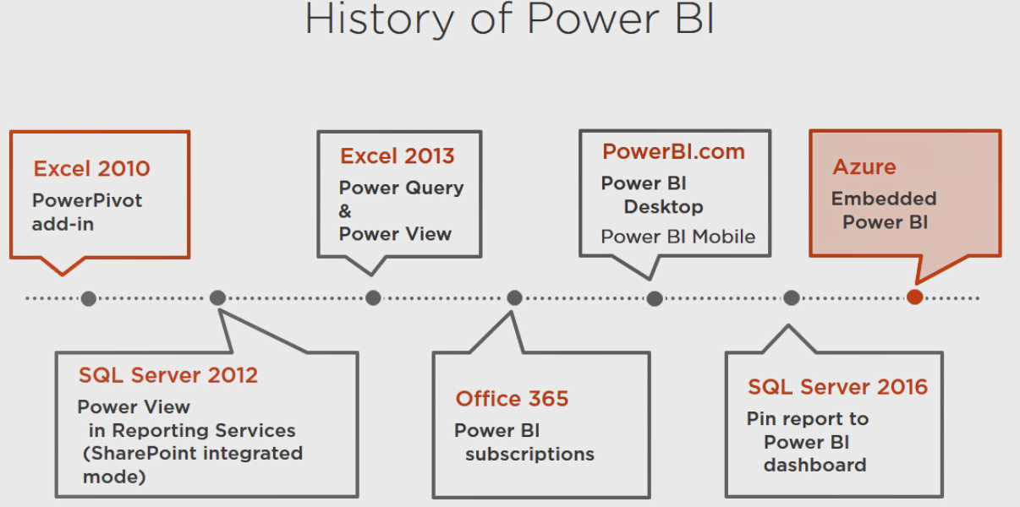

**Choosing a Development Tool**

Because the focus of this course is the cloud service PowerBI. com, you have two choices for creating content to upload.

You can use Excel 2013 or higher for Windows, but the Mac version of Excel does not support the Power BI tools at this time, or

you can use Power BI Desktop for Windows. Again, there's no Mac version available here either.

**Using Excel**

Let's start by looking at Excel. You start by acquiring data using the Get & Transform Data tool in Excel 2016, but that's called Power Query in Excel 2010 and Excel 2013. You don't have to use this tool to get your data ready for Power BI, but the advantage is that you can connect to more data sources with Power Query and if you have Office 365 or Azure Data Catalog, you can share the result of your transform data with other people in your organization.

After you prepare your data, you then use Power Pivot to create the data model. A data model is more than just a copy of the rows and columns from your data source, it's the enhanced data that you create by adding relationships between tables and setting up formatting for numeric data and hiding columns that you don't need for reporting purposes and several other tasks.

Power View is the tool that you use to create visualizations. You set up a special type of worksheet in Excel and you can add tables and charts and apply filters and so on to build out a report that gets uploaded with your data model to PowerBI. com.

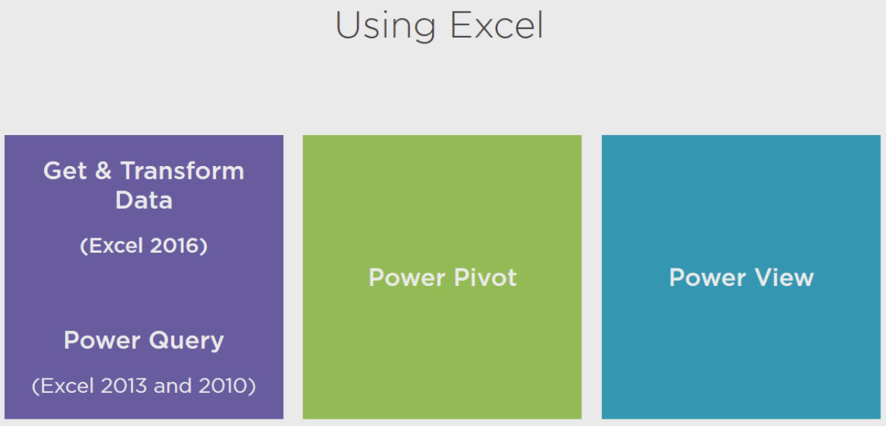

**Demo: Using Excel 2016**

Let's take a look at where you find these tools in Excel. I'm working with Excel 2016 here, but the process is similar in Excel 2013.

First, if you haven't used any of the Power BI tools before, you need to go to the File menu, select Options, go to Add-ins, then select COM Add-ins from the dropdown list here and click Go. You should see Power Pivot for Excel and Power View for Excel in the Add-ins list and just select the checkboxes. In Excel 2013 you'll also need to select Power Query for Excel after you download Power Query from the Microsoft Download Center.

Power Query is built into Excel 2016, but it has a new name. Now if you're using Excel 2013, what you'll find is another tab in here called Power Query, either version of Excel will have a Power Pivot tab.

In Excel 2016, which I have here, the equivalent of Power Query is found on the Data tab in this Get & Transform Data Section.

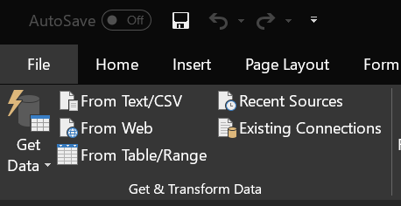

So we could create a new query here, but as I mentioned, Excel 2013 will have another tab just like Power Pivot where we can set up the new queries. Otherwise, the functionality is pretty similar.

So we would create a new query here selecting from some source, once we've added our source we can add it to a data model and that's when it gets loaded into Power Pivot. We would click the Manage button and this gets us into the data model itself, and if we had data loaded in here we'd be able to do some sort of operation on that, and then for Power View, in Excel 2013 you'll find a Power View button on the Insert tab, but in Excel 2016 it's missing. So we need to add it to this Insert tab by going to Options once again, Customize Ribbon, and then on the right hand side where you're customizing the ribbon, select Insert and create a new group, we'll call this Power View, and then on the left hand side we'll select from the dropdown Commands Not in the Ribbon, and then find the Insert a Power View Report and add it into our new group. Again, this will automatically be there in Excel 2013, but we need to manually add that into 2016. So we have queries where we get our data, Power Pivot where we manage the data model, and then we have the visualizations from Power View.

**Using Power BI Desktop**

Power BI Desktop is the tool that I'll be using primarily throughout this course. Although I will take some detours along the way to show you how to do something in Excel in case that's the tool you want to use.

But the process in Power BI Desktop is very similar. You start with a Get Data step, and unlike your options in Excel, this is the only way to get data for use in the Power BI Desktop. Each source that you connect to by using Get Data becomes a separate query.

Then you move on to the Model step and this is where you enhance the data from the query, just like you do with Power Pivot in Excel, you create relationships and format columns and so on.

And then the final step is the report, which is similar to Power View.

Now there are some slight differences from Excel here, which might affect your decision to use one tool versus the other.

**Demo: Using Power BI Desktop**

If you did not download the Power BI Desktop when you signed up for your Power BI service, you can still get it here when you're logged into PowerBI. com, just click this down arrow at the top of the page and click Power BI Desktop to download it and install it.

After you install Power BI Desktop and open it up, this is what you'll see. On the left hand side you've got three icons. So when you open Power BI Desktop you're actually looking at the reporting page, but you need to get data first. So that option occurs on the Home tab where you have this Get Data button and you would select a source. Once you've obtained your data and you're ready to model it, then the second icon on the left gets you into the modeling inside of Power BI Desktop. And we'll see how this works later, but there is different options that you have on the Modeling tab, such as management relationships and creating measures and columns and so forth. You also have a page here for setting up relationships. These two buttons on the left have to do with modeling and then when we finished all of the modeling, then we build out the reports on this first page that's in our Power BI Desktop.

**Summary**

And now we've come to the end of the first module in which I introduced you to Power BI. We explored the main features of this suite of tools by uploading a completed data set so you could see what you're aiming for when you develop your own content and I showed you how to get ready to develop your content with the development tools using either Excel or Power BI Desktop. Here's some additional resources for getting setup to work with Power BI, you'll need to download the Power BI Desktop or if you're using Excel 2013, download the Power Query add-in, Excel 2016 already comes with Get & Transform data options, so there's nothing additional to download there.

**Getting Data**

**Getting Data**

Hi I'm Stacia Varga and welcome to Getting Data, the second module in the Getting Started with Power BI course. In this module I'll start by showing you different ways to get data to use in Power BI. There are many different types of data available and our tools to get data into Power BI makes it very easy to get at that data. The list of the kinds of data sources that Power BI supports automatically is pretty extensive and includes the following groups. First you can get data from databases stored on-premises in your organization. Most of the time this data is copied into a Power BI data set, which you need to refresh periodically. But in some cases you can create a live connection to work with the data directly. You can also get data from files that are on your computer or your company's network or even from files stored in OneDrive. Or you can get data that's accessible from a web URL or an OData feed, just to name a couple of options. If you have data in Azure, Power BI makes it easy to use that data as well. And if you're using Software as a Service, such as Salesforce for Google Analytics, you can connect with Power BI to get that data for analysis. In this module I'll describe the first three options in more detail, then at the end of this module I'll point you to resources for working with Azure or Software as a Service sources.

Databases

When working with databases you might have some choices to make, depending on the type of database that you're using. For any of the supported databases you can always import data, that means Power BI copies your data into the Power BI service in the cloud and you'll have to take additional steps to update the data later if it changes. With some databases import is the only option you have, such as DB2 and MySQL, among others. With Analysis Services databases you can import data from either multidimensional models or tabular models. Another option is to use DirectQuery, which at the time of this recording is limited to a subset of databases. As with anything I describe in this course, Power BI changes frequently, but you'll know when you connect to a data source which options are currently available to you. With Direct Query the data does not move out of the source database, instead Power BI queries the database when you view the report, so the data is always current, which sounds good, but you will need to have Enterprise Gateway installed by your IT department to work with these sources in Direct Query mode. Your model can only use data from the same database. That means you won't be able to mix and match data sources as I show you how to do later in this module. Remember, this applies in Direct Query mode only and with Direct Query mode you're not going to be able to add calculated columns or tables to your model either. And you also won't be able to change data types for columns. Despite these limitations, Direct Query can be a great option when your data set is large or when you need real time data. A third option, Connect Live, is unique to Analysis Services. If you're connecting to a tabular model, then you can work with the data directly without making any changes to the model, but you cannot combine tabular data with other sources. You can also set up a live connection for multidimensional models, but this is strictly for exploring data and Power BI Desktop. You won't be able to publish reports that you create to the Power BI service when using multidimensional data. Either way, you do need to have an Enterprise Gateway installed by your IT department if you plan to publish reports to the Power BI service for your tabular model source. With Access and Excel data sources, Power BI uses the provider for the redistributable Microsoft Access database engine 2010. If you don't have it or if you don't have the right version installed, you get an error, like this. If you have 32-bit office components you'll need the 32-bit Access Database Engine or if you have 64-bit office components, you'll need the 64-bit version. Now sometimes that's not enough to correct the problem, but regardless, this link takes you to a page describing different solutions for this particular error.

Demo: Getting Data from Databases Using Power BI Desktop

Now I'm going to show you how to work with databases to get data into your model using Power BI Desktop. On the Home tab, click the Get Data button, and you can see the various sources here. If you have data in SQL Server, for example, you would put in the server name and the database name. And here's where you have this option to choose whether you want to import data into your model or if you want to use Direct Query mode. Similarly, if you want to get data from Analysis Services, you have the option to connect live or import data into your model. For this demonstration we're going to get data from Access, so click on the More button. You can see here the different groups for getting data. Here in the Database group we'll choose Access Database and click Connect and in the location where you've extracted the demo files for this course, there's a getting-started-power-bi-data folder where you will find the AdventureWorksDemo access database, so we'll select that, click Open. And this particular database has two tables, we'll select both of them, Customer, and you can see a preview, as well as Sales, we get a preview of that as well. And we'll edit this query and you'll notice that we're in the Query editor. This is where you can clean up any data issues that might be in the data or transform the data into the shape that you want. I'll come back later and work on this data transformation later. But as you work on your own data sources, you can go ahead and do the transformations right away. To close this out, I'll select Close and Apply. And at this time Power BI is loading all of this data into my Data Model.

Demo: Getting Data from Databases (Excel)

To get data in Excel 2016 we'll go to the Data tab and click on New Query, point to From Database, and again we have the same options over here, From SQL Server Database, when we make this selection notice that we do not get the option for Import or Direct Query, that only happens in the Power BI Desktop. Let's go ahead and get data from our Access Database, we'll locate the data in the getting-started-power-bi-data folder and we'll select the AdventureWorksDemo database. The interface here is similar as we saw in Power BI Desktop, the difference is by default we can select only one table, but if we need to select two, just select the checkbox here, select multiple items and then we can choose both of the tables that are in this database. And again we can see the preview of this information as well. Now if you want to edit this data before you build out your model, you click the Edit button and that opens up the Query editor. We're going to save this task for later, however. When you close the Query editor, make sure that you select the Close & Load To option and you want to add this data to the Data Model and you only need to create the connection. We do not need to load this data into an Excel worksheet, we simply want it added to the Data Model. So we click Load and now we have Workbook Queries that are visible here in this panel. You can always hide or show this panel just by clicking the Show Queries button in the top of the Get & Transform group of your Data ribbon. In Excel 2013 you will have your Power Query tab of the ribbon which will have a similar button to hide or close this panel. When the data is loaded, you can always come back to this panel and right click on one of your queries and select Edit to open up the Query editor.

Files

Another type of data source that you can use to bring data into Power BI are files. You can use Excel files in XLS or XLSX format or data in text or comma separated files, structured files such as JSON or XML files are another supported file type, and then you can also connect to a specific folder on your computer or to a SharePoint folder to get metadata about the folder contents.

Demo: Getting Data from Files Using Power BI Desktop

In this demonstration I'll show you how to work with files to import into Power BI. So if we go to the Get Data and point to More and look at our various file types, we can see that there's different types of files that we can connect to and then we have folders which aren't technically files, but they're give us information about files in a specific location. Now I'll explain more about the different files that I'll be working with a bit later on in this module, but for now I have a couple different kinds that I need. This is survey data that I've downloaded from the US Census Bureau and we use it to discover information about where our customers live. So for example I have some CSV files and in the folder getting-started-power-bi-data, I have three CSV files that all start with a g. This gives us information about places in a particular state. So if I pick California, for example, we can see there's different columns of data, there's no header information in here, and there's a lot of columns. If we scroll over to about column 50 we can see that there are place names in here. So this file is not completely useful to you as is, you're going to have to do some transformations, which I'll explain later. But for now I'm just going to load all the files without doing any editing. So here's California, and I'll just repeat the process for Oregon and again for Washington. All of this data is getting imported into our model and it's listed on the right hand side here in this Fields panel as a table, and I can expand each table to see the columns that each table contains. Now I also have text files that have demographics information from the survey, so I'll use a similar process to get those files. This time they're text files. Again, one file for California (Typing), Oregon, and Washington. Now I have some Excel files that will help decipher these other files that I've already loaded in. First I have an Excel file that helps me label the columns from the files that start with a g and because Excel can have multiple worksheets, the Navigator window opens up so that I can select a specific worksheet, and here I can see columns with some descriptions. Go ahead and load that. And one more Excel file, this gives us the information for all the files that start with an e, in fact in this case we'll select only the worksheet that has the letter e in front of it. So this gives us the column names for the data in these e tables.

Demo: Getting Data from Files Using Excel

If you're using Excel, the process is very similar. By the way, I saved my file just in case because it's always good to save your work while you're working. Let's get data from file and we'll start with the CSV files and we'll import each of the CSV files that starts with a g and we'll just do the Load To option here, very similar to what we did with the access database where we're creating the connection and adding to the Data Model. So now I have multiple files loaded in here. I have the three g files coming from the CSV imports, I have the three e files coming from the text file imports, and then I have an Excel import and another Excel import to provide column headers for these other CSV and text files that I loaded, but we'll learn more how to do that later on in this module.

Web and Other Sources

You can also get data from a variety of sources online, both inside and outside your organization, such as a file that you can download from a URL or from a SharePoint list or a Hadoop file stored in HDFS or you can get Active Directory information or pull data from an OData feed or connect to some other type of database that doesn't have a specific connector by using ODBC or get data from an Exchange Server or use R Script to get data for your Power BI model.

Demo: Getting Data from the Web

Let's get some data from the web. In our getting-started-power-bi-data folder I have a web URL file that has a URL that we can use. So let's copy this and let's go back to the Power BI Desktop, and we'll use Get Data from the web and paste in this URL. Now depending upon the location of this data, we might need to provide credentials, but because this is publically accessible information we can use anonymous access here and click Connect, and here we can see the data has been downloaded for us, and what this provides for us is some zip code information in this first column because I have all of my customer data by zip code and I have census survey data by place, but to tie the two sets of data together I need to be able to cross reference places by zip code and this file helps me do that. Now sometimes the internet connection might be a little slow, so what you do in that case is just try again to apply the changes. Now if for some reason you just cannot get that data downloaded, I have another option for you and that is I've put the data into an Excel file. So if you import the zip data file from an Excel workbook instead, you can skip the import from a web URL step. This process works very much the same way in Excel, so I'm not going to include a demonstration of those steps this time around.

Azure and Software as a Service

Other sources you can use in Power BI include Azure sources, such as SQL Database and SQL Data Warehouse. You can use the Direct Query method to get fresh data and you don't need a gateway to make this work, just credentials to access the data, but you can also use the import option to pull data from these two data sources into Power BI, and you can do the same with all kinds of other sources in Azure. Power BI currently supports Blob storage and Table storage and DocumentDB and Data Lakes and Azure Marketplace and HDInsight, and Spark for HDInsight, and it that's not enough, there are Software as a Service data sources too, which currently include SharePoint Online, Dynamics CRM, Google Analytics, Facebook, Salesforce, and Exchange Online, and this is just to name a few, and many more are likely to appear in the future.

Manual Entry

Sometimes you might not have a data source set up and although you could set up an Excel file or text file, another option is to simply enter the data directly. Power BI includes a grid interface that you can use to type data into as many rows or columns as you need.

Demo: Adding Data Manually Using Power BI

Let's take a moment to see how to add data manually in the Power BI Desktop. One of the things we need for our report is a way to flag each customer's income as above or below the median. So we need a table containing those labels. Here on the Home tab we have the Enter Data button. So we'll just start typing. I'll replace the Column1 with a new name, we'll call this the MedianGroupKey, and I'll click in the second column and call this MedianGroup, and then I can just start typing the data itself, double click the first row, first column and type 0, we'll call this Unknown, and in the second row I'll type in a 1 and we'll call this Below Median, and then I'll have a third row where I have 2 and we'll put in Above Median. And we'll give the table a name and we'll click the Load button to load this into our Data Model.

Demo: Adding Data Manually Using Excel

In Excel 2016 we actually need to create our table in a worksheet if we're going to use manual data entry. So I can set up my table like this and once I've typed in the data I need to format this as a table, so once I have my data entered into a worksheet, I can point to From Table, and notice that it tells me that if it's not already formatted as a table, Excel will convert it into a table for me. So I'll click From Table, I'll let it know the range here that I've selected, my table has headers, click OK. Replace this Table1 with the name of the table. So I'm going to close and load this to our Data Model, just like we did for the other types of data.

Summary

In this module I showed you how to perform a number of tasks. You now know how to get data from databases, from different file types and from a web URL. Now here are some resources related to working with getting data from sources that I didn't cover in this module and how to get the Access Database Engine download. Also, here's some background information with more information about prerequisites for some of your data source types and what you should know about Direct Query. And here's the location of the documentation for the American Community Survey census information, and the data in case you want to download information for other states.

**Transforming Data**

Transforming Data

Hi I'm Stacia Vargo and welcome to Transforming Data. You have a lot of data loaded into the model now, but it's not usable in its current state for reporting. Fortunately, you have a lot of options for transforming that data. You can give objects friendlier names, combine two or more queries to work with the results as if it were a single query, fix up metadata such as column names or data types, filter out rows, remove columns that you don't need, or add in new columns in a few different ways. There are a whole lot more transformations, but in this module I'll focus on showing you these six basic types.

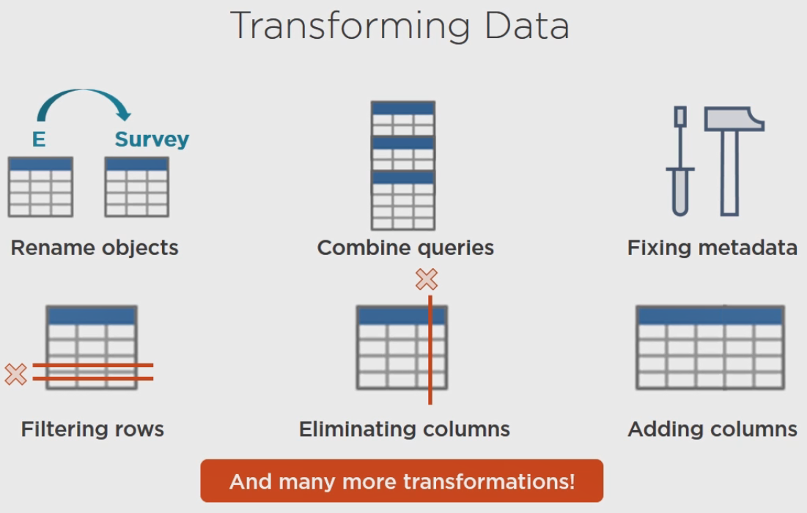

**Renaming Queries**

One problem that we have with all the queries right now is that the name of the queries in the current model are mysterious. It would be better to rename them to make it easier to work with the data, whether you're modeling the data or building reports. And it's really easy to rename the queries, let's see how.

**Demo: Renaming Queries**

In Power BI Desktop let's see how easy it is to rename queries. Let's go to the Edit Queries button and you can see all of the queries listed on the left. Now for all of our tables that start with a g, let's rename these to the state plus Geo in there, so CA Geo, hit Enter and the table changes.

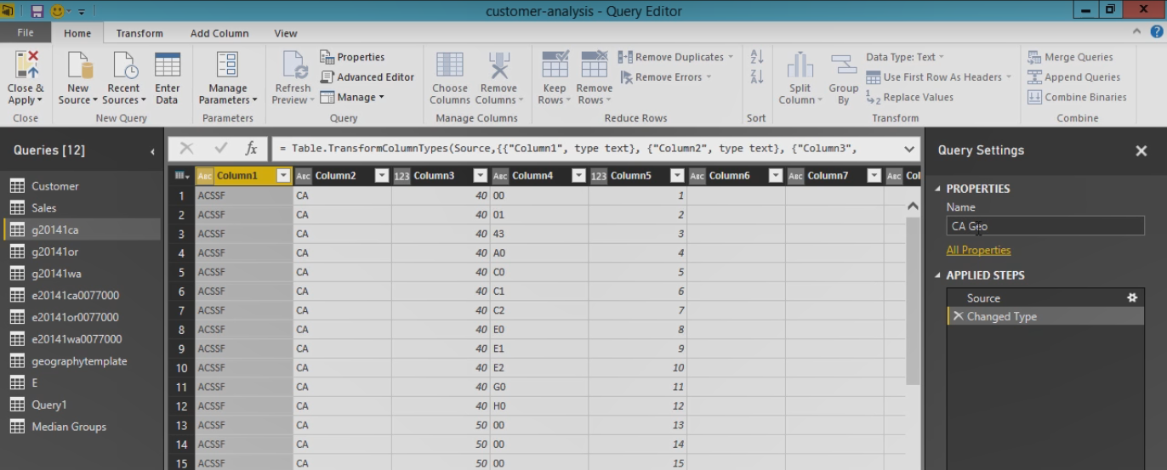

You could also right click a table and select Rename, so we could type in OR Geo here. Whichever location you prefer.

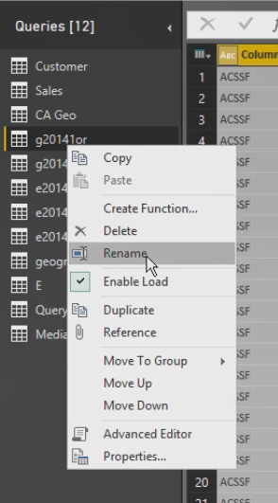For our queries that start with e, we'll rename this with a survey prefix. Be sure and hit Enter after you've made the name change. I'm going to rename the geography template, Geography, for the table that has just e let's call this Survey and for our zip code data let's call this Location. So now we have much friendly names for each of our tables. And when you're finished click Close & Apply.

In Excel you'll need to edit properties for your queries or you can rename your queries without opening up the Query editor, and we get a prompt that if we have created a Data Model we might break some things in that model definition by renaming this query. But fortunately we haven't done anything with the Data Model yet, so renaming all of our queries is just fine. And so you would just repeat this process for each of the queries, just like we did in Power BI Desktop.

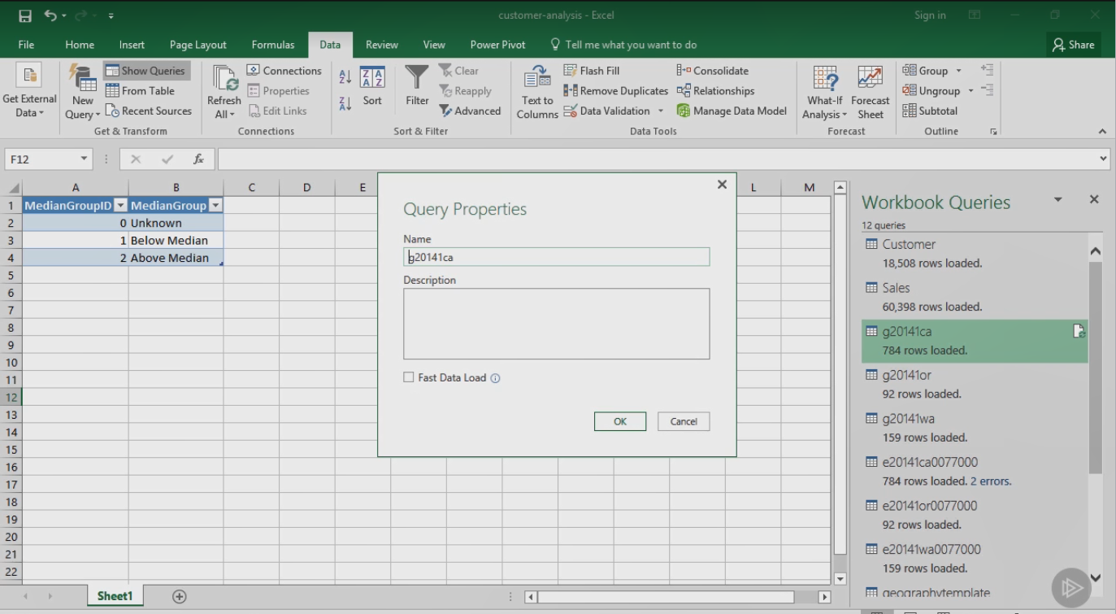

**Combining Queries: Append**

There's many different reasons why you might need to combine queries, the data for the model in this course has separate queries for each state. So to view all of the information together in a report for easy comparison, you need to combine the queries, but these query sets also are missing header rows to describe each column. So we can combine the individual files with the corresponding header files to produce one big query for each set. This is an example of appending queries.

**Demo: Appending Queries Using Power BI**

Now let's see how this works. Let's go into the Edit Queries option here in the Power BI Desktop, and as we saw earlier, some of this data doesn't have column names, but we have that information in other files. So we're going to append various queries together, so let's start with geography as the beginning query because it has the header rows that we need, and we'll use this option over in the Combine group, we'll use the Append Queries option here,

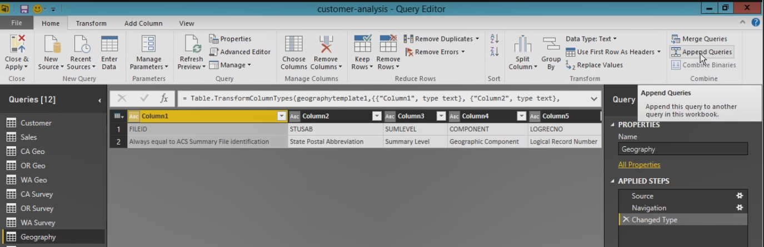

and it asks us what we want to append to the query that we currently have selected.

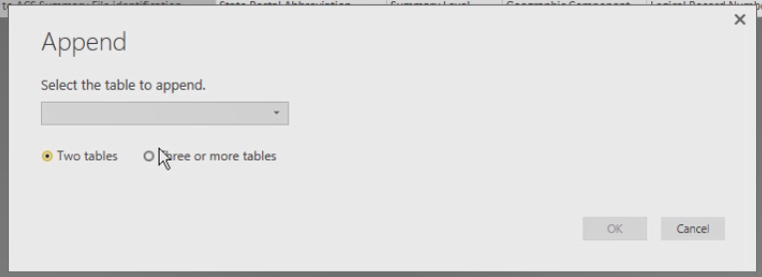We need to combine the geography table with these three geo tables, so there are three or more tables that we're going to use and we just select them one by one to add them to the table list on the right hand side.

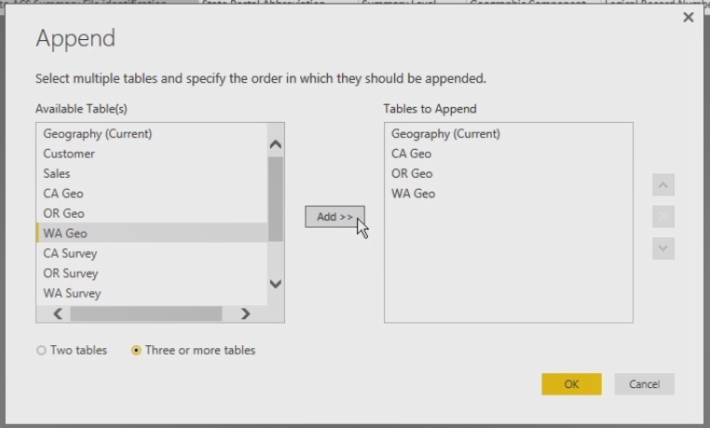

Then we click OK and we can see all of this information got brought together. We can preview some of it here. We can't see the California, Washington, and Oregon through scrolling, but if we were to look at this filter here, we could see that we have California, Oregon, and Washington as potential options.

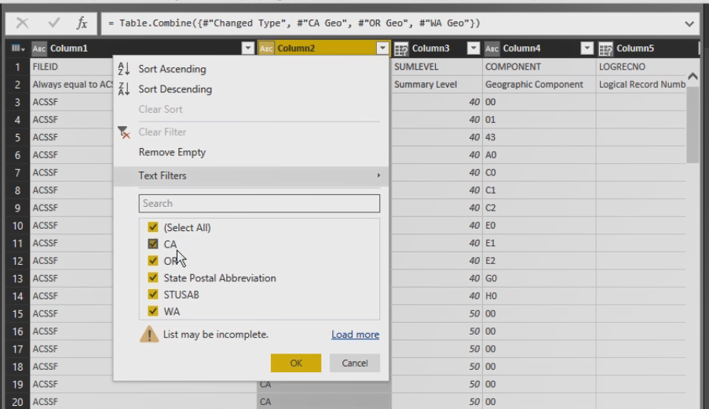Now one of the things that's great about the Query editor is that we can see the steps that we've applied and if we make a mistake we can always remove a step. But at any point in the series of steps we can see what things look like. For example, here was the beginning geography file, there was some changes to column types that Power BI made automatically, and then we appended the queries to bring in California, Oregon, and Washington.

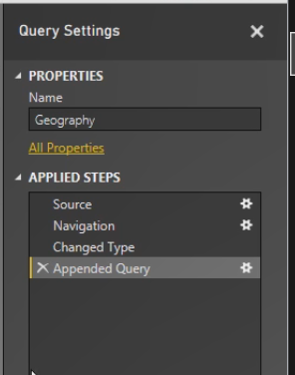Let's do the same thing with Survey. We'll select Survey first, Append Queries, select three or more tables, and now we will append the California, Oregon, and Washington surveys.

Now after we've done this it might be easier for us to work with queries in the Query panel if we group them into queries that we no longer want to work with in our transformations versus those that we'll be using in our model. So for example, if I go to CA Geo, we've appended that to something else. So I'm going to move this into a group, a new group because we don't have any set up yet, but we can call it something like Queries not in model.

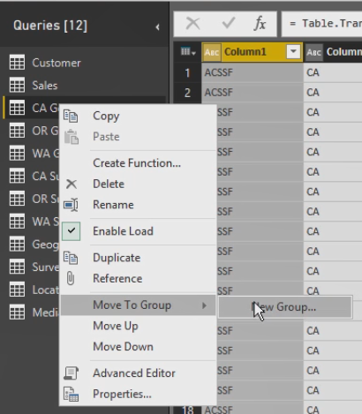

And you can see how our queries now are reorganized. So I can move individual tables in, one by one, into this same group (Typing). This doesn't affect our model, it's just simply for us to work with our queries a little more easily to keep track of which ones we're going to continue to transform as we prepare our model.

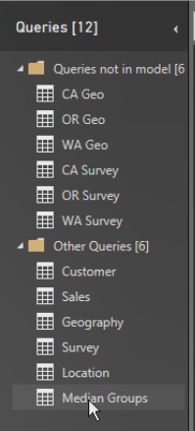

**Demo: Appending Queries Using Excel**

In Excel the process is similar, we can take geography, right click on it, and we can append three or more tables just like we did in Power BI Desktop.

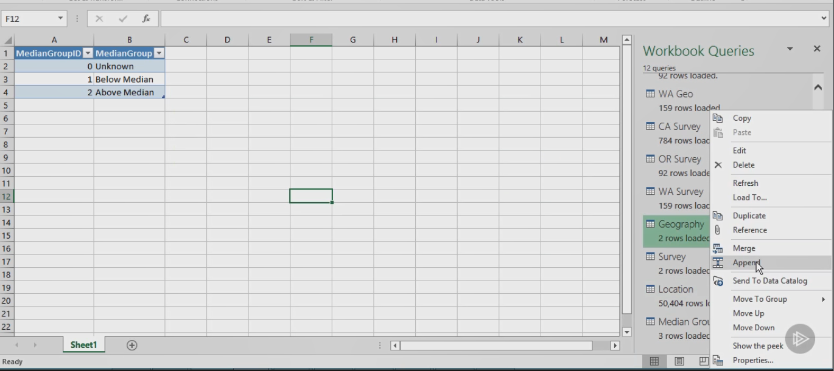

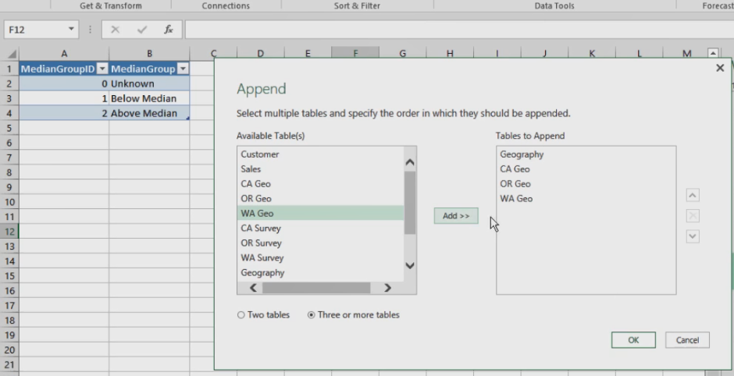And we'll give it a name, let's just call it Geo here so it doesn't conflict with Geography. Let's close and load this to the Data Model and repeat the process for Survey (Typing). Let's call this West Coast Survey and Close & Load this to our Data Model.

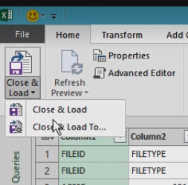

We can also create groups for our queries, right click on a particular group, click Move To Group and then define a new group, and we can continue to move other queries into that group.

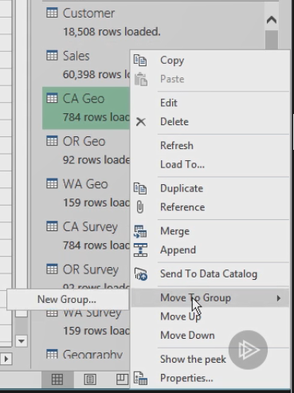

**Fixing Metadata**

Sometimes you might need to do some cleanup of your queries. When you fix metadata, you're fixing data about your data. For example, usually Power BI figures out when a row should be a header and not part of the data itself, but sometimes it needs help. You can use a transform to pull the header out of the data.

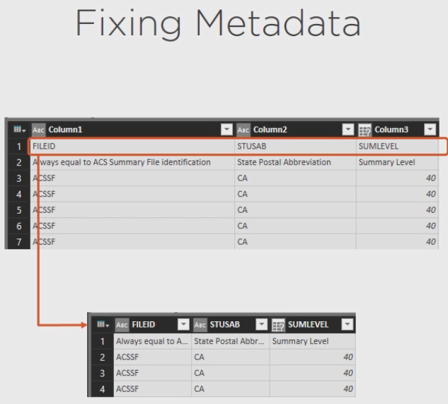

Or sometimes our header data includes more than one row that you don't really need, so you can remove it.

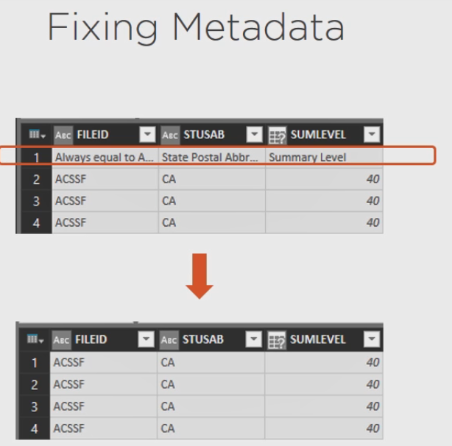

In this case the row that you don't need is metadata, but you can use this technique to remove a specified number of rows.

Also, sometimes when you import data, Power BI gets the data type incorrect or doesn't recognize the data type as shown here, and you're going to need to fix this manually. In the next demonstration I'll show you how.

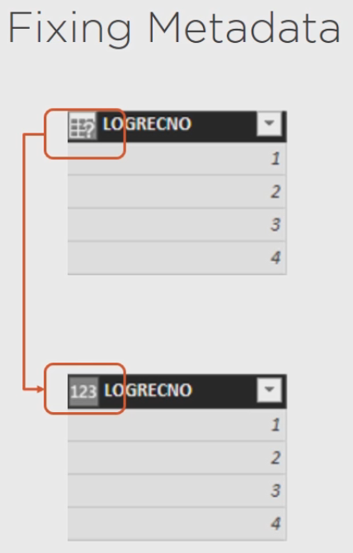

**Demo: Fixing Metadata Using Power BI**

In the previous demonstration I appended queries together and I closed the editor, so now there's some changes that need to be applied. And when I do this I get an error because we have some duplicate values in our Geography table, and that's because we need to fix some metadata first. So let's go into the Edit Queries and we'll go to the Geography table and we can see there's some problems in here. The first thing we need to do is to make this first row a header row. So if I point to row 1, there's an option in the ribbon to Use First Row As Header. What was data in row 1 becomes column headers.

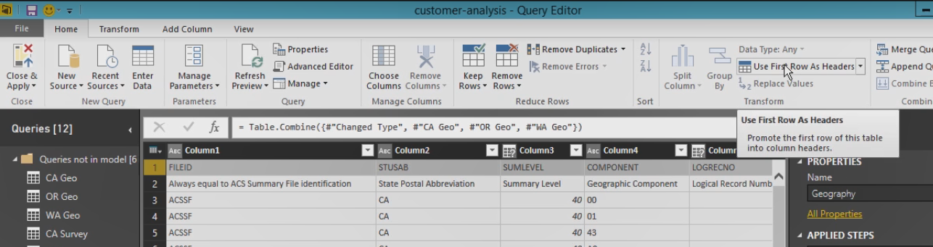

We can also eliminate rows. This is a duplicate or more detailed type of column header row, but we're going to remove this so we can go to the Remove Rows button, select Remove Top Rows, and type in 1 row.

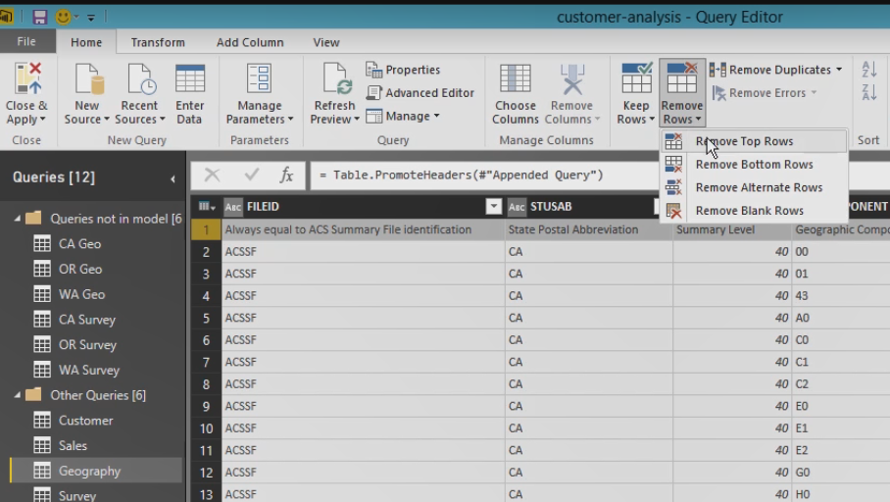

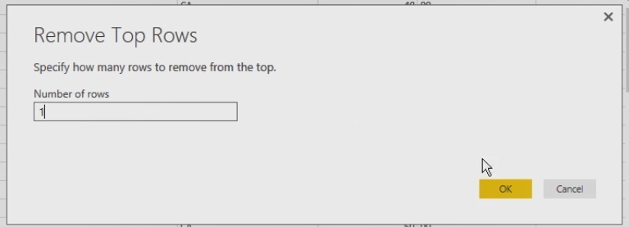

In the Survey table we have a similar, but slightly different problem. In this case we want to keep the second row and eliminate the first row because of these column names aren't very meaningful in this firsts row, the second row actually has column names that will be helpful to us. So in this case we'll reverse the process we did before, we're going to remove the top row, just row #1, and then with the remaining row that's left as row 1, we'll use that as our header row.

Now let's fix some data types. If we go back to Geography, notice we have Abc in some columns, that represents text, or we have columns with a question mark.



So for columns that we know we need later, like this logical record number, we know we need this to be numeric. So we select the column and then here's the Data Type, we select whole number, and now we see the question mark has been replaced with 123.

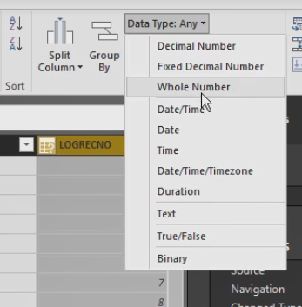

Let's find the State column, this is another one that we're going to need. Let's change this to whole number also and also Place.

In a location query, let's rename this first column as Zip Code and we'll change its data type to text because this is a zip code and we're missing some leading 0's in here.

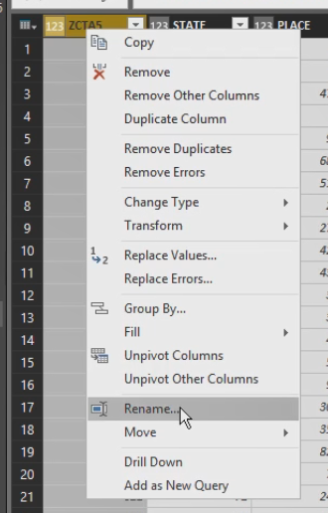

Now I'm going to ignore that for the demonstrations in this course because I know we're going to be using only West Coast zip codes, which will not have those leading 0's. In the Survey table, let's change this logical record number to a whole number data type, and in the Sales table find the SalesAmount column. And notice how it is set to text. Let's change this to decimal number.

**Demo: Fixing Metadata (Excel)**

In Excel the process is the same, we just need to edit each query individually.

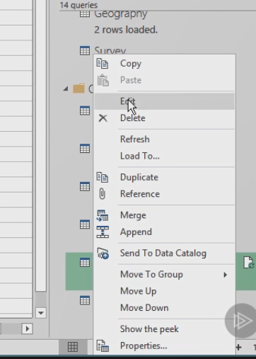

So with Geography, again we have Use First Row As Headers and then we can eliminate the top row, and we can select a column and change a data type. So everything we did in Power BI Desktop is almost the same in Excel, the difference is we're working with queries individually instead of having them all accessible to us in the Query editor.

**Filtering Rows**

Another cleanup task when working with data is to filter the rows that you don't need. Data in rows take up memory, so a good practice is to save memory for the things you need.

* For a numeric column you can choose values explicitly or use a numeric comparison such as equal to or greater than and
* for text columns you can also choose explicit values or use text comparisons, such as starts with or contains.

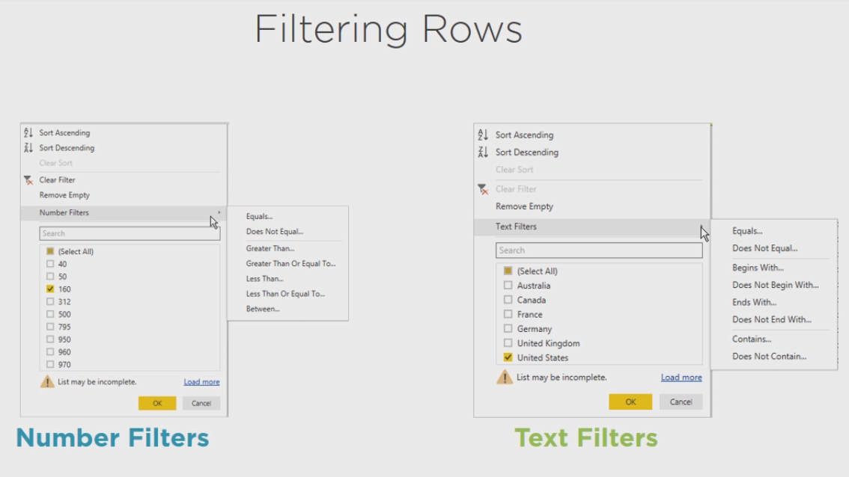

**Demo: Filtering Rows**

In the Geography table we have data that summarize at different levels. If we scroll over to the Place names, which is way to the right, we can see that we have states and metropolitan areas and counties and so on. The way that we can tell the difference between these is in the Sum Level column. This has codes that we can use to identify the level we want. In this case the level that we want is 160, so we can use this dropdown list to get to the filters, clear the Select All checkbox, select 160 and click OK.

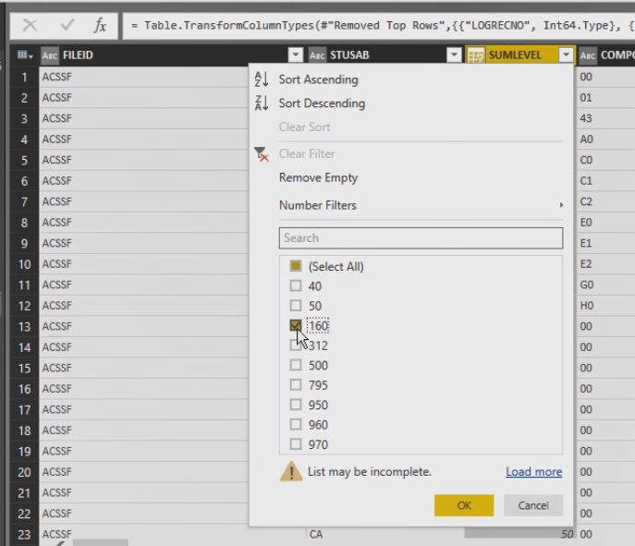

And that gets rid of all of the rows except those having 160 in them. Also because our customers are for all states, but our census survey data is only from three states, we can filter our customers to only include our three states, California and Oregon and Washington. So in the State Province Name we can clear the Select All list and select California, Oregon, and Washington so that we only have our West Coast customers in this query. The process is similar in Excel, so I think you'll be able to work that one out on your own.

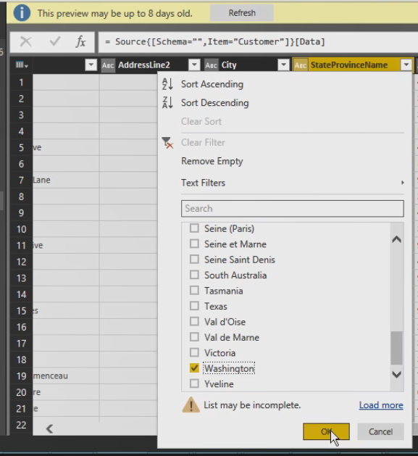

**Eliminating Columns**

Similarly you can eliminate columns to reduce the memory required to store your data and also to make it easier to find what you need when building reports. You can chose columns to keep or you can choose columns to remove.

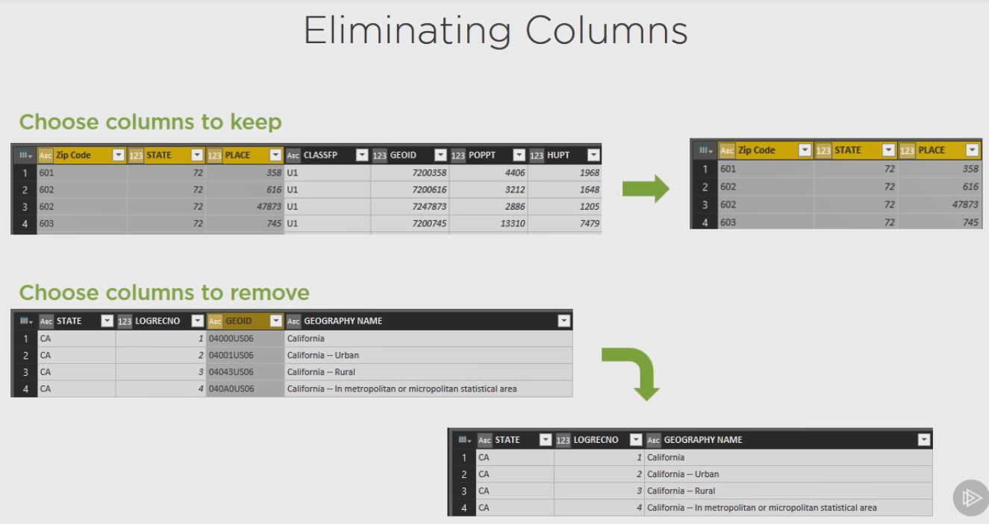

**Demo: Eliminating Columns**

Let's go to the Geography table, we can remove File ID, State US Ab and Sum Level. Just hold down the Shift key and click the last column in the group that you want to remove and then you can remove the columns that are selected.

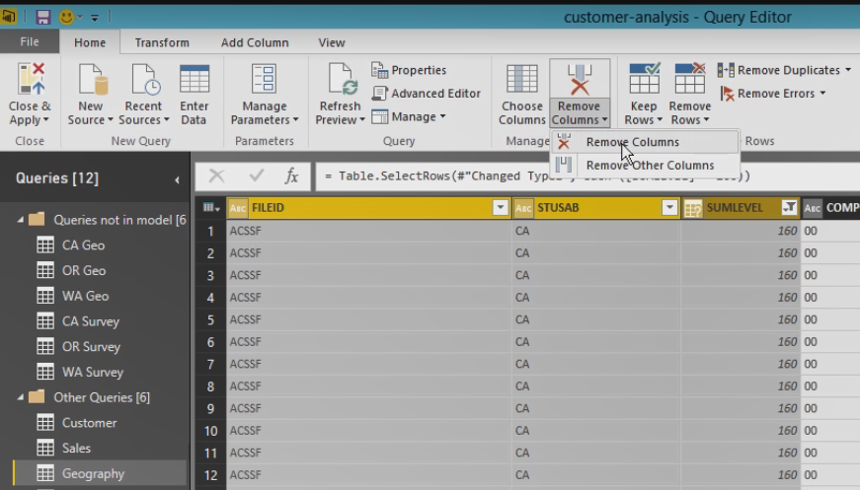

Let's also remove Component. We want to keep Logical Record Number here. Then we'll take from US to State CE and remove those columns. We'll keep State and then we'll eliminate County and the sub-column here, we'll keep Place and then from Tract we're going to select that and then go all the way to the right, almost to the very end where we see Geo ID and I'm holding down the Shift key when I click on Geo ID and I'm going to remove all of those columns and then we have the Name column and after that we just have three more columns, I'll select all of those three and remove those, so that our geography query at the end only has these four columns, Logical Record Number, State, Place, and Name.

In the survey query I just want to keep the state abbreviation, so I'll eliminate the first two columns, and I want the Logical Record Number next so I'll eliminate the columns in between, and then I'm looking for Median Household Income, so I'll start with this column, we'll select this and then we have to look carefully until we find the Median Household Income here. It's easy to get past it because there's so many columns in here, so I'm going to right click. I can also select Remove Columns when I right click here, and the column that's first in this list here is Median Household Income in the Past 12 Months, and we can't see the whole thing but we can widen this and it says Inflation Adjusted Dollars and so forth, and we see that there's also a Median Household Income over here. If I were just to double click in that and hit the End button I could see that this is with White Alone Householder and there's various racial groups that are included in the additional columns, we don't need those. We just want the Median Household Income, the very first one that applies, therefore we're going to eliminate all of the other columns. So when we're all finished here then we have in our survey, the State Abbreviation, the Logical Record Number, and then this Median Household Income, which is a very long name here, so why don't we go ahead and just rename this. Our Location query, I just want Zip Code, State, and Place. We'll be using this to map the zip codes in our customer query to the geographies, so we just eliminate all of these other columns. In Excel the process works the same way, we just open up each query individually to make the same sort of changes that I just did here in the Power BI Desktop.

**Combining Queries: Merge**

Let's go back to the topic of combining data now that the data is in a better shape and ready for this step, you can merge queries together when you have columns in both queries that have matching data. And this helps you consolidate information for easier reporting.

Now there's several ways to merge, you can do a left outer join to keep all the data from the first query and include only the matching data from the second query, or you can do a right outer join to keep all the data from the second query and only include the matching data from the first query or you can do a full outer join to include rows from both queries or an inner join to keep only the rows that match across both queries. Another option is the left anti join to keep only the rows that exist in the first query, in other words, keep the rows that don't match anything in the second query or the opposite is the right anti join to keep rows from the second query that don't match anything in the first query.

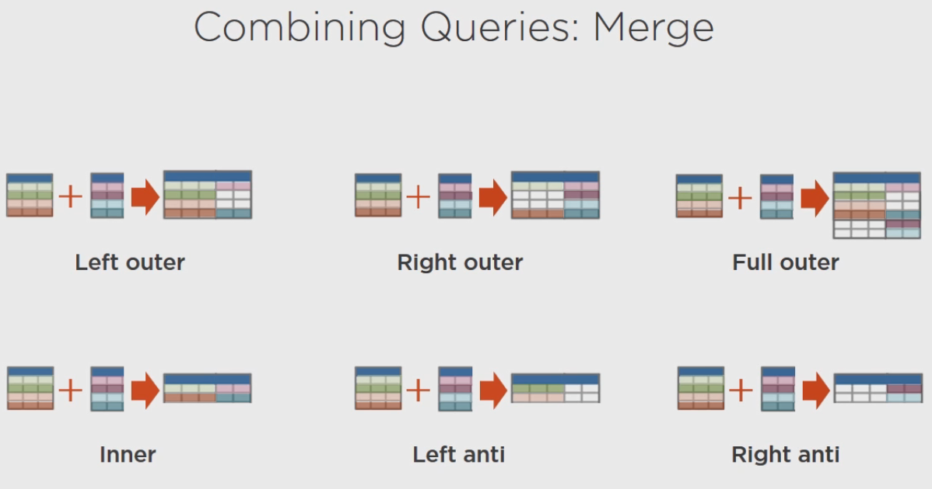

**Demo: Merging Queries**

Let me show you how this works. The Location query has zip code information that includes a state code and a place code, but it would be better to consolidate this information with the Geography query so that you can see the name of the place for each zip code. So here's how we can use merge to combine the data. We're going to select Merge queries and then we'll select the Geography table, and we can select which columns we want to match on.

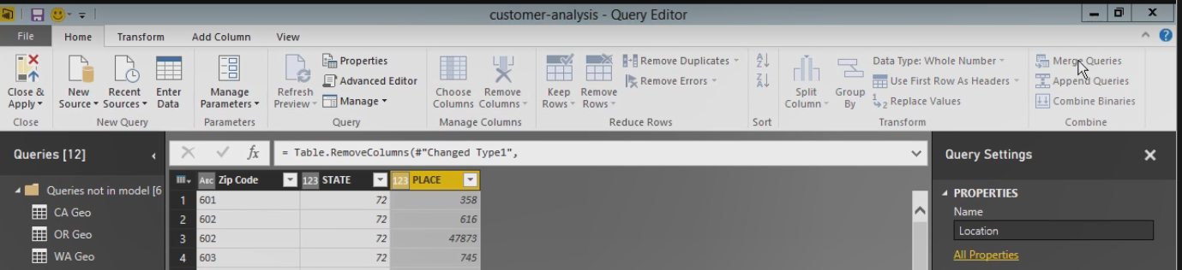

In the case of Location we want to do State and Place together, and we'll select the same columns in the Geography table, State and Place. We need to match on both of those columns in each query because the place codes are unique only within each state, otherwise you might wind up with a zip code matching to one place in California and another place in Oregon, which doesn't make sense.

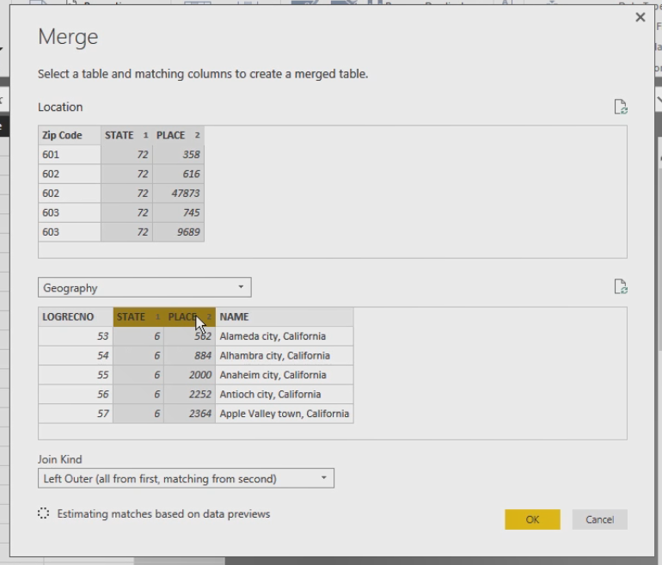

Now we need to specify privacy levels to make sure that we're not leaking any sensitive data, but this is all data that we've downloaded anyway, so we can specify the public access here because this is not private information.

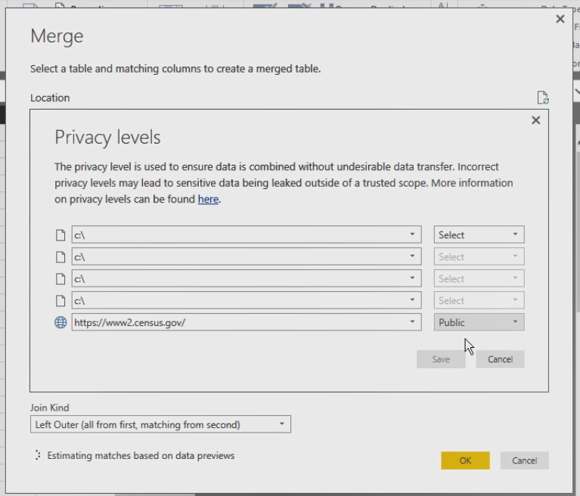

Then we can specify our join type here, we want to do an Inner join so that we can automatically filter out the rows that don't belong to the three states that we're working with here.

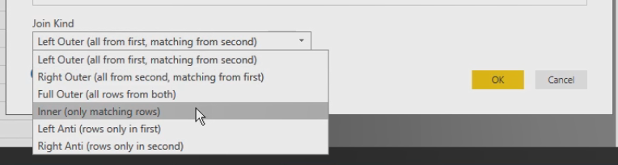

Then we click OK. And when you do a merge, the new data is added as a table to the original data. And we can expand this by clicking the little icon in the right hand corner here and then we select the columns from Geography to merge into our Location query.

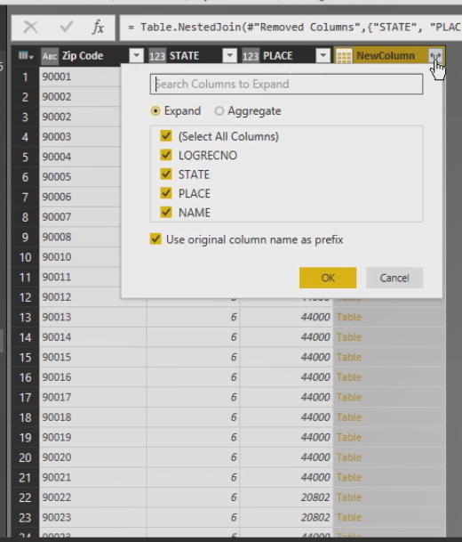

So let's get just the Logical Record Number because we already have State and Place and we'll get the name. Now let's click OK and you can see that it used that new column name as a prefix to this column, which we can change if we want a friendlier name (Typing).

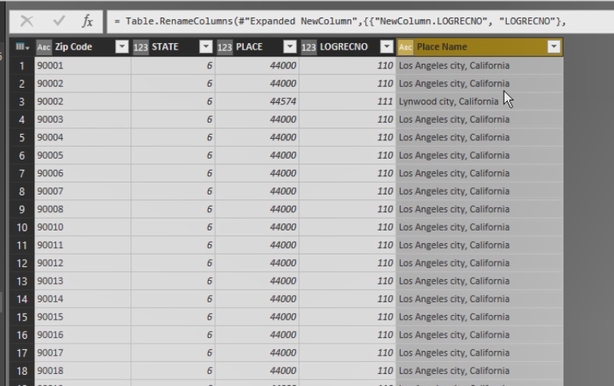

Now sometimes you'll find that there are matches for one zip code to multiple places. Let's find one now. For example, here's 90222 for Compton City as well as for Lynwood City. In this case we don't need a lot of high precision in our model, so we can eliminate duplicates. We'll highlight the Zip Code column and click the Remove Duplicates button.

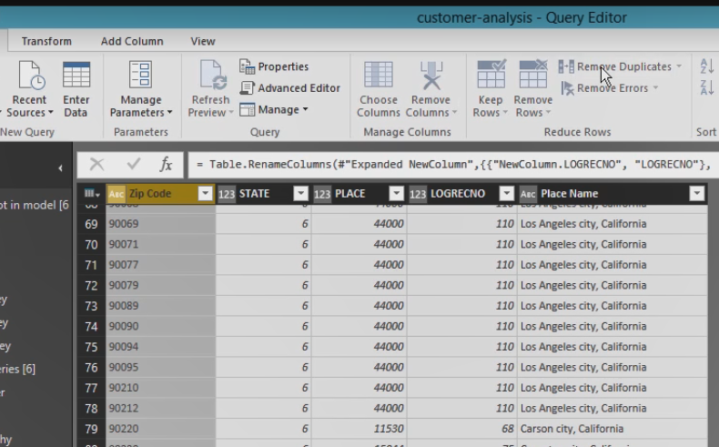

And now that we combine Geography and Location together we can go ahead and move Geography into the other group.

Now our Sales table also includes information for all of our customers. Remember earlier we had filtered the customers to show only California, Oregon, and Washington. We don't have that information in the Sales table, but we can use the information from Customer table to filter down the Sales Table as well, just by using that Merge Query option again. Because our Customer table has a Business Entity Id column and our Sales table has a Business Entity Id column. In this case, again, we only want matching rows that match across both tables, so we'll click OK. We get a New Column of customer information, which we really don't need. We only used that merge operation to filter out the Sales table, so we can eliminate this column now. And as we've seen with other operations, the Merge Query's operation works the same way in Excel, so you should be able to do that on your own.

**Adding a Column**

Other times the data is not quite structured the way you need it, so you can transform it to get what you need into a new column. One option is to duplicate a column. You select the column and then just make a copy of it. And you can apply changes to the new column while preserving the original column

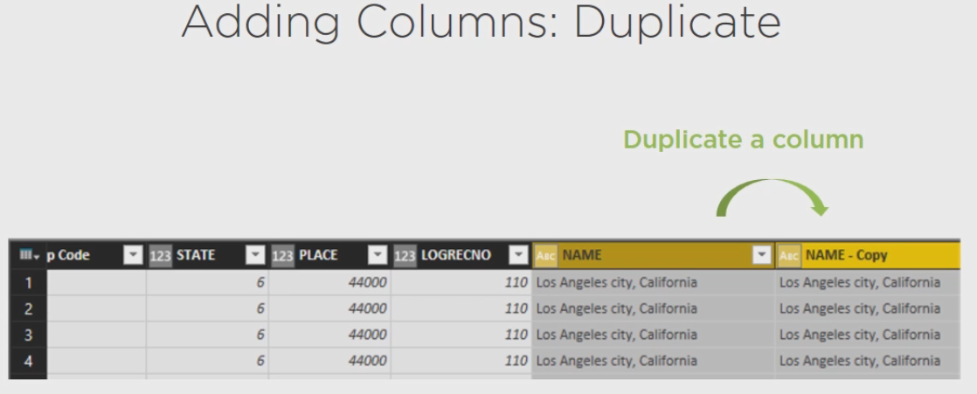

or you can take an existing column and split it into separate columns, and there's many ways to do this, but a common way is to use a delimiter, such as a comma.

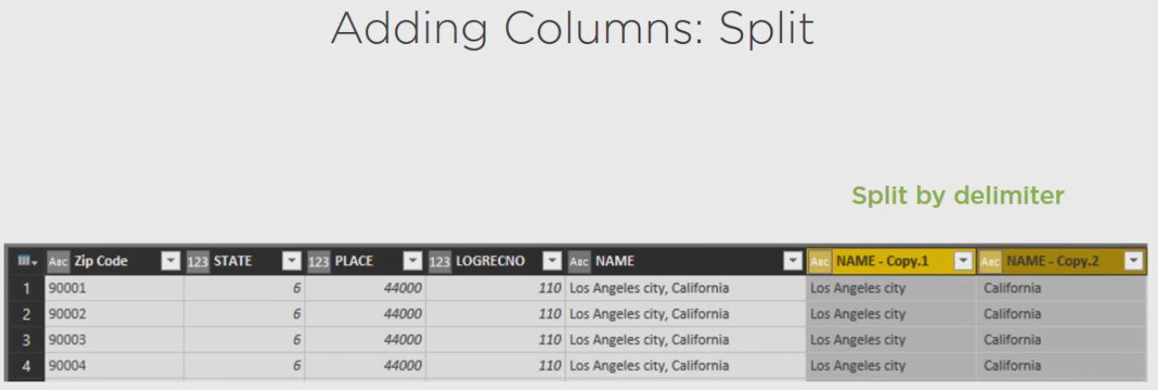

**Demo: Adding Columns by Splitting Text**

Now I'll show you how to use these different techniques in Power BI Desktop. Again, the process is very similar in Excel, so you should be able to follow along if that's your development tool of choice. Let's start with the Location Query. Right now we have State indicated here as a number, but let's say that we want the state abbreviation in another column here. So the first thing we need to do is to add a column and we'll add a duplicate column here

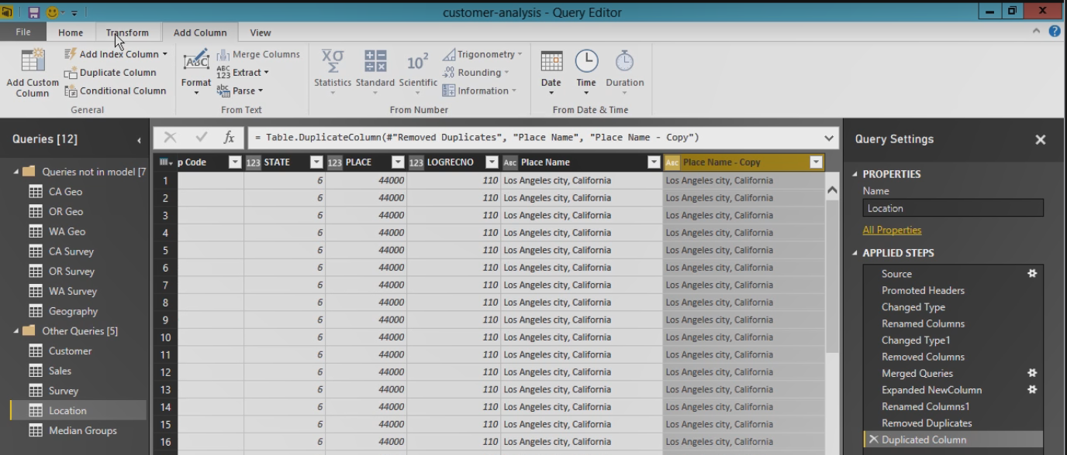

back in Transform tab or in the Home tab we have split column by delimiter, which is the same thing if we just right click the column and point to Split Column and select By Delimiter, it brings up the same thing.

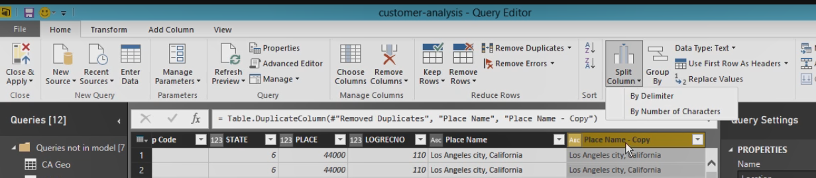

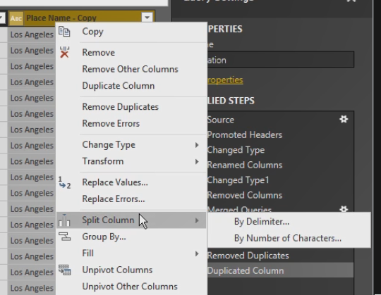

The delimiter will be comma, so we're basically saying take everything in front of the comma and put it into one column and everything after the comma in a second column. We can do a custom delimiter and so we can say our delimiter is the comma and the space and we can choose the first time that happens starting from the left or the first time it happens starting from the right, or each time that it happens.

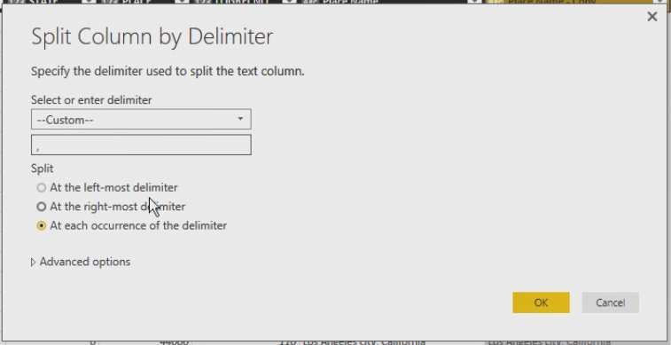

So any of those options would give us the same result. We click OK and now what we're going to get is instead of this one column we'll have two columns. So I'm going to eliminate this first column, we don't need that anymore, and we can rename the second column, we'll call this StateAb for abbreviation, and then we can do a simple transform to get the first two characters. So again, we can use the Split Column, but this time let's split by number of characters and I want two characters, once as far left as possible, click OK, and again the split transformation gives me two columns, but now I have the first two letters in the first column, we'll rename this, and we can eliminate the second column.

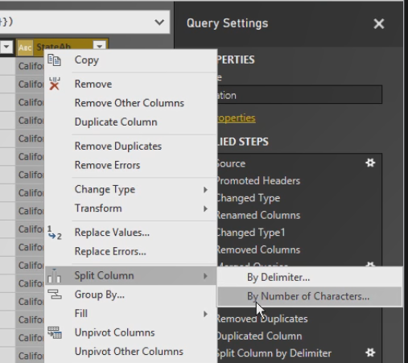

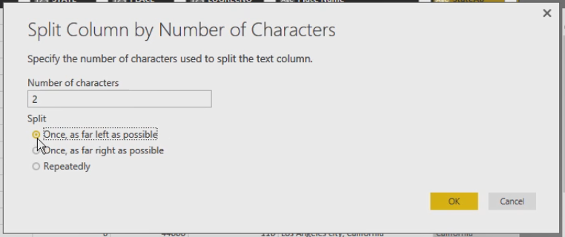

**Demo: Adding Columns by Splitting XML**

Now I have another example for using split and that's in our Customer query. If you scroll to the right, you will find that there is a column in here called Demographics and this contains information about our customer. If we scroll down here we can look at it, we can see that there's information about date of first purchase, the birth date, marital status and so forth, this is stored in XML format. And we can split this information out into separate columns. So the first thing we're going to do is a Split By Delimiter and we'll use a Custom split again, this time using the tag opener symbol, which is a less than sign. We'll do this at each occurrence of the delimiter because we have many of them, so we'll click OK. And we can eliminate things as we go. For example, we don't need a Demographics 1 and 2 here, we don't need total purchases or date of first purchase either. And we're not interested in birth date information. But we do want marital status. Now notice that the label and the value are included together here, so what we can do is a couple of steps. Number one, we'll rename the column to Marital Status and then we can eliminate this value, Marital status and this greater than sign, we do this by using the Replace Values option.

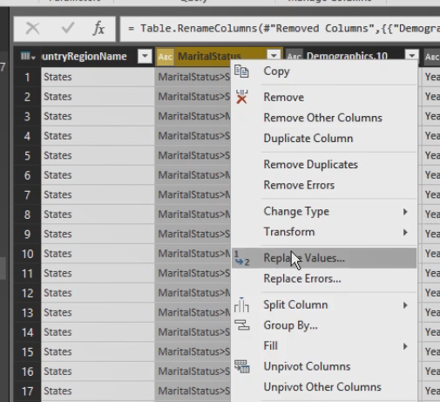

So I can tell it what I'm trying to get rid of, Marital Status and that greater than sign, and I'll replace it with an empty string.

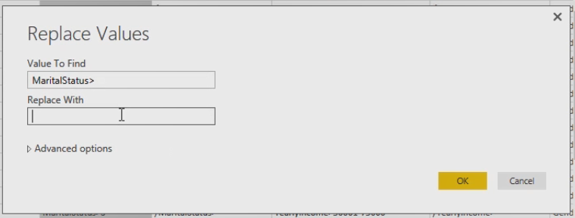

And now I just have the S or M standing for Single or Married and I can eliminate the other column that came along with Marital Status and I would just repeat this process for all of those columns. One easy way to do this would be if I click in that cell I can highlight the text, do a Control+C to copy that to the clipboard, and then do my Rename with a Control+V to paste, remove the extra symbol there, click Enter, and then right click and select Replace Values and do another Control+V to paste. So that minimizes the typing that I have to do.

So I'm going to do the rest very quickly so that we can clean up this Customer query. We'll remove the last two columns here. Now with Yearly Income, we're only going to use the initial value, so let's use the Split Column transformation again to split this by delimiter. We're going to use a dash in this case, we'll eliminate the second column that was generated. So I'm going to copy this value and then use the replace values function and put in 100001 and then we'll just quickly rename this column as well.

**Demo: Adding Columns for Sorting**

Now another step that we need to perform to clean up our data is to get some things to sort properly, like Education, we want to sort with partial high school and high school and partial college and bachelors and graduate degree. We want a specific order. And the same thing with Commute Distance, because this has text in it we would see 0-1 miles, then 10 miles because the 1 would follow the 10, then we'd have 5-10 miles and that isn't necessarily what we want to see. First let's duplicate each column (Typing) and with Commute Distance we'll just use the Split Transformation again and split everything before the dash. We'll eliminate the second column and then all we need to do here is replace values to get the 10+ miles to say just 10, so we'll have + Miles with an empty string. We'll convert this to a whole number and we'll rename it to Commute Distance Sort.

For Education we can just do a series of Replace Values, so if I want to have partial high school I could type it in like this, which would be long and tedious for everything, or another option would be just to highlight the value that I want and select Replace Values here and it types it in for me.

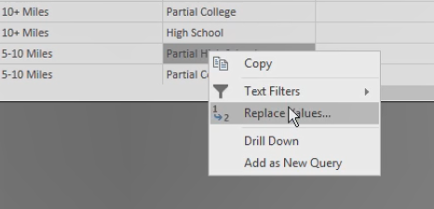

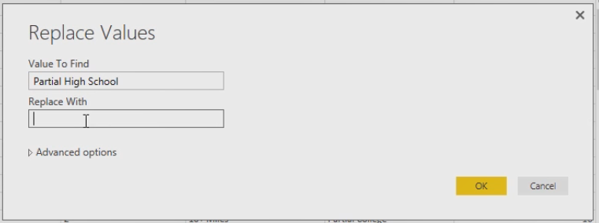

Now I can say that is a value of 1. And for high school we'll make that a 2. Partial college is a 3, bachelors is a 4 and last, graduate degree is a 5. Let's rename this Education Sort and we'll also make this a whole number.

Let's fix some of the data types in our demographics like Number of Cars Owned should be a whole number. Homeowner Flag can be a whole number. Number of Children at Home, also a whole number. And Total Children, and it's good to just double check through everything as you work. We're finished getting and transforming our data, so let's Close & Apply our work and apply the changes, and again with internet connectivity for the location it might be a little slow and fail the first time, so if that happens, just like it did here, the remote name could not be resolved, just click Close and try again.

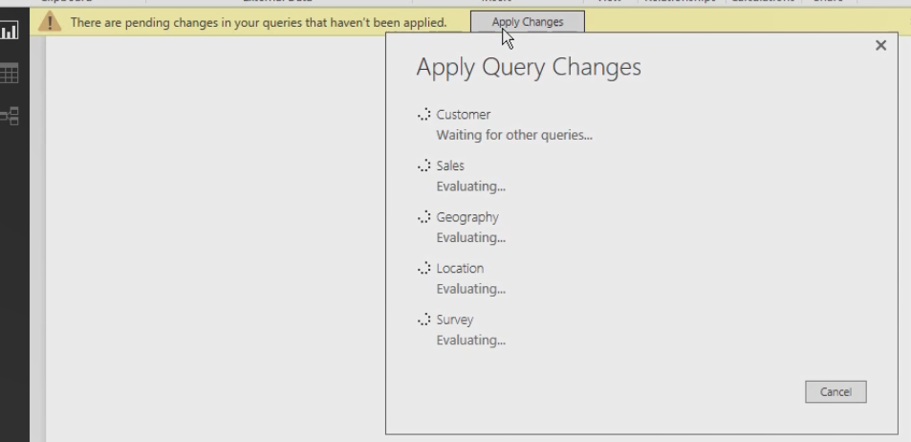

Click the Apply Changes button, and it might take a couple of tries. All of these techniques that I showed you in Power BI Desktop, you should be able to recreate this in Excel if you want to use that tool instead.

**Summary**

In this module I showed you how to transform data using a variety of techniques. Now there are many, many more transformations possible, but you know enough now about how to explore the Query editor and find the transformations you need. And you know that if you try something and it doesn't do what you expect, you can always eliminate that step and back up to a previous state. In the next you'll learn how to model data in preparation for interactively exploring your data to uncover new insights.

**Modeling Data for Analysis**

**Modeling Data for Analysis**

Hi, I'm Stacia Varga and welcome to Modeling Data for Analysis. Your query has actually become tables in a Data Model, but the Power of Power BI “is the ability to create connections between these tables, relationships, and you use those relationships to explore your data from a variety of perspectives.”

You can also define new columns to create new data points that are useful for reporting or to connect your queries together.

If you're not working with a data warehouse you probably need a table to store dates. You need this when you want to compare changes in your data over time.

**Creating Relationships**

Relationships between tables are the key to successful Data Models in Power BI. Right now in your Data Model you have a lot of tables, but there are no relationships between them. You can view data from the Sales table to show sales by Business Entity ID and you can view data from the Customer table to see the customer name for each Business Entity ID. But you get an error in Power BI Desktop if you try to display all of these columns in a single visualization because Power BI doesn't know how the tables are related.

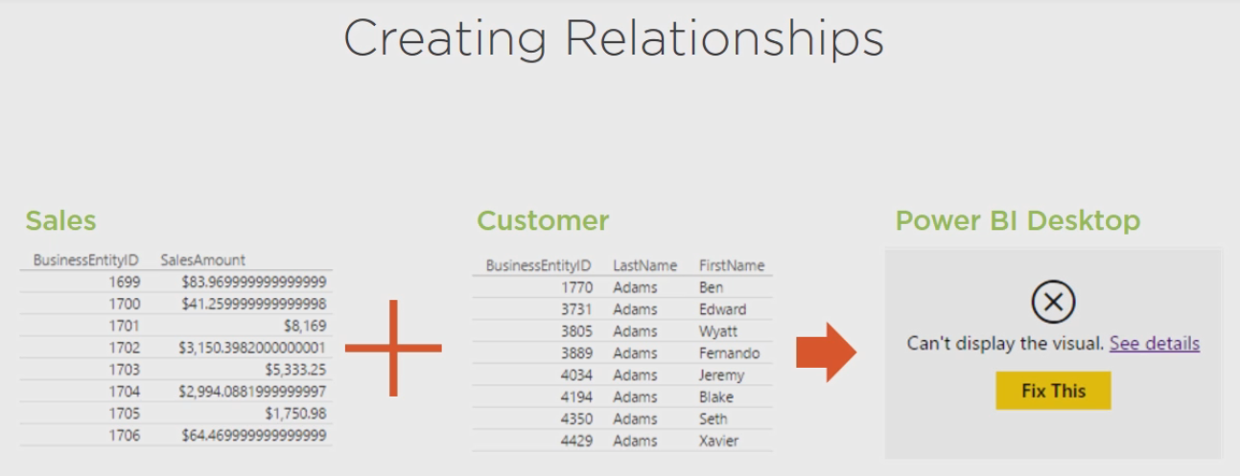

You might be able to have Power BI fix this if you tell it to auto detect relationships, but you can certainly define the relationship manually if necessary as you'll see in the next demonstration. But if you use Excel, notice the Sum of the Sales Amount column in the Pivot table repeats for every customer. That's usually a clue that a relationship is missing because Excel doesn't know how to break down the grand total into separate customers without this relationship and in the Pivot table field list you'll see a message that suggests that a relationship might be needed. Now sometimes Power Pivot can automatically create relationships for you, but it's not fool proof. It uses a relationship detection algorithm that looks at the contents of the columns in each table to see if they contain similar values. When you want to analyze data for multiple tables you need to define relationships between the tables. There are a couple of ways to do this, but regardless of technique the end result looks like this for all the tables in your model, and then you can successfully combine columns from multiple tables like this.

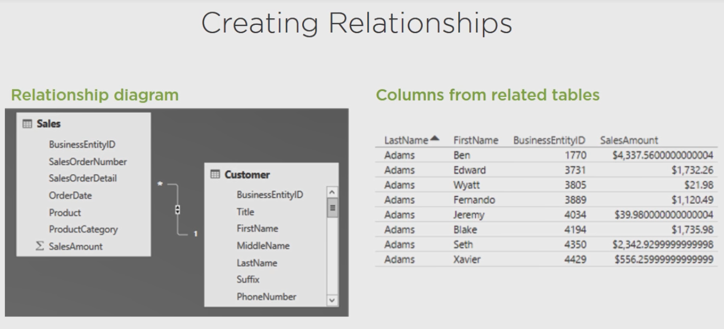

**Demo: Creating Relationships Using Power BI Desktop**

In Power BI Desktop you can see existing relationships by going to the third tab here in the Navigation pane for Diagram, and you can see that some relationships were already created. We have tables that have lines connecting them. This was automatically, but for tables we won't be using directly in reporting, so we can safely eliminate those, so let's do that first. And the easiest way, especially when you have a lot of tables, is to click the Manage Relationships button. So these Survey tables and the Geo tables, those were things that we used to combine into other tables, so we don't need the relationships defined here. We'll go ahead and delete each one, one by one, even the ones that are not active we'll go ahead and delete.

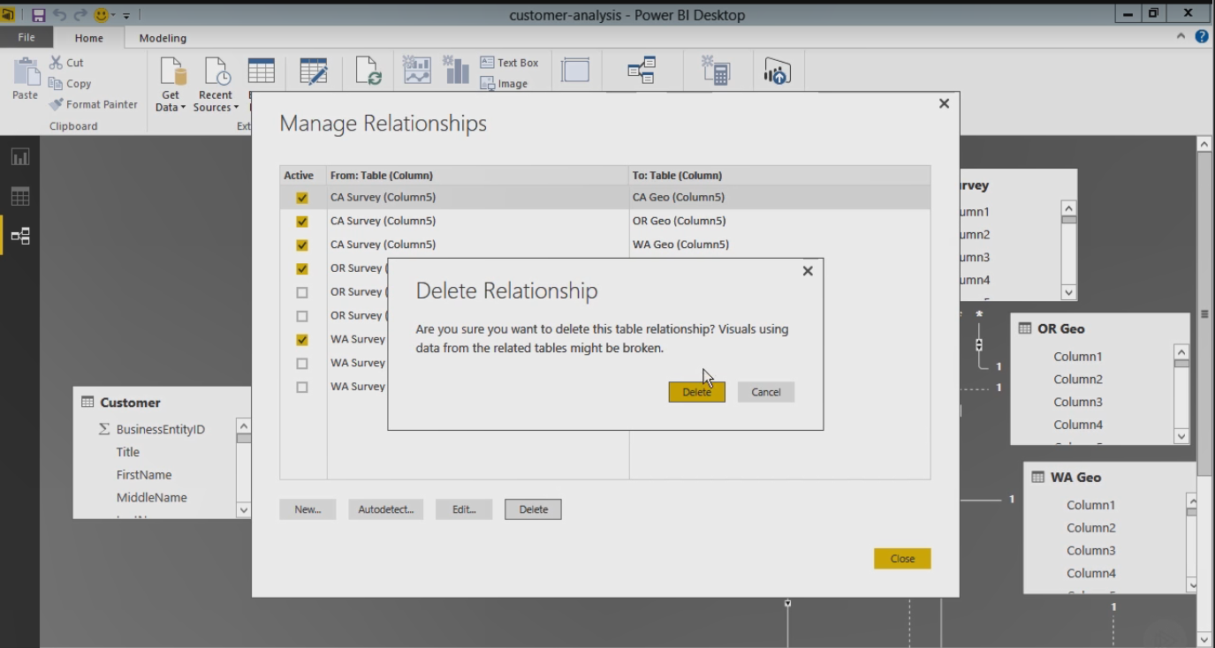

Now when we click Close, we can see that those lines have disappeared and you can zoom out if you want to see all of your tables. We can rearrange things, so maybe I'll put the Survey tables all together and the Geo tables all together. I'm just clicking on the header and dragging and dropping these where I want to use them. Geography we don't really need because we combined that with location. We'll move Survey and Location over closer to the other tables.

Now one thing we can do is connect Sales with our Customers. There's a Business Entity ID in both of these tables, so the normal way to do this is to drag a line from one table to the other, but we get an error. It says we cannot create a relationship because maybe there's some missing data to connect the two columns.

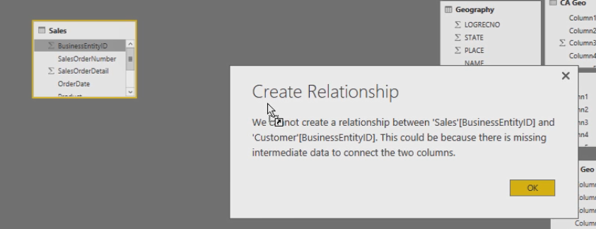

But the problem is, you see this little symbol next to Business Entity ID in both of those tables, that means that Power BI wants to sum up the values here because those are numeric columns, but actually you want to use it just as an identifier, so here's where we can go into our model and change the property for each of these so that we don't get those summarized. So this second button here takes us into our Data Model, now this is separate from our queries, remember that our queries were in the get data portion and we could fix things there, sometimes we can fix things directly in the model itself.

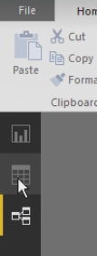

So if we go to Customer, for example, and go to Business Entity ID, then we can go to the Modeling tab and there's this option here, Default Summarization. So normally what Power BI would do would be to want to count the values in this column to come up with a grand total, but we're going to say don't do any of that. Don't try to sum it, average it, min it, max it, and so forth, just don't summarize it all and we'll do that for the Business Entity ID column for Customer, and notice that that symbol went away,

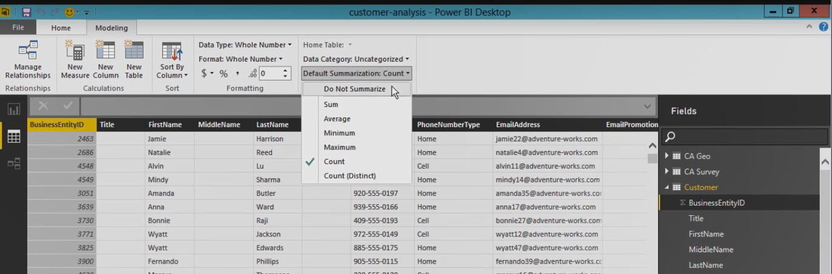

and also if we go to Sales and repeat that process, we'll do Business Entity ID and change this to Do Not Summarize.

So we can go back to our diagram and we'll see that those symbols go away, if we try to connect these two items again we still get an error. Now the problem is slightly different, if we go look at our data again and let's look at Customer, what we'll find is that there's a column here for Address Type and for most of these we have a home address type, but in some cases we'll also have a shipping address and the problem is that we'll get duplicates for our customers because of that home versus shipping. So in this case we need to go back to our query because we cannot filter in our Data Model. We need to go back to the query for Customer and then we can eliminate the shipping address, Close & Apply the change, and let's try to connect these two tables once again, and finally that works. So the quality of our data matters when we're trying to define relationships.

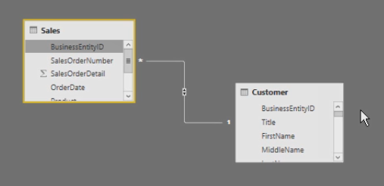

And we should have one more table over here for Median groups. We'll bring that over. Let's fix this Median Group key so that it's not summarizing also. And then back to our relationships. What we'll want to do is we're going to associate Customers with Median Groups, but we have some more work to do before we can do that, we'll have to add another column to our customers to know which Median Group that they belong to.

Meanwhile, in Location if we try to match Zip Code or Postal Code as it's called in Customer, to Zip Code in Location, that works fine. We can always rearrange things to make it look a little nicer for us. And then we have Logical Record Number and Location that we want to associate with Survey. And again, it's telling us that there's a problem because of that summarization. So let's fix Location and Survey so that we do not summarize the Logical Record Number here, and if we try this again, we find that we're still getting a problem. And the reason in this case is because Logical Record Numbers are not unique to state. So California has a Logical Record of 1 and Oregon has one starting with 1 and Washington has one with 1. So we need to be able to create a relationship on multiple columns, but Power BI doesn't let us do that. We're going to do some more work to the model before we can handle that. We'll save that task for a little later.

**Demo: Creating Relationships Using Excel**

To work with our model in Excel 2013 or 2016, we go to the Power Pivot tab and we can click the Manage button here to open up a new window that represents our model. We can see each of our queries is represented as a table in here and we can access all of the data, but we can't type anything in here, this is just view only. There's a button in the bottom right hand corner that toggles us to diagram view, and this is very similar to Power BI Desktop, the difference is Excel did not detect a lot of the same relationships that we saw in Power BI Desktop. But the principle is the same. I can create relationships by dragging and dropping and we also get the duplicate values issue in here, just like we had in Power BI Desktop. So I'll need to switch back over to Excel and go to my Queries and adjust my Customer query so that I only get the home address types. Notice in Excel I was able to relate the two tables on Business Entity ID even without changing the summarization type on this column because Power Pivot behaves slightly differently. I'll zoom out so I can see my other tables. If we go to the Design tab and select Manage Relationships, we can click the Create button here and manually select tables. So we had Location with Logical Record Numbers and West Coast Survey where we have Logical Record Numbers, but just as we found in Power BI, we need to relate on a single column, but in order to have a correct relationship we need to have the State Abbreviation in addition to the Logical Record Number so we cannot set this relationship up yet. Customer and Median Groups, we're going to need to do eventually, but we need another column in Customer to make that happen. The other thing we can do now, however, is set up Customer and our Zip Codes, which are in Location, and we click OK and that relationship is correctly created. So now we can see our existing relationships in the tables that we need to work with.

**Defining New Columns**

Another task that you commonly need to perform with your Data Model is adding calculated columns. Now one reason you might create a calculated column is to combine or concatenate values in separate columns so that they become one column. Or you might want to lookup values from another table, and another reason is when you want to translate or decode values to show another meaning.

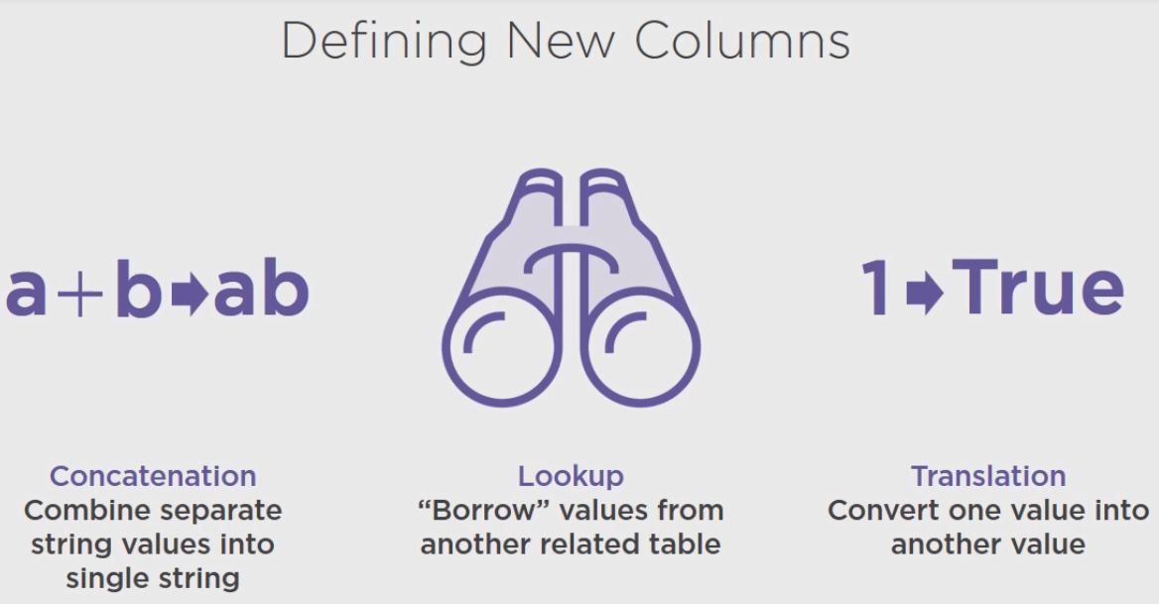

To define a calculated column you use a language called DAX, which stands for Data Analysis Expressions.

Excel formulas and DAX expressions are similar, but Data Models in Power BI are enough different from Excel spreadsheets that a whole new language is necessary. Instead of working with cells individually or in ranges, you work with tables or columns.

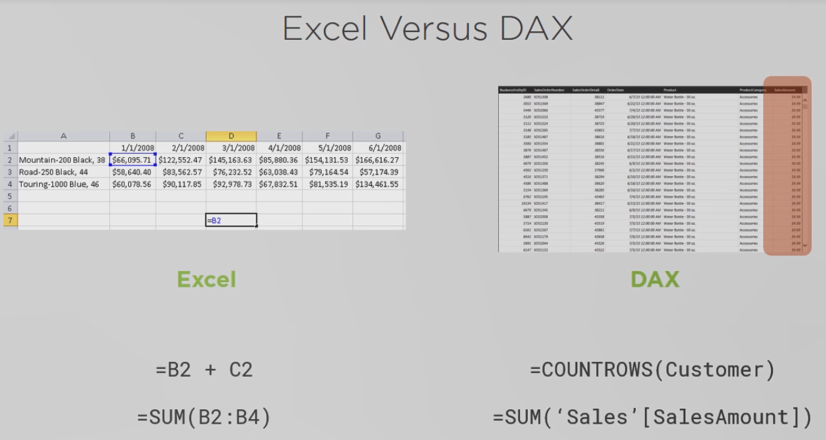

**Concatenating Columns**

You use concatenation for reporting. That is, instead of creating a table that looks like this, you want a table that looks like this, combining Fist Name and Last Name of a customer to create a single column with both names.

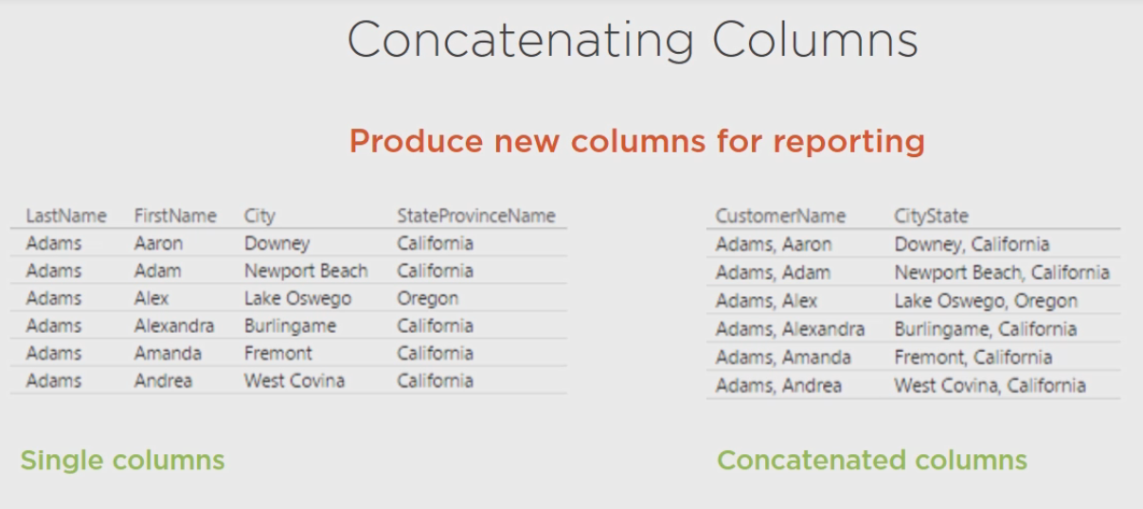

Or when you need to create a single column to perform a lookup because you cannot create a relationship based on two columns. When you do this, the lookup needs to have unique values in order to create the relationship.

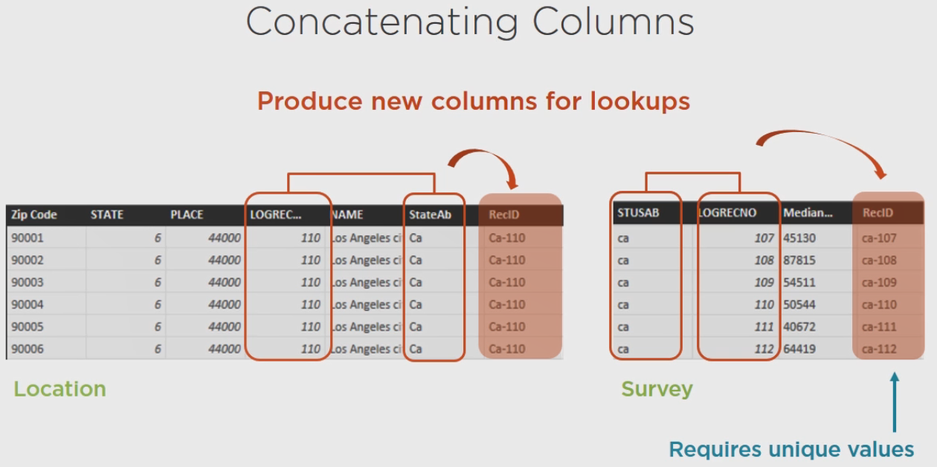

**Demo: Concatenating Columns Using Power BI Desktop**

Let's see now to concatenate columns in Power BI Desktop in the Data Model. Make sure that you click on the Data tab here and then click on the Customer table in the Fields list. In the Modeling tab you can click New Column, it's also available on the Home tab if you click New Measure and then New Column, the same thing happens, an empty column is added to the end of the table and when you select this column, the formula bar above is much like working with formulas in Excel, except Excel formulas work against individual cells, here our formula works against the entire column.

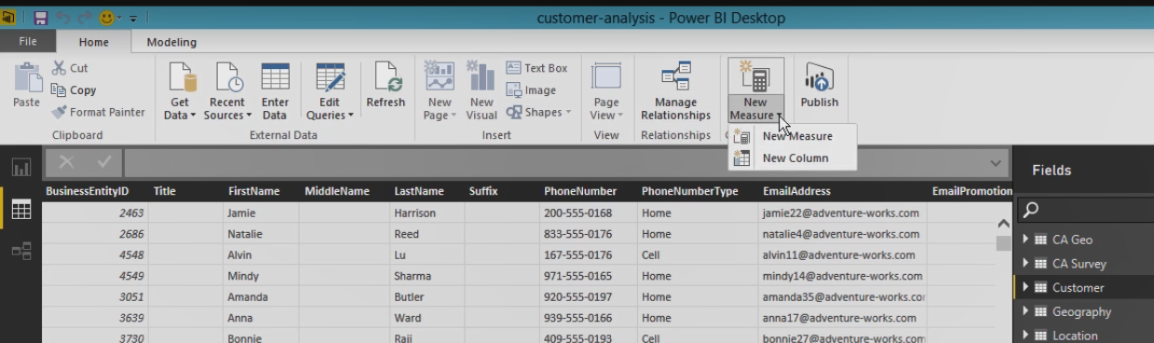

We can give it a name just by replacing the word column here, we'll call this Customer Name and then after the equal sign is where we need to type in our formula.

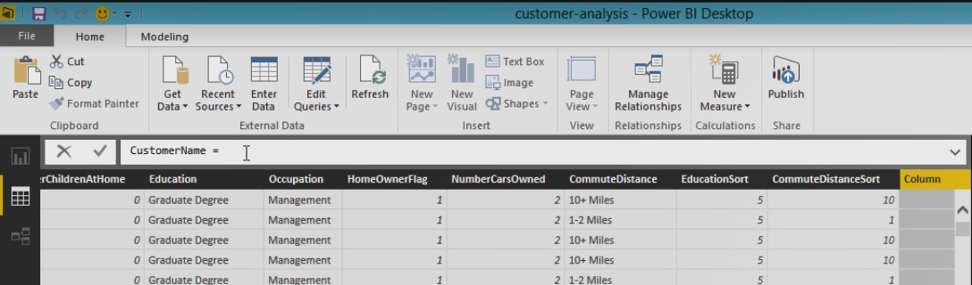

Now there's lot of different functions, but the main thing you need to know right now with concatenation is we're going to take values from one column and concatenate those with values in another column.

Column names are always represented with brackets, so if I type a left bracket, the formula bar gives me a list of all of the columns, and so I can just look through here for Last Name, which is what I want to show first, and I double click that and it builds out the column name for me and closes off the parentheses. And then concatenation in the DAX language is performed whenever you use an ampersand symbol. So I just type that, we can do another space and I want to put a comma in between my Last Name and First Name, so any time you need specific text in your formula use double quotes. I'll type in a comma and a space and another double quote and then another ampersand, and then I'll put in the First Name column. So again I put in just the bracket and I get a list of all of the possible columns that I can use, so there's First Name, there's my Formula, and if I click this little checkmark here, then it evaluates that formula to see, number one if it's valid and if it is it computes the results on a row by row basis here, so we can see all of this data that gets generated.

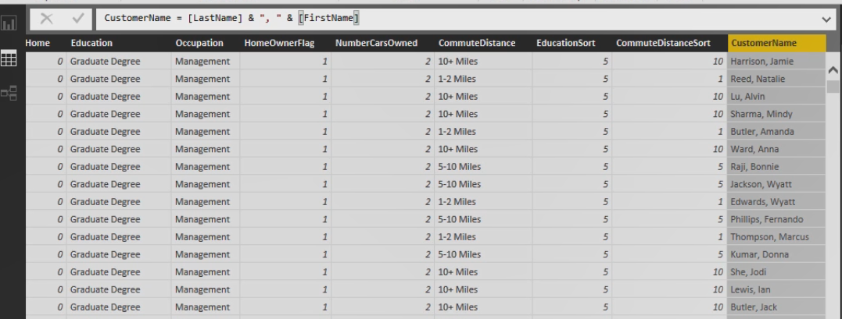

Now this gets added to my Data Model in memory. So I've created a bunch more data that is now requiring more memory space on my computer, so you want to be careful about how you use this, if you have very big data sets, this will require more memory every time you add in a new column. Sometimes that's all we need to do and sometimes our data is not too big, where this is not generally a problem if we're working with small data sets as we are in this example.

Now we can repeat this process to combine City and State, let's add in a new column. We'll call this City State and just like we did before, we will concatenate two columns, City with State Province Name, click the checkmark and as long as everything's good, we'll see data up here in the column.

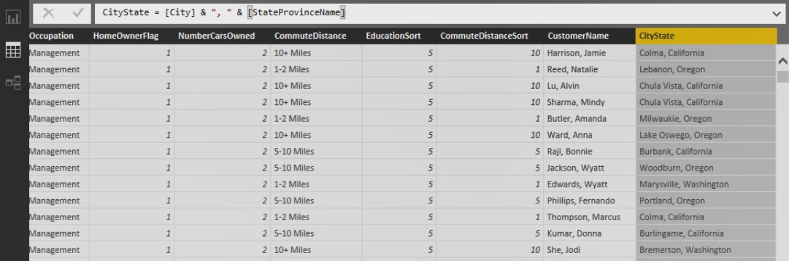

Now you may be wondering if we can do this in the queries and the answer is yes, but I wanted to show you how to do this in the model as well.

So where you create this column, in the queries or in the model, depends on whether you plan to share queries, if you have an organization Power BI infrastructure set up it might be better to define this concatenation in the query because you can share your queries and that way other people who are creating models don't need to repeat the same task over and over again, just as long as the expression references only columns in the same table.

In other cases you might need to do something one time and, as you can see, it's very easy to do in the model. Either way the result is the same.

So we need to do this similar process in the Location table. Here we're going to combine the State Abbreviation and the Logical Record Number. So let's just give this a name Rec ID, so we'll take the State Abbreviation, we'll separate the two values with a dash this time, and Logical Record Number. Now State is string and Logical Record Number is a number, but because we're using concatenation like this the DAX expression language automatically converts the Logical Record Number into a string so that we can build out one big string out of this.

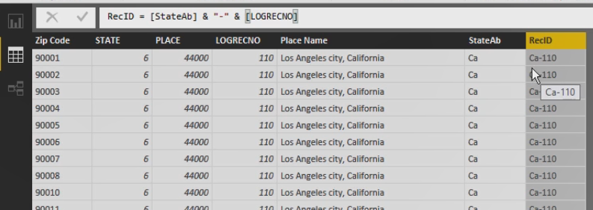

Let's do the same thing in Survey. We'll concatenate this first column with a Logical Record Number. So now that we have created this column, we try to go from Location to Record ID, our relationship gets created.

**Demo: Concatenating Columns Using Excel**

Power Pivot for Excel works similarly. If we toggle back to our data view of the model, we would go to the applicable table and we simply go to the end of our table where there's an empty column, if we just click that column we have a formula bar here and we type in an equal sign to start the DAX formula, but everything else is the same, we type in a bracket and we can get the list of columns. We can double click on that and type our concatenation operator and constant string, a concatenation operator and First Name in here. The difference from Power BI Desktop is that we don't include the column name in our expression here. We just create the expression and then after it's created we come to the column, right click the column and then we can rename it.

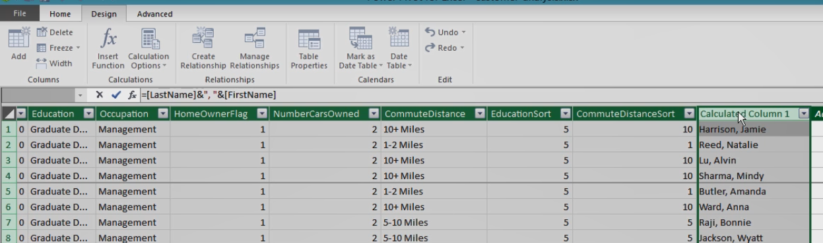

And we can quickly add our column for City and State and when you type in the first letter after the bracket, it will shorten the list down to everything for the letters you've typed. Right click the column and rename it, and then quickly let's add in our columns for concatenating the State and the Logical Record Number here so that we can define relationships. Be sure to name your columns (Typing). Repeat in the location, and we can either go back to the diagram view for relationships or we can create a relationship here between Location, Rec ID, and the West Coast Survey Rec ID.

**Performing a Lookup to a Related Table**

When you perform a lookup to another table you're in effect borrowing values from that other table to store in a new column of your current table. When you have a relationship between Customer and Location and between Location and Survey, you have an indirect relationship between Customer and Table that you can take advantage of by using an expression that uses the related function like this.

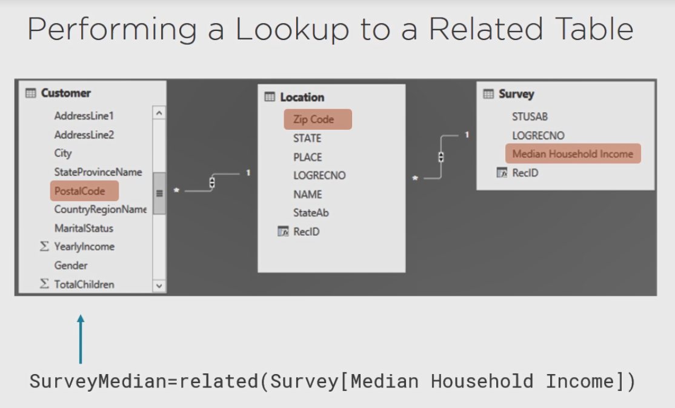

You can add a column name Survey Median to the Customer table that will find the Zip Code for each customer and for each Zip Code find the right Rec ID in the Location table, and then use that to find a single Median Household Income value to store for each customer.

**Demo: Using the Related Function**

Here I'm in the model and I've selected Customer. I want to add in another column so that I can do a lookup for the Median Household Income based on each customer's zip code. You might do this when you want to simplify reporting and put related information in a single table or maybe you want to simplify calculations to separate steps of the calculation into separate columns, it might make it a little easier to troubleshoot. So I'm going to add in a new column here. If you're doing this in Excel you just go to the customer table and go to the final column where you have the add column option, and in Excel you won't have this column naming in the formula itself, but you know how to adjust the name after the fact. But let's call this Survey Median and then we'll use the related function. So when I start typing in values without the bracket I see DAX functions that start with those letters. And if I move to highlight one of those functions, I get a little explanation of what that function does.

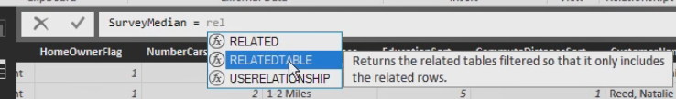

In this case, the related function gets a related value from another table and it's using those relationships that we defined to figure out how to find that related value. So I'll double click here. It lets me know that the related function requires a column name and when we reference a column name from another table, we need to include the table name with that column name.

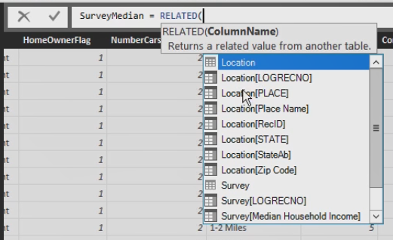

So I want to do a lookup to the Survey Median Household Income. So I double click here, close off my parentheses and there's my formula. I just click the checkbox and for each individual customer, whatever zip code they belong in, the Location table has the Zip Code, with each Zip Code there's a State Abbreviation and a Logical Record Number that matches one row in the Survey table, and so the median income for that particular zip code is reflected here.

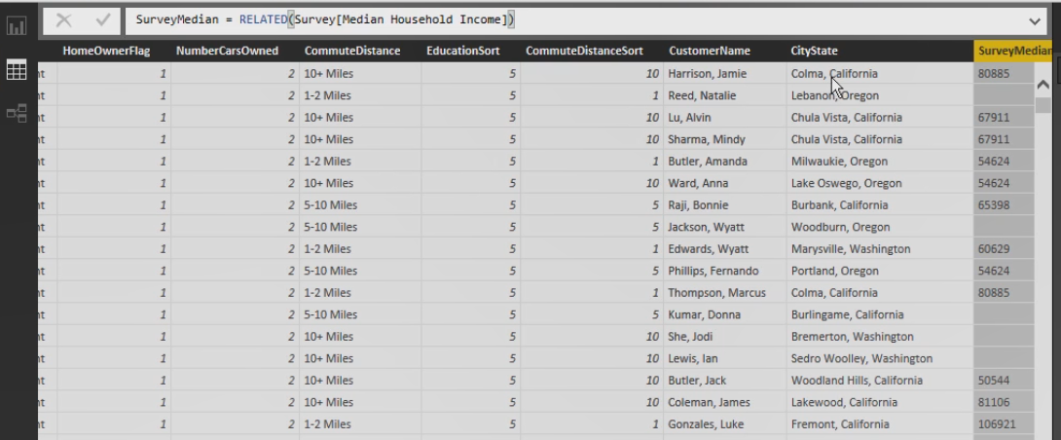

So here we have two customers that are from the same city and state and we can see that that median household income matches for those two customers because they're in the same zip code.

**Translating a Value**

You can also use a calculated column to translate a value to something more meaningful in a report. For example, you might want to use words as labels rather than codes, so you can create an expression like this to translate a value of 0 in the HomeOwnerFlag column to the words Not Homeowner, and any other value to Homeowner.

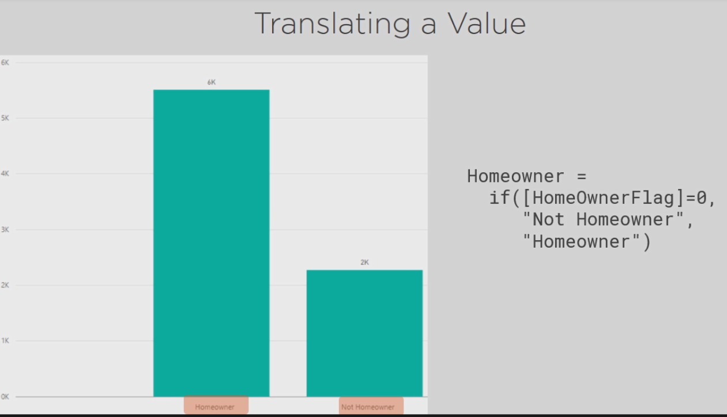

Or you might translate a column value into a new value that you can use for a lookup. The expression, similar to the previous example, compares the Survey Median column to the Yearly Income column to return a 1 or 2, or if the Survey Median column is blank, the expression returns 0.

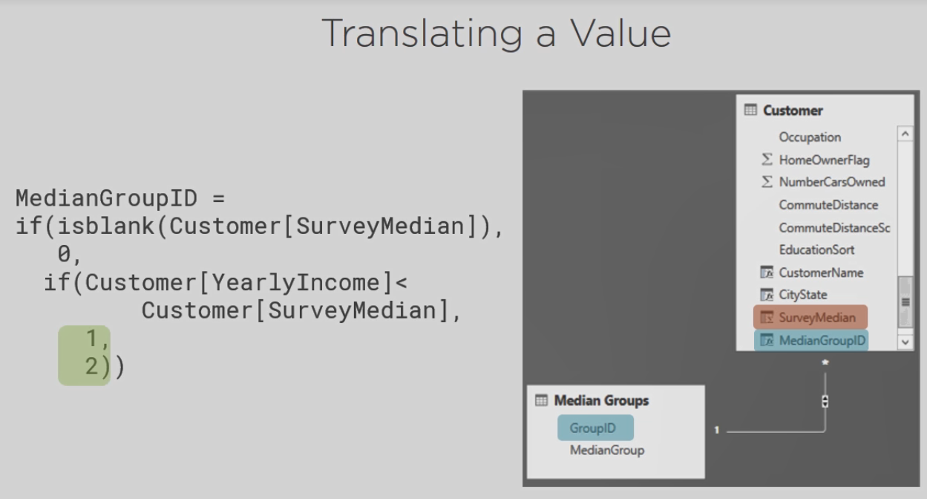

## **Demo: Using the If Function**

So let's add some more expressions to the Data Model and I'll explain these functions in more detail when you have data to look at. So let's add in a new column, this one I'll call Homeowner, and I'm going to use the if function and when I do this, it's checking for condition and based on the results of the condition it will return one value or another. So first let's set up the condition. We want to look at a particular column, the HomeOwnerFlag, and we want to compare it to another value. There's only two possible values, 0 or 1. So if we say HomeOwnerFlag equals to 0 on a row by row basis, the DAX expression is going to evaluate whether it's a 0 or a 1 for each customer. I put in a comma and the expression that I put here is what DAX is going to put in this column if HomeOwnerFlag is indeed equal to 0. So we can put a string here, Not Homeowner. When I put in a comma then the next argument is, what does DAX do if the HomeOwnerFlag is something other than 0? We'll give it another string, this time Homeowner. And we complete our expression with a parenthesis, click the checkmark and now we can see several of our customers are homeowners, if we scroll through we find that there are several who are not homeowners.

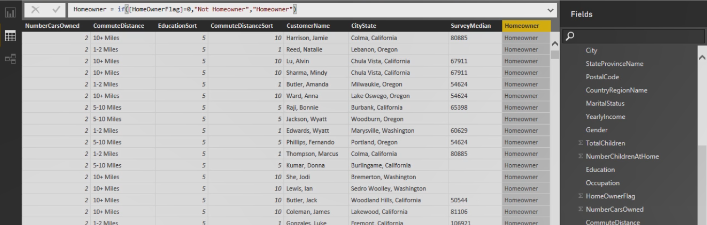

The next step we want to perform is to look at the Survey Median and decide for any given customer what the value is compared to our yearly income. So if we're looking at a Yearly Income of 50001 and we're looking at a Survey Median of 85070, then we would say that that particular customer has an income below the Survey Median. So let's add in a new column and I'm going to call this Median Group ID and what I want this to do is return a value that matches one of the values that we have in our Median Group table, so we have 0 for unknown, 1 for below median, and 2 for above median. So let's just start with one simple step, I'm going to use the if function again and we're going to compare the yearly Income to the Survey Median, so if I say Yearly Income is below Survey Median, then I would return a 1, otherwise I return a 2. And we look at the results, we can see that sometimes 1, sometimes 2. Except that here we have Survey Median on the second row where there's an empty value, so this 2 is acting like this particular row is above the median, when we actually don't know what it is. It should be unknown. So we need to modify our expression to account for the times when Survey Median is blank or empty. Now notice also, Survey Median is set to a text type and Yearly Income is set to a text type. If we want to make absolutely certain that mathematically everything is correct, we should go ahead and change our data types, so we'll make Survey Median a whole number, and you can see that this now throws an error because we're comparing a number with text. We'll fix Yearly Income as well, and we can see the Median Group ID column is now correct again. So let's select this column and let's modify our formula. We could have nested formulas. So I can start by simply evaluating whether Survey Median is empty or not. So let's modify this by clicking in the expression just before the if function, I'll type in if again and I have a new function called ISBLANK and you can see it says checks whether a value is blank and returns true or false. That's one of the requirements for our condition. So we're going to look at a particular column, Survey Median, close the parentheses for the ISBLANK function and then a comma, so that becomes a new condition that we're evaluating and if this is true, we need to return a 0, so that gives us the unknown Median Group and then a comma and then everything after that is what happens if Survey Median is not blank. So this is a more complex type of expression. We need one more parenthesis to close off that first if function. And you can see whenever your cursor is in the part of the function, that's either true or false, the little IntelliSense window below will bold the portion that you're in to help you keep track of where you are.

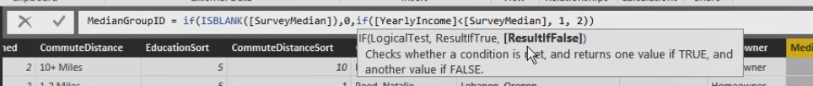

When you're finished, click the Enter. The process works exactly the same in Excel.

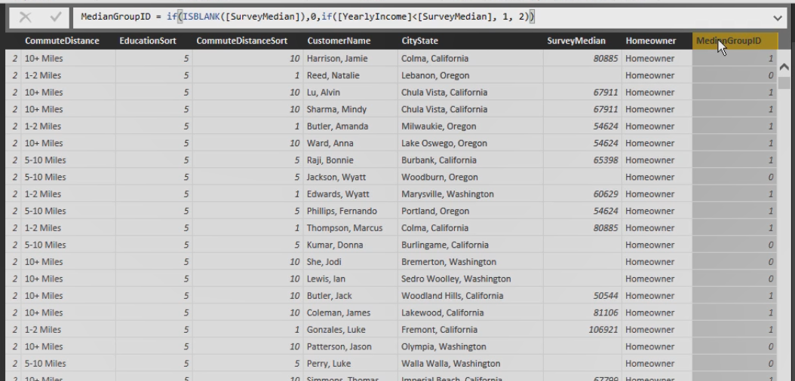

Now that we've created this, we can set up a relationship with the Median Group Table. First let's set up this column so that we're not summarizing and then Manage Relationships. We'll create a new relationship from our Customer table where we're going to do a lookup based on this Median Group ID over to the Median Groups table where we have Median Group Key and we'll click OK.

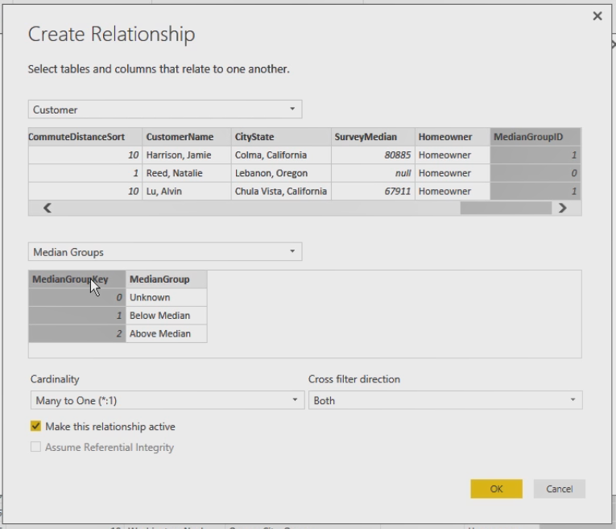

## **Adding a Date Table**

If you need to do comparisons of your data over time and did not import a Date Table from a data warehouse, then you need to add a Date Table. DAX makes this very easy for you. You can use the CALENDARAUTO function to generate a list that contains every date between the earliest and latest dates in your model, and then you could add calculated columns to your table to add things like Year and MonthYear as an example.

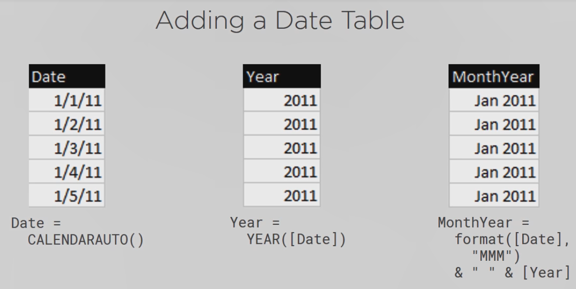

You also need to add a column to your Date Table to handle sorting. You can do this by concatenating together the year and month, but for month you need to be sure to make the number appear as two digits so that you can have 01 for January and have that sort correctly.

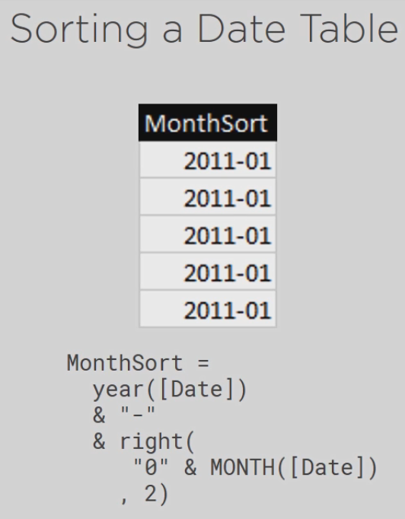

## Demo: Adding a Date Table in Power BI Desktop

To add a Date Table to our model, in the Power BI Desktop on the Modeling tab, you have a button for New Table. We can give it a name and then we can either use the CALENDAR function or the CALENDARAUTO function. With CALENDAR we have to give it a start and an end date, but with CALENDARAUTO it'll look at our model and figure out what the earliest and the latest date is, so let's use that option. And we can leave the argument blank here.

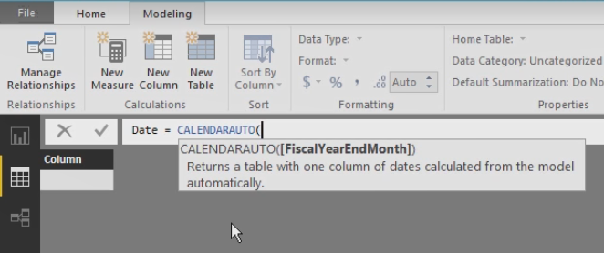

If you need a fiscal year that ends in something other than December, you would put a value of 1 through 11, January through November, and if your fiscal year end is in December, you could use a 12 here or just leave it blank. It gives us the same results. So we get a single column and we can format this just to give us the dates, and you can make columns from parts of the date. Let's go to Home, select New Column, and I can make one column represent the year, and we have a YEAR function that looks at a date and returns a 4 digit integer. So we tell it what column has the date and it's the column that's called Date.

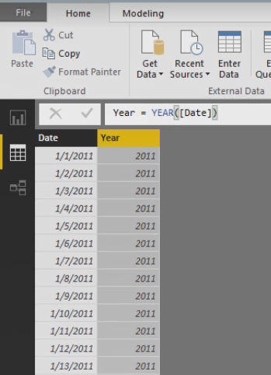

We can also add a column that has month and year in it. So we'll do a couple of things here. We'll call this MonthYear, and the way that I can pull the month out of that Date column is to use a FORMAT function, so if I point to that column Date as an argument, as the formatting, I can put in, inside of double quotes, the letter M three times, and that says use the first three characters of the month name. And we can just hit Enter here just so we can see the result. We can see January appears appropriately, and it would be good to concatenate this with the year also. So let's just use our concatenation operators, we'll put in a space between them, and then we'll put in the year, and here we can just reference the Year column.

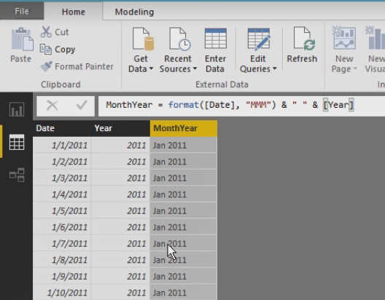

Now, if we try to sort this column it's going to do things in alphabetical order. So we need a different type of sort in order to make this something that we can work with. So we'll add in one more column and I'll call this the MonthSort, and what I wanted to do is sort first by year, but I want to concatenate it with a dash, so by doing this the year is going to be converted to a text, and then we'll concatenate that with the month number, but I want to make it 01 for January or 10 for October, so that I get things sequenced correctly through text. I will concatenate a 0 first and then we'll use the month function with the Date column and let's just take a look at this first. I have 01's for January, if we scroll through we'll find 010's for October, 011 for November and so forth. So my little trick for getting this to work is to have a right function that says take this combination of 0 and month number and just give me the last 2 characters. Well 01 is the last 2 characters here, so these won't change, but when we look at the Octobers and Novembers and Decembers, we'll pick up the 10 and 11 and the 12 correctly, just by using this right function. So we can combine a lot of things together to do string manipulation and get the results that we need. So here we are.

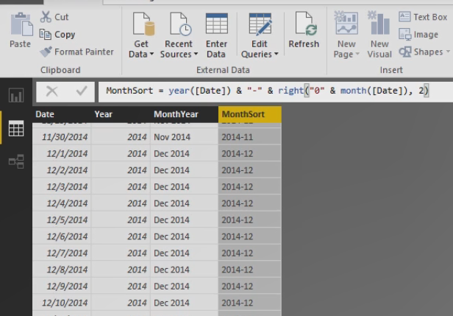

We have 12's for Decembers and 01's for Januarys. Now that we have a Date Table we can create a relationship between this table and the Sales table.

## **Demo: Adding a Date Table in Excel 2016**

In Excel 2016 we have a slightly different process, in the Design tab we have this Date Table and we can click New to get our column of dates. Not only that, but we get Year, Month Number, Month, Year Month, so this gives us an opportunity to sort, so a lot easier in our Excel 2016.

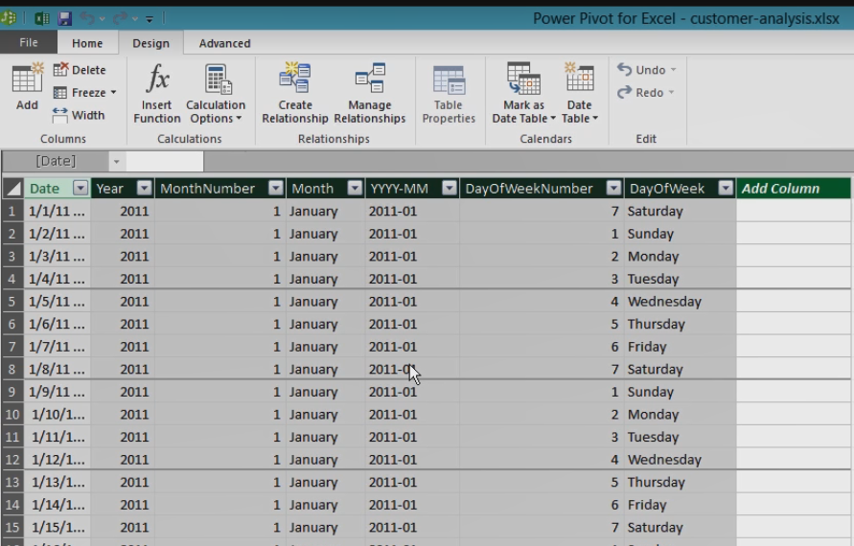

## Summary

In this module you learned various tasks to prepare your model for exploration of that data. You need relationships to make sure you can analyze data across multiple tables. You might need new columns in the model to display values in a new way by combining columns into one or by bringing in a value from a related table or by translating a value into something new that's useful for your report.

And you might need a Date Table if your IT department has not already created one for you, but you can add one easily with the CALENDARAUTO function in the Power BI Desktop or by using the Date Table feature in Excel 2016, and then you can add more columns if necessary to break out the date into years and month, or whatever you need. You learned some simple DAX expressions, but bear in mind that there are a lot of functions available, and there's much more to learn to fully take advantage of Power BI. Here's a link for more information about learning DAX.



# Enhancing the Data Model

## Enhancing Data Models

Hi I'm Stacia Varga and welcome to module 5, Enhancing the Data Model. In this module you continue working with your Data Model to make it even better for exploring your data. For example, you learn about defining hierarchies and also you learn how the model includes more than data, it also contains properties for every table and column in a table. You'll learn how to configure these properties to control the experience and the visualizations that you learn to create in the next module, and last, you learn about creating measures, which are the summarized values that you use to explore your data.

## Defining Hierarchies

Another useful technique is modeling data is adding hierarchies. A hierarchy allows you to drill from one level of detail to a lower level of detail. You define a hierarchy by creating as many levels as you need.

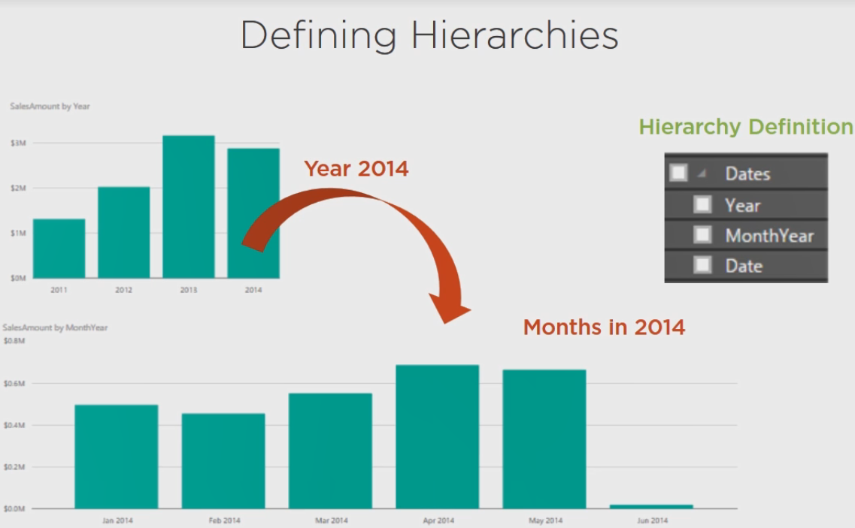

## Demo: Defining Hierarchies in Power BI Desktop

The way that we create hierarchies depends on which tool you're using.

In Power BI Desktop, you actually need to go to the Reporting tab and then find your tables in the Fields list off to the right here. I'll just collapse everything to make it easier to see. In our Customer table let's create a hierarchy by location. Let's say that I want to create a hierarchy where I go from the State Province Name and create a hierarchy that supports drill down to City and then into Customers. So I'm going to right click on StateProvinceName and select New hierarchy and it created this extra field here.

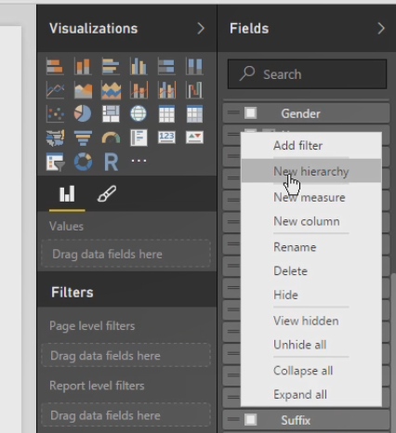Now I can rename the top level here, we'll call this Location, and then we have StateProvinceName below that, and if I want to add City below that we created, when we right click we can add it to the location hierarchy, and similarly we can take Customer Name, the column that we created, and add it to the location hierarchy.

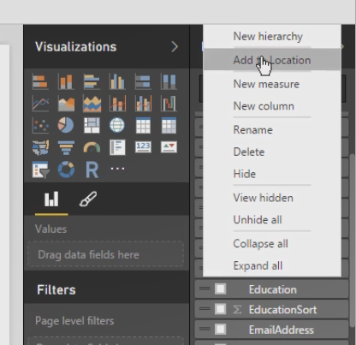

You can have as many hierarchies as you want and as many levels as you want. Similarly, let's create a hierarchy for our dates. I want to start with year and we can rename this, we'll call this the Calendar, and we could add MonthYear as well as Date. So we can use fields individually or we can use things from a hierarchy as we'll see later when we get into reporting.

## Demo: Defining Hierarchies in Excel

In Excel we need to be in the Diagram view and then in the header for a table we can click this button that is Create Hierarchy. You can right click on this and give it a name. You can resize this table and drag and drop a column right onto your hierarchy, but when you have large tables this might be a little challenging. So we'll add in CityState and CustomerName. Let's do the same thing for the Date Table in Excel 2016. The DateHierarchy was already created with Year, Month, and Date. We can rename this to something else if we prefer.

## Configuring Properties

Another important part of modeling your data that cannot be done in the getting data part of your project is configuring properties of various objects in the model.

With one exception, you can rename tables or columns in either the data query or the model, but remember you have calculated columns that you add only to the model and so you can always rename these.

You might consider hiding tables or columns to make it easier to find the objects you need to add to a report. Some of the queries in your model might only be necessary to set up relationships or build larger data sets or compute column values, but they're not useful as individual objects, so you can hide them.

Sometimes you might need to adjust the sort order and sometimes Power BI takes its best guess at data types and categories for each column in a table, but it's not always accurate. To get the report to behave properly, you need to look at the data types and categories individually.

For numeric columns you should fix the formatting so that you get commas or currency symbols when you need them or the right number of decimal places.

And last, Power BI wants to sum up numeric values by default, but sometimes that's not the way you want to summarize values and sometimes even though a column contains numeric values it's not really appropriate to summarize the values at all, such as when you have an identifier number.

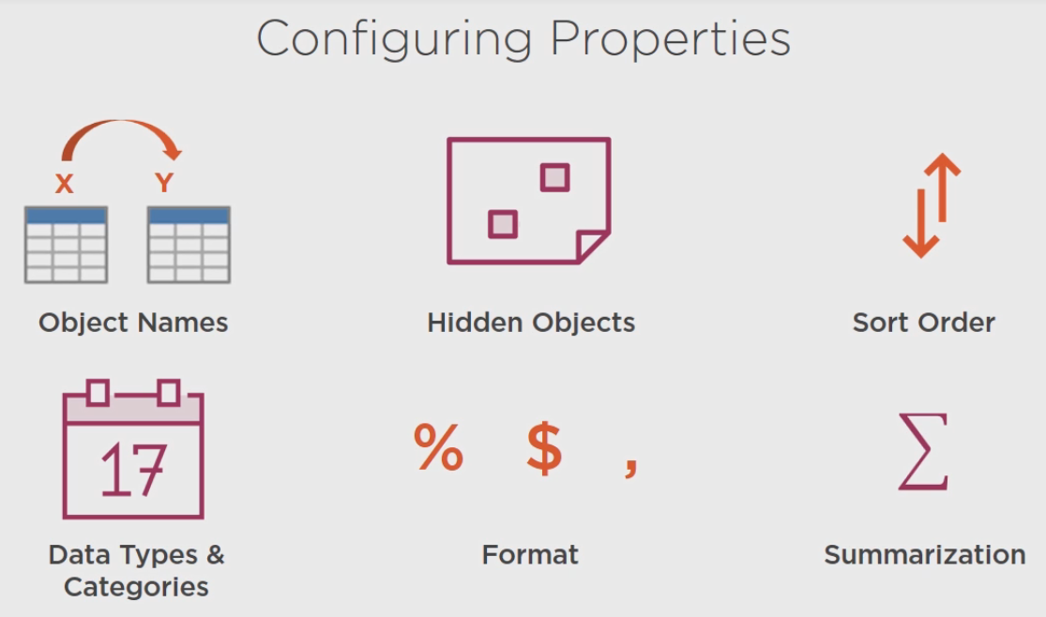

## Demo: Configuring Properties in Power BI Desktop

Let's see how to work with properties in our model in the Power BI Desktop first.

First thing is if we want to hide tables or columns, we need to go to the Model tab so we can hide each one individually just by right clicking on it and selecting the Hide in Report View.

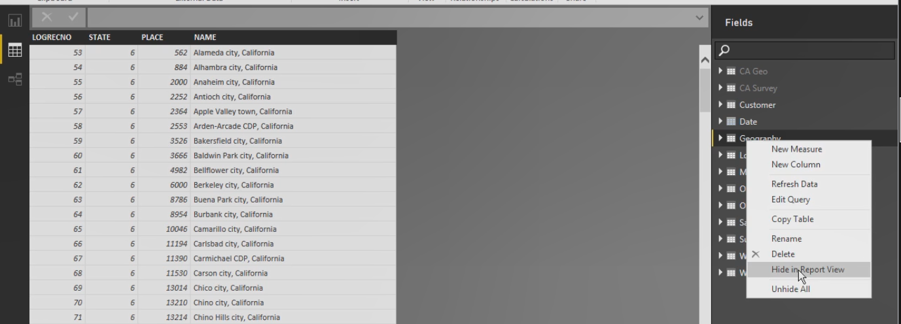

We'll hide Geography, we don't really need Location, we don't need the Oregon stuff, we don't even really need the Survey, that just helped us with a formula in our Customer table. So you can see how everything is grayed out when we hide it.

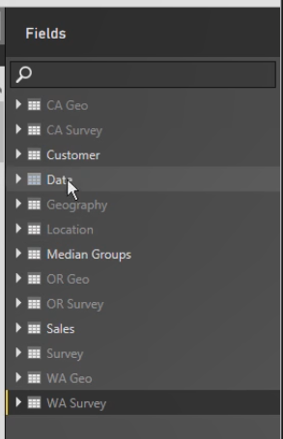

So we have Customer, Date, and Median Groups and Sales and those are the only tables that we want to see when we're reporting.

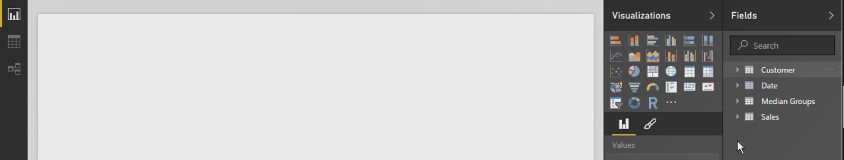

Now you can do this for individual columns as well. If we go to the Customer table, there's things we don't need to see in here either. For example, the HomeOwnerFlag we translated to a new value, or when we did the First Name and Last Name, we created a new column for that, so we don't necessarily need to see the Name columns in here or the Suffix. Anything that we hide, not only will be unavailable for reports, but also the Quick Insights feature that we saw in module 1 will not look at those particular columns.

Now we have these sort columns, EducationSort and CommuteDistanceSort, let's see how we use those in the model now. I want to look at my Customer table, so we'll select this and then for the Education column I can select it in the model, go to the Modeling tab and there's a button here for Sort By Column. So I can point to the EducationSort so that when we report on this column using values here, they'll sort in the order that we specify. And same thing for CommuteDistance, we'll select the Sort By Column and then CommuteDistanceSort, and then in our Date table we have MonthYear that we want to sort by the MonthSort column and we can decide whether or not we want to show this MonthSort column. This could be something that we hide as well.

## Demo: Configuring Properties in Excel

In Excel, in your data view, the way that you can hide tables would be to right click and select Hide from Client Tools. Notice as you do this, the tabs are a dark gray as compared to a light gray for the unhidden tables. And then if you want to hide any particular columns, you just simply right click on that column and select Hide from Client Tools. If you want to sort by columns, you select the column and then on the Home tab you have the Sort By Column button here where it's a slightly different interface, but the same idea where you can point to the Sort column.

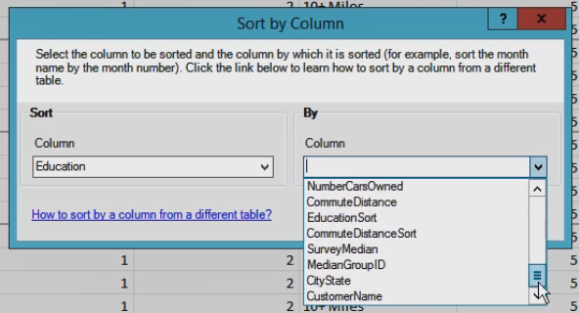

## Demo: Configuring Properties: Data Categories

Another property to consider changing is anything that is geographic related, like CityState here. We can go to the Advanced tab in Excel and assign it to a category. We can say this is a city and this helps us out when we build reports, where it recognizes locations and can map our data points appropriately. I can identify a country here, it already detected that as Country/Region, I have StateProvinceName, it thought it might be a County, but in this case we're going to set this to State or Province.

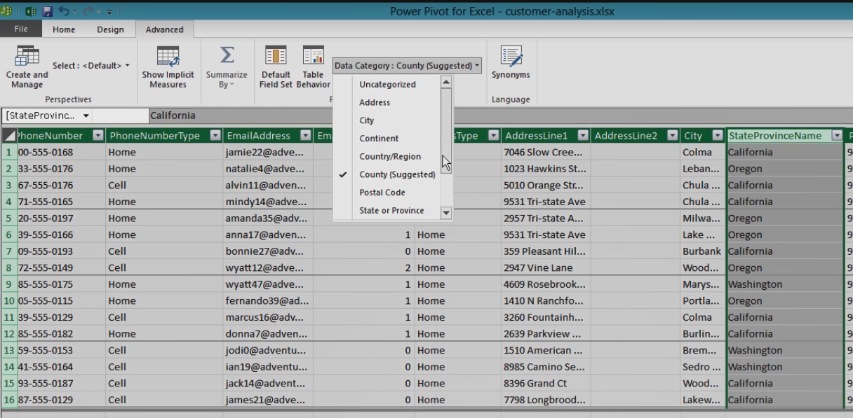

We can set City and we can set the Postal Code, it already detected that. We can even get to an address, and then over in the Power BI Desktop, same thing, we would just highlight, we would just select the column and on the Modeling tab we would identify what we have.

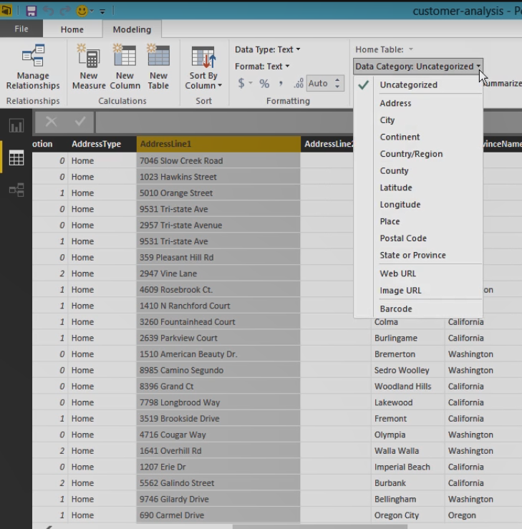

## Demo: Configuring Properties: Formatting & Default Summarization

So for example, let's look at Sales Amount and it's set to a decimal number, we can change the number of decimal places. We can change the currency symbol if we need to, and it already has comma selected here. The same formatting options are available in Excel.

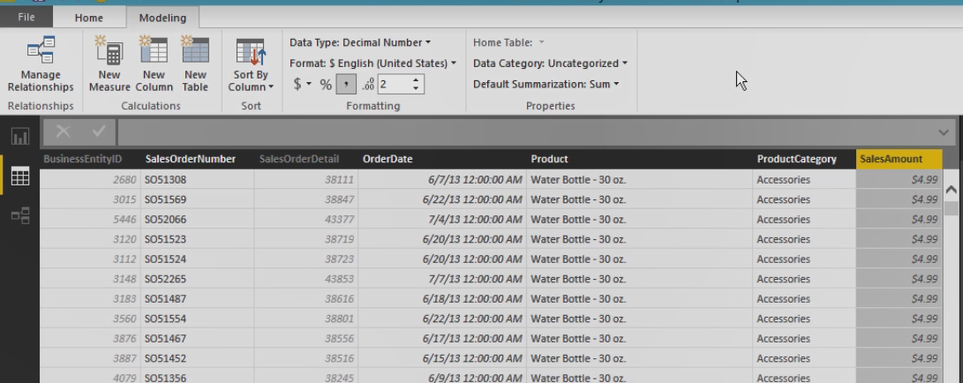

And then last, we've seen this before, we have the summarization of values. But let's go ahead and finish this in the model, for example SalesOrderDetail is not something that we want to have summarized, and Customer has Email Promotion that we also do not want to summarize.

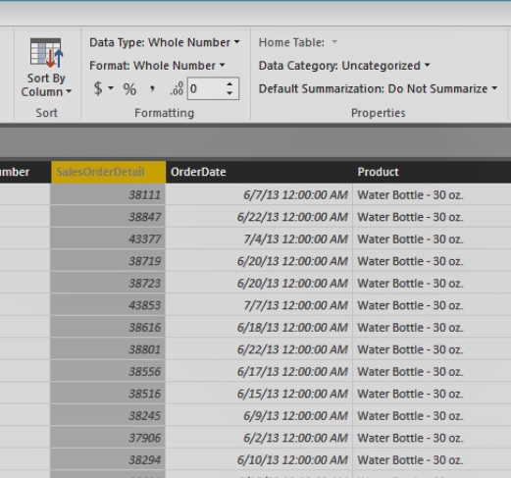

So as you go through your model, you need to look at your columns and make sure that you're displaying only the things that you want to display, they're formatted properly, they're specified as geographical locations as necessary, and you could very easily look at some of the symbols inside of your Field list here to quickly validate various columns.

## Defining New Measures

The last thing you need to do for your model is to add in measures. Measures are created by using DAX to calculate and summarize values for your visualizations. For the current model there are all kinds of measures you can create, but let's just focus on a few to get a general idea of how DAX formulas work for measures.

First, you can count all the rows in a table like this and you can calculate a percentage of values by referencing the first calculations as a numerator and then ensuring the denominator includes all the customers.

Now this will make more sense when I show you this calculation in the next demonstration, so don't worry too much about it right now.

We can also create a special measure that just sums up all the values in a table.

You can use similar aggregate functions like count or average or min or max. And you can use time intelligence functions like previous year to get values for a different time period.

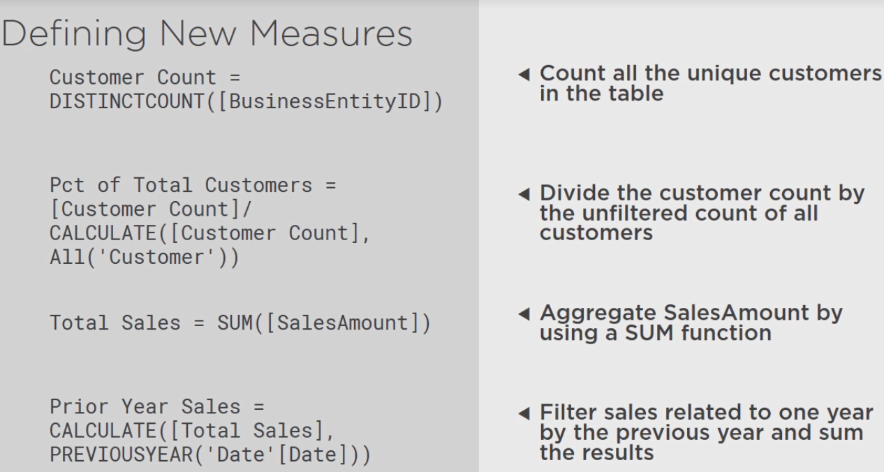

## Demo: Defining Customer Count & Pct of Total Customers

When you create measures you add them to specific tables, so if I want to count customers, I'll add that measure to the Customer table. I'll just select it here in the list and then on the Modeling tab I will click New Measure, but of course on the Home tab we also have New Measure, same thing both places.

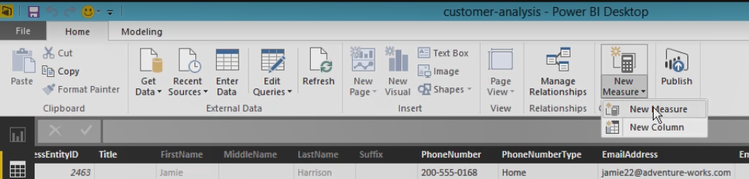

Now this doesn't add a column to our table like a calculated column does, but it works similarly in that I give it a name here and then I type in my function, so I could use sum or average. As I start typing those letters it'll give me a list, in this case I want distinct count and it tells me it needs a Column Name and it will count the number of distinct values in that column. Now because I am creating this measure inside the Customer table, I don't need to specify the Customer table in front of the Column Name, I can just do a left bracket and BusinessEntityID and then I close parenthesis to close off that function and now I have a new measure.

It's not visible in the table, when I scroll over here I won't be able to see that, but in the list of fields for the Customer table I will see that Customer Count added here and it's got a little calculate icon to let me know that that is a measure, which is different from a calculated column above it that has little fx symbol.

Now let's do a little bit more complicated measure here. This time I want to do a percent of total customers. Now if I do this in steps, let me show you if I just have the Customer Count in the top part, let's call this Percent of Total Customers, just to get started, I can reference the other measure that I've created. It's like a field, I just do a bracket and then I can do Customer Count here, and I'll just leave this alone, just for a moment. I'm going to go to my Reporting tab and I'm going to select Customer Count, they're in alphabetical order here, and I'm going to select Percent of Total. Now because I've selected some values, Power BI decides that I want to see this as a chart. Let's switch this to a table. And now I can see these values, well sort of, they're very, very tiny, but I can click this button to expand out and I can see that the number's the same. Now one of the things that's special about the way that DAX works is that the context changes based upon what I have filtered. One thing I'd like to do here before we go any further though is to format my measures. So I want to add in a comma for both of these, just to make them easier to read. When I go back to my report, expand it out a little bit better, I can see that comma is in there. Now this context gets remembered, if I were to add into this table something like StateProvince, and let's rearrange this so StateProvince comes before everything else, I can widen out my table and let's blow it up so we can see this, California, Washington, Oregon, I can see my Customer Count, and it's the same in both cases still, but what happens is that 7, 780 was broken up into the respective states. What I want to do with Percent of Total is I want to know what percentage California is of the grand total, but remember what I said that DAX is trying to apply this filtering on every single row here, so what I need is a way to tell DAX to ignore the current filter, in other words, on California I want the denominator for this expression to be 7, 780 every single time. So let's see how to do that. If I go back to this measure, Percent of Total Customers, there is a Calculate function that I can use. I can say Calculate, and notice it says it evaluates an expression in a context modified by filters.

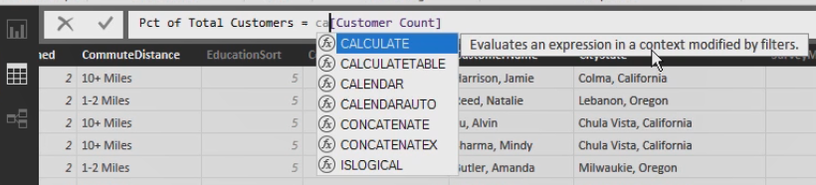

Well, Customer Count is already being modified by a filter on the rows, but I'm going to do what I call an unfilter, and there's this All function that says basically ignore any filters that are already applied. So I can just say, take the table, if we're modifying by anything in the Customer table already, just ignore that. No matter what I'm putting into that table from the customer, whether it's state or city or gender or what have you, anything from the Customer table that wants to divide up or group my values, we're applying an unfilter here to say ignore that. Now when I save this, watch what happens when we go back to the report. We'll expand this out, and now we can see the 7, 780 applies on every single row. So now I can put these two things together, I can have Customer Count, which does divide up by state, and I have that as my numerator, and then I have this Calculate with the unfilter all for the denominator, and I can come up with the proper percentage of total customers. So I just add in Customer Count at the top here, do a divide by, and then my Calculate, and so that gives me a percentage, I want to be sure to format that as a percentage, by the way, and then when we go back to our little table that we have, we can see that California has 57% of our customers, Washington has 29%, and Oregon has 14%, all of which adds up to 100%.

## Demo: Defining Total Sales & Previous Year Sales

Another thing that we might want to do is add in an explicit measure for adding up our sales. Now already if we were to create a report, because of the sigma symbol here, Power BI is going to go ahead and automatically sum that, but we can make an explicit measure called Total Sales and that might be easier for us to work with in other calculations. Type in the word sum, point to that Sales Amount column and we'd get something that we could put in a report, Total Sales. And let's apply commas. Now if we click on this table, we can add in our Total Sales, go back and let's apply the currency to this (Typing) and now we see it is correctly formatted.

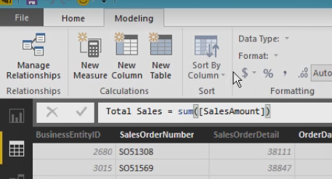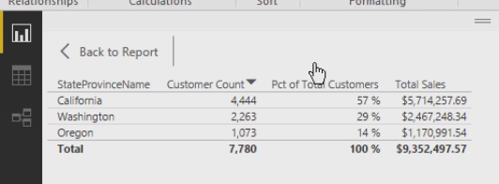

Another option we have is time intelligence calculation, so again in Sales I'll add a new measure and I'll give it a name, Previous Year Sales. We'll use the calculate function again and we'll point to that Total Sales calculation, this time rather than do an unfilter, we're going to apply a filter, and this would be PREVIOUSYEAR acts a filter, it's going to look at all of the dates, we'll tell it what our Date table is, Date table, so we don't use the brackets there. You can put table names inside of single quotes, those are required if the table name has spaces in it, by the way, they're not required if it doesn't. But in any event, we point to the Date table and actually we need to point to the Date column in that Date table as well. And if you have a particular fiscal year end, you would put that as an additional argument in here, we're just using the 12/31 date so we can end our PREVIOUSYEAR function here.

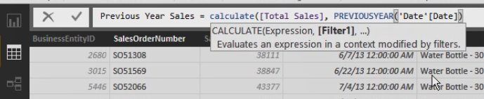

So what we're doing is we're going to filter and say ignore whatever the year filter is in the report and use this filter instead, the previous year. So we'll look at this in context, and we finish out this calculation with another parenthesis for the calculate function, we'll save this. We also want to apply the currency format. Now when we go and add this into our report, Previous Year Sales, we'll see that nothing is here, and the reason is because right now we haven't filtered anything by year.

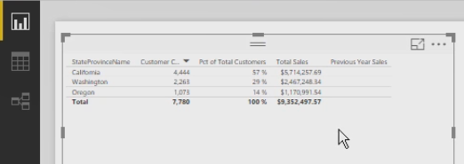

So if we're unapplying that and calculating the previous year, it doesn't know what that is yet. So we need to add in the year into our table, and notice how year adds up these values. So here we have another problem with modeling, we need to go back to our model and go to Date, specifically the Year column, and tell it don't summarize that. Now when we go back to the report, let's take this out because it tried to sum that, let's add it back in. Now we can see years, and when you blow this up so we can see it better, what we can see is 2013 has sales of 1, 915, 090 for 2013, for 2014 it's 1. 7, but notice the previous year sales matches what was 2013.

In Excel it works slightly differently in that you might have noticed at the bottom of your grid of data, there's a section in here that's got a bunch of empty cells in here. Now this is what's called the calculation area. So you can hide it by clicking this Calculation Area button or show it, and then in one of these cells, it doesn't really matter where you put them, just make sure that you can find them, you would type in the name of your measure, so let's say I have Customer Count, and then a colon and an equal sign, and then you can type in the same functions that we used in Power BI Desktop. I might want to do a DISTINCTCOUNT by BusinessEntityID and then save this, and if you've done this correctly you'll see the measure appear and if you widen out the column, you can actually even see its value.

## Summary

In this module you learned a lot more about how to prepare your model for exploration of the data. You learned that you can define hierarchies in a table to provide a way to drill down to more detailed information in a report. And then you learned that you should always review the properties of numeric fields in particular for formatting and summarization behavior, but also you should check properties for Geographic columns to get maps to behave properly, make sure values sort properly for various columns, and also hide any columns or tables that aren't useful for reporting so that you can find what you need when you need it. And last, you learned how to add measures that you need for analysis, such as counts and totals.

# Visualizing Data

## Visualizing Data

Hi I'm Stacia Vargo and welcome to Visualizing Data. In modules 2 and 3 you learned how to get data from various sources to create a data model and enhance that data model in a variety of ways to ensure that dashboard and reports work correctly. Now you're ready to explore your data through visualizations. In this module you learn how to work with different types of visuals and how different types of filters affect what you see on a page or in a report. You also learn how to fine tune the appearance of your visuals by setting properties, and last you learn how to work with hierarchical data in a visual.

## Adding Visuals

When you create a report you select the fields to display simply by checking a box in a list. When you're working with a data model you can choose fields from multiple tables and ideally the data model is structured in a way to make it easy for you to explore the data.

Then Power BI tries to figure out the best visualization for your field selection, but you can specify one before you even start. In this case you have fields in a table. After selecting fields, you can easily change from a table to a column chart, as one example.

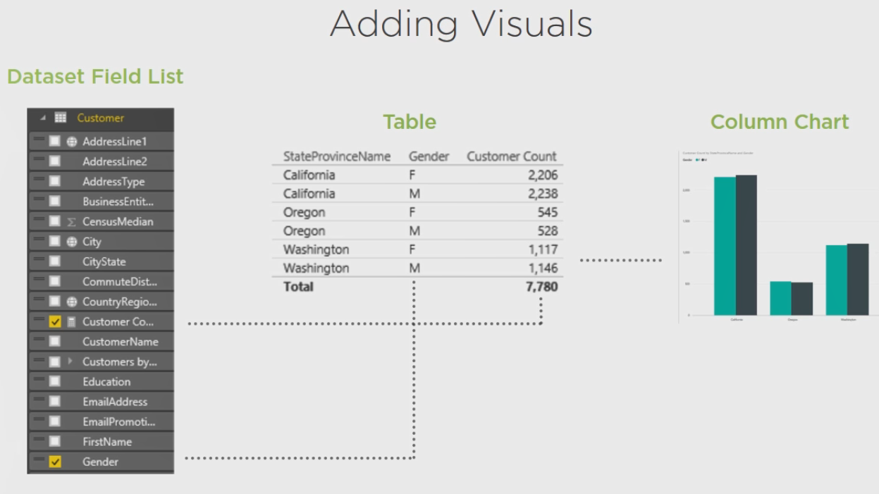

There are many different types of visualizations you can use in Power BI and there are even custom visuals that you can have a programmer at your company create or you can download a custom visual from the Power BI gallery. In this module we'll take a look at some of the more commonly use visualizations.

* There's a Table where you define the fields to display as columns,
* a Clustered Column Chart where you define a field to display on the horizontal axis, a value for the vertical axis, and optionally a legend to show different groupings of values for each category that you have on the horizontal axis.
* You can have a Map where you superimpose values in the form of pie charts on geographic locations or
* a Card where you can display a simple metric.
* Then there's the Matrix where you can display values and cells that intersect rows and columns or
* a Bar Chart where you put categories along the vertical axis and values on the horizontal axis or
* a Filled Map where you fill in a regional area with color densities to reflect areas with more or less of a value that you're monitoring.
* Or a KPI where you can watch progress over time for a metric that you're comparing to a target.

## Demo: Adding a Table, Clustered Column Chart, & Bar Chart

Now let's build a report with several visualizations. In the previous module we had a single table built on our report, let's get rid of that. Just point to the three dots in the upper right hand corner, and then click Remove. So now we can start fresh. In Power BI Desktop you have one report with one page to start with. Now if I want to define the visualization that I want to use first, rather than have Power BI decide for me, I can click the visualization I want, Table in this case, and notice when you hover over any of the visualizations its label displays for you. And incidentally, to use the custom visualizations you can click the ellipses button here. We'll start with the Table, so when I click this I get a placeholder in my report. Now as long as I can see the edges of this report I know this is the current selection and any fields now that I select from my field list will go to that visualization. So here from the Customer table, I'm going to locate my StateProvinceName and then the distinct values for that field display in my report. Now it shows rather small, so you can always change the focus by clicking this icon in the top right corner to get a better view of the visualization that you're creating, and then click back to report to go back to the Design mode. Let's add in Customer Count and Percent of Total. We can always resize by dragging the edges of our table to the right or closing it in like so.

Now we can use this same visualization as the starting point for a new visualization. All you need to do is just make sure that the visualization is selected and you can tell because you can see the edges, and then select Copy in the ribbon and then Paste. Now you get a separate copy and there's two lines at the top of the visualization that you could use to drag your visualization to a new location. So now I have two versions of the same table, but with the second version selected I can convert this into a different style of chart. So let's use a clustered column chart here and automatically my visualization changes and I can resize this to get a better view. In this Visualizations panel I can see how my fields are configured, for example the StateProvinceName is along the axis, this is the horizontal axis that we see going across the bottom of our column chart. Now we don't really need to show Customer Count and Percent of Total Customers in the same chart because one number is considerably higher than the other. So we can remove the Percent of Total Customers just by clicking this X to the right of the label. And notice how that changes the structure of the column chart now that it's not displaying two values. Now if I want to create groupings for my three states, I might want to show my Median Groups and add that as a legend. I can just click the box here and it automatically assumes that I'm going to store that field selection as legends. And so we can see Above Median, Below Median, and the Unknown. And we can repeat this process. If I select the New Column chart and Copy and then Paste, I can create yet another chart. You have to be careful where you grab it because you might inadvertently resize, but that's okay you can always fix whatever you've done. So now I want this to be, we have clustered bar chart and we'll remove the legend so that we just see our customers by state. Let's rearrange some things here, let's say that I want to move this to the very top and stretch it out a bit and then maybe I'll have my column chart beneath and move my table to the right and I'll do some adjustments to try to line this up a bit more. Get this as small as I can and line up visually the California, Oregon, and Washington a bit better there, so I have both a graphical view of the data as well as text view of the data.

## Demo: Adding a Map, Card, and Matrix

Let's paste one more time, I still have in the clipboard the last visualization, and let's put it over here to the left. We could stretch it out. And now I'm going to turn this into a map, which is this globe here. Now in this case it's not showing me anything, I need to change my map slightly here. So it's trying to render the information by state, so we can see a pie chart showing us our Above Median, Below Median and Unknown, so on a state by state basis, but I can provide a little bit more detail. Let's take out StateProvinceName and let's instead use PostalCode and see how my map gives me more detailed information now.

And let's say that I want to add in a brand new visual, I'll just click in the whitespace here and now I just wanted to display a metric of my total customers. So we'll choose a card, there's the multi-row card versus a single card. A single card will just show us our value and in this particular visualization I'll select Customer Count and we can resize this and reposition it.

And last I want to create a matrix. A matrix is similar to a table in that I can add in items into rows, but I can also define things on columns. So let's say that I want to do my StateProvince and then CityState and then I want my CustomerName, and I can do a Customer Count, which of course will show 1 each for each of those customers, but just to show you with the matrix, I can take Gender and instead of just clicking the box, which would put this onto rows, I can drag it over into columns, and so what a matrix does is take your column information and break down your measure, your counts or your sums, whatever your measure happens to be, and break it across to provide a value for each intersection of a particular row and column combination, and it includes totals as well for those columns and rows. So if we went all the way down to the bottom we'd see a grand total here. Now for our purposes here, I don't want truly to have a matrix. What I'm trying to do here is to get something like a table, but look at our table where we have a value in every single row and what I've got here with the matrix is that for all of my California cities it just shows California once and then the cities, one city versus individual customers. If this were a table instead, I would get that same information repeated on every single row. So by switching this over to a matrix I can list unique values a single time in its particular column. We'll remove the value here and it still preserves that style of layout here. I'm going to add in one more bit of information, we'll have Email Address. So now I've got some information about my customers and let's go ahead and add Gender in here as well so that we know something about each of our customers. So now we've created an entire report.

## Demo: Adding a New Page, Column Chart, Filled Map, and KPI

We can double click for page number here and give this a new name, let's call it Customers By Location and press Enter to save that name. If we want to create a report with multiple pages, we just click the plus sign here and I'll give it a name. I know I want this to be Sales Information. We can start making selections. Let's say that I want to see my information by year, so let's start with date. I'll select Year here and Total Sales. I can also add in Previous Year Sales, and now we have a chart showing us information, comparing one year to its prior year, and you can see this prior year matches the year on the axis that's preceding. But this gives us a way of very quickly comparing one year to another where we can see most of the time the sales are increasing from the prior year, except for the year 2014 where the prior year sales were higher. Again, we can copy a visualization and paste it to get a new visualization. Let's put over on the right hand side now and remove Previous Year Sales so that we just have Sales, and I'm going to change this into a field map, and for Location we'll use the StateProvinceName, and we'll remove the Year. So simply a very high level of a region that has boundaries defined in our map, states in this case. We can see that the darker color has the higher sales and the lightest color has the least amount of sales.

We can always resize our charts and then one last visualization, we'll add in a KPI. So I'll click this space and for our KPI we want to specify what is the data that we're measuring. So in this case we'll use Total Sales. We need to tell it what time period we're comparing against, so I'm going to select Year and so now it just shows us our grand total, so this would be our most current year is 2014 with 2. 87 million in sales. That's the value that we see here. We also see a curve, so we can see that over time our sales are increasing from a low value to a peak value and then dropping. So this is a visual indicator that the 2013 sales were higher than 2014 sales. Now if we want to have a visualization indication of whether this is going well or not, we can have a target and so this is where Previous Year Sales could be our target, so we're showing that in this case 2014 sales are not exceeding our 2013 sales, and this is what we see in the chart above to actually confirm that we're going down and therefore we show a red value to indicate that we're not exceeding our goals, we're actually moving away from our goals.

## Demo: Adding Visuals Using Excel

To create reports in Excel the process is slightly different. So in our workbook we need to go to the Insert tab of the ribbon and then click Power View. Now this will be here in Excel 2013 if you've added the Power View add-in to the Excel configuration or if you've customized the ribbon for Excel 2016 in addition to adding the add-in, and these are steps that I describe in module 1. So when we click the Power View button, a new sheet gets added into the workbook. It's a special type of sheet, it's not one where we can use standard Excel functions, it's a sheet that is specific to Power View. You may get prompted to install Silver Light on your machine as well. So here we have a page. I can call this Customers by Location, so I'd right click and rename it. And otherwise the process is pretty much the same. To make it easier to view your report you might close the filter area now, we'll talk about filters later. So we have this empty space in which to add our report. So if we want to start with a table we define what fields we want to use. We can just open up a particular table and start making selections. So I'll have StateProvinceName, Customer Count and Percent of Total Customers and just like we can do in Power BI Desktop, I can copy just by pointing to the edges of this visualization, and if I go back to the Power View I can copy and then paste to create my new visualization. Notice when we have a visualization selected, we have both a Power View tab where I have certain options, and I have a Design tab that's specific to Power View that only appears when I have a visualization selected. And I have my various visualization options. So we have Table, Matrix, and Card, here I want this to be a Clustered Column Chart, so we'll make this selection here. And I can clear out my percent of total customers, we can remove the field here or clear the checkbox here, either way. And we can resize things as well. We'll copy this and paste. I have another copy of this chart that I'll turn into a Bar Chart and for the Column Chart we need to add in our median groups. Now what happens is when we start building out visualizations Excel separates our selections into Active versus All fields. So what I need to do in order to add in the medians is go back to All fields and select MedianGroup. Now my space is a little bit more limited here in the Excel layout than it is in Power BI Desktop. So we might choose to rearrange things a little bit differently and maybe I will have a map, let's take this chart, copy and paste. We'll bring this up a little higher and in our ribbon select Map. And instead of our StateProvince locations we'll use PostalCode. So we get a very similar experience in Excel here, the differences are that our color schemes are different, but we can change that later if you prefer using Properties, and we have a little bit different in real estate, and we have some differences in visualizations. So for example, we have only a Card here instead of Card and Multi-Card, so I'm going to create a total Customer Count here and switch this to a Card and so you see, the behavior is slightly different than we get in our Power BI Desktop. Some different visualizations. Here I have one type of map versus two kinds of maps that we have in Power BI Desktop. If I need to create another page I just click the Insert button and create a new Power View page. I can rename it and add in my sales information, just like we did in Power BI. The difference is also here we don't have the KPIs. We can tell it right on the spot, don't summarize, if we didn't set that in the model, and then we could have Total Sales compared to Previous Year Sales and Power View's default mode is going to be to create a table every time, but we can convert this as needed.

## Filtering

With filters you can interact and explore your data for new insights. You can use a basic filter to simply select values from a list related to a field in your data set or you can define an advanced filter with conditions and you can have up to two conditions that you combine using either AND or OR logic.

When you create a filter you specify whether you want the filter to affect all visualizations in all pages of a report, or you can set up a page filter for all visualizations on a single page. Or you can filter a single visual only. These three types of filters work similarly, you can change the filter value when viewing your report at any time.

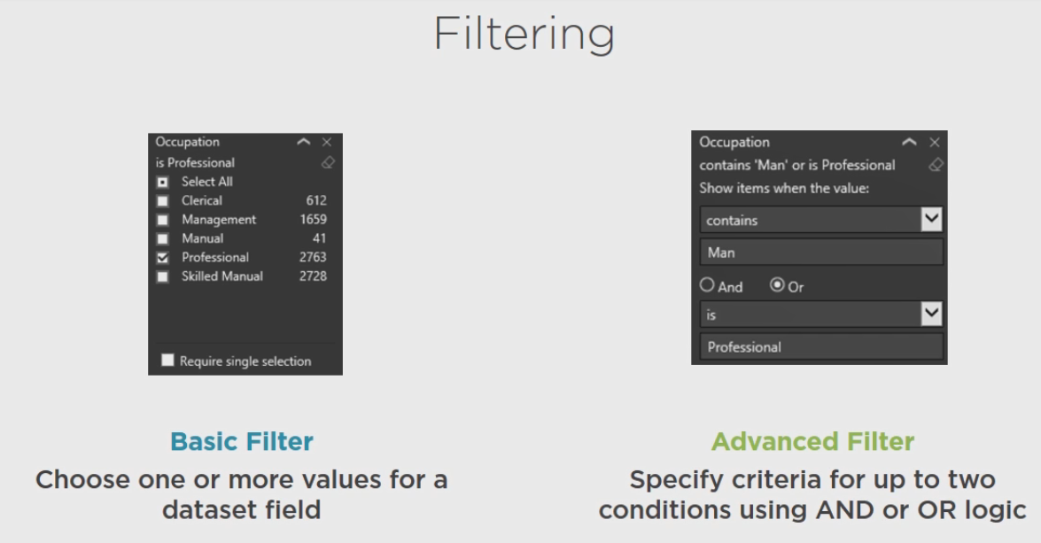

## Demo: Filtering In Power BI Desktop

Here in Power BI Desktop if we want to add a filter we need to decide whether we want to affect one visualization, all the visualizations on the page or everything at the report level.

Let's see what happens if we just do a visual level. Let's say that I want to look at Occupation for the selected filter, which happens to be the KPI right now. I can tell that because of the handles that I can see here. So once I add this filter, then I can view my options. If I want to see just Professional I can see how many customers are in this particular category and I make the selection and only the one visualization changed. I can collapse this down. Let's make it a page level filter. Let's take Occupation and move it to page level filters just by dragging and dropping and I can do the same thing. Now everything changed. I can clear that selection and make a different selection or I can choose two different options here. So this is a basic filter when I'm just selecting off the list. My other option is to require that I only select one at a time. Or I can use Advanced filtered and I can say that I want everything that has man in it, which is my manual and skilled manual, I can apply the filter or I can select or contains Prof for professional.

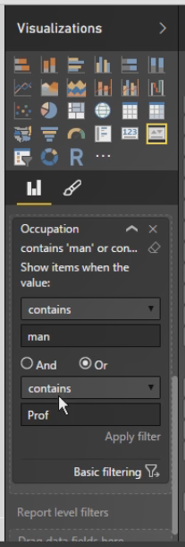

So you only have up to two options and then depending on what your values are determines what you see in this list.

With string data you can have contains, does not contain, starts with, and so on. If you want to clear the filter there is a little eraser icon here to remove all of the filters. So we can remove this filter entirely, and again, you can filter at the visual level, the page level or the report level. With the report level any filters that I apply here will affect all of the visualizations on every single page.

## Demo: Filtering in Excel Power View

In Excel we can also filter, but the process is a bit different. Here we have the filters area, this is just a button that hides or shows the filters area. And we can apply filters only to a single page, we do not have report level filters. Now when I have the filter open, I have a View or a specific visualization that might be selected. If I just click anywhere in the report that map goes away, if I select the Column Chart up here, you can see Chart appear or if I click this table, then Table appears. So that would be visualization specific, if I chose that option I can have a filter that only applies to that table. If I choose View then this is my page level filtering. So I can, again, specify an occupation here and I would just take my field that I want to use and drag and drop it into this Filters area, making sure that I've selected either the page level or the visualization level here. And again, I can just choose an item to update all of my visualizations, and I also have an advanced filter mode where I can type in partial strings using the same type of functionality that we saw in Power BI Desktop, using and or or logic.

## Slicer Filtering

When you want to filter everything on a page, a simple option might be to set up a slicer on the report itself to enable a quick change between values. The slicer acts like a page filter so each visualization now reflects data associated with the current selection in the slicer. By the way, with a slicer you can only select one value at a time, but you do not have the same limitation with the regular filter.

## Demo: Slicer Filtering in Power BI Desktop

Let's add some slicers to our page, Customers by Location, in the Power BI Desktop. I'm going to make some room by making this chart a little bit smaller, then I'm going to click the slicer visualization here and I'll start with MedianGroup, and there's only a few values in here so we'll make this a little bit smaller and I'll add one more slicer for State and Province and we'll also arrange this by resizing it and we'll put right underneath, try to line up with the MedianGroup. Now when I use this I can specify a particular median and all of the visualizations on this page update accordingly and I can focus on a particular state, and I can easily clear this. That way when I'm working with the report I can hide these visualizations and fields and have a larger view of my report.

## Demo: Slicer Filtering in Excel Power View

We also have slicers in Excel. So all I need to do is just click in an empty space here, find what I want to use as a slicer, so here's one, and on the Design tab click Slicer to convert this. We can still resize and move this over a bit, and below this we'll have StateProvinceName and convert this to a slicer as well. To move things around in Excel you want to grab the edge, as long as you have the edge selected here then you can move this, get the cursor to change into a little hand. Now we can make a single selection in either slicer and you can clear the selection by clicking this little icon that appears above the slicer. We can also copy a slicer from one page to another. That works in our Power BI Desktop as well.

## Highlighting

Highlighting is another interactive technique for your report. You can click on a data point in one visualization to highlight or change related data in other visualizations on the same page. It's similar to a filter. In the case of the chart here, the data that's unrelated to California is still visible, it's just not highlighted like the California data is, whereas the KPI only shows results for California, and a table or a matrix would also show filtered data only.

## Demo: Highlighting

So here we are in the Sales page of the report in Power BI Desktop. And I have a slicer set which affects all of my visualizations, and now when I click on something like California in the map then everything changes. We have in our chart the amount that is using the darker color represents California so that we can see for each of our years California represents a significant percentage of overall sales, and we see this for both Current Year and Previous Year Sales. The KPI also changed, so we can see that, again, our goal is not being met for the current year. To clear the selection you just click the same thing that you clicked to apply the highlighting, so it's just a toggle on and off, or if I want to switch to Oregon, for example, we can see that - oh look Oregon sales are increasing over time as opposed to the overall trend of decreasing in the last year that we have in our data. We don't have to clear the selection, we can just point to California or point to Oregon or point to Washington and change our view very quickly. Again, click the last thing that you selected in order to remove all of those filters. Highlighting works the same way in our Excel version as well, we just simply click on a data element and everything in the other visualization is highlighted accordingly.

## Setting Properties

You can also configure properties of visualizations. For example, you might resize the legend text or increase the size of the font used for the visualization title, or maybe you want to add data labels. And these are just a few of the options as you'll see later. Basically you have a lot of control over the appearance of your visualizations, more so in Power BI Desktop than in Excel, however.

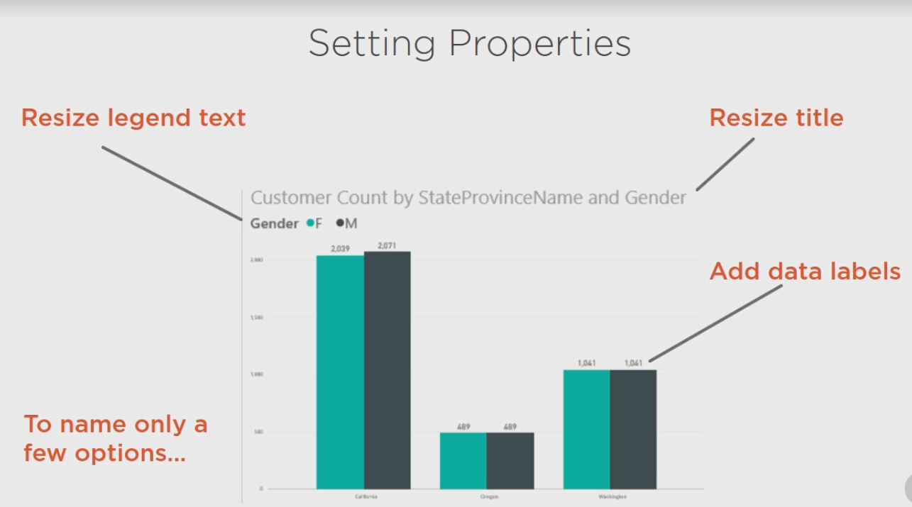

## Demo: Setting Properties in Power BI Desktop

Let's change the appearance of one of these charts just by configuring its properties. So I'll select it in the layout and then open up the Visualizations panel, and so far we've learned how to select a visualization and we can control what appears in our visualization by adding fields to different areas, but now let's click this button here for formatting and we can see there are many different things that we can apply properties so. So for example with the legend, right now we display the legend but we could disable that if we wanted to.

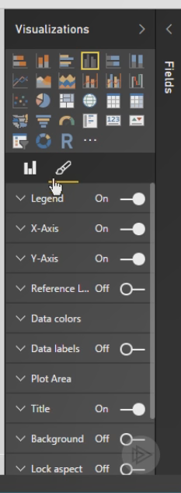Or if we keep it we can decide where does it go, above the chart, below the chart, and so forth? We can include a title or not for our legend, and if we have a title for it we can actually modify that title as well. We can change the color that we're using for our legend and we can change the text size here, you can resize by typing in a value here or you can use the slider bar to adjust the size wherever you like. You can make changes to your titles and colors used on the X axis and the Y axis and adjust the size of the title as well. Maybe you want to display data labels to make it easier for people to understand what these values are. And when you configure data labels you can choose the color, you can choose the format to abbreviate or let Power BI decide. You can also enhance the layout. For example, maybe I want to make it more obvious that we have slicers over here and to draw attention to them I can add a rectangle and position this rectangle over my slicers and I have to just click off of there to see that it's covering my slicers. So what I can do here is have this selected and then I have this format option in my ribbon where I can send this rectangle to the back, then when I click away from it I can see where my slicers are and then I can adjust the size of this to match the outline of my slicers a bit better. So it doesn't do anything other than draw attention to our slicers and we can still use our slicers because they're on top, so I can make different selections here, and I can copy this rectangle and place it over the same slicers in my second page of my report. And with it selected, again, I can set this so that it's behind my slicers so that I'll be able to see them as well as use them.

## Demo: Setting Properties in Excel Power View

In Excel your options are much more limited. You can adjust the font or text sizes and you can change color schemes, you can move things in front of or behind things, you can add pictures or text boxes, you can set an image or a background color and we can adjust the text on a visualization by visualization basis. On the Layout tab you can decide whether or not to display your titles and legends and whether to include labels for your data points, but that is the extent of the property configuration that you have inside of Excel.

## Drilling Within a Hiearchy

When you set up a visualization with multiple fields from a hierarchy you'll see a Drill All button in the top left corner, and when you click this button the visualization changes to show you everything on the next level down. So here we have a bar chart with every city for every state. But you can also drill down on a particular data element. Here we have a bar chart only for cities in Oregon.

## Demo: Drilling in Power BI Desktop

In Power BI Desktop, if you select your visualization right now we have on the Axis StateProvinceName, but we can add other items from our Location hierarchy, and notice that when we do that we get some buttons that appear in the visualization.

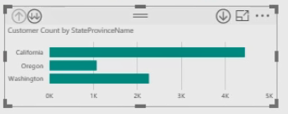

We can also add items that are not in our hierarchy, for example I might add in Occupation and even though I can't see that right now, the axis is defined to show items from my hierarchy as well as another field. Let's see what happens, let's close these things down and let's expand this so it's a little easier to view.

But once we set up that hierarchical structure in the visualization, one option is to use this Drill All button so we can drill down to the next level, and this shows us every city in every state, and we can scroll through to see all of our data. If I drill down one more time I can see the occupations, but this again represents every city and every state. We can drill back up to city and up to state.

Now another option for drilling would be to select a particular data point, so we would enable drill down by clicking this button to the right and then when I click on Washington, then the only cities that I see here are cities for Washington and I can continue by clicking on Bellingham, Washington, seeing the count of customers by occupation just for Bellingham, Washington. This is visible also in our chart, it's just a little harder to see when we're looking at an entire page. Here I'm not able to drill any farther, I can go up, switch to a different location, and notice that the highlighting feature does not work in this option. However, one of the things that we can do is export this data and what data can we see? Well if you go to the Drill tab you have the See Data button and you'd be able to get the counts associated with this information. If we disable drilling, now that we have just the Drill All, when I do the Drill All I can highlight the information and also filter the other charts and tables on this page, and maybe I just want to get a list of the customers for Ballard, Washington, and here they are.

## Demo: Drilling in Excel Power View

In Excel our drilling capability is a bit more limited. Let's move this out of our way a little bit more, and let's add in a matrix. So I'm going to start with a table where I have State and City and then Occupation and let's do a Customer Count here, and let's turn this into a matrix. Maybe we put Occupation on columns like so and we can see we have State and Province, and CityState here. But on our Design tab we have this option called Show Levels where we can enable drill down one level at a time and what that does is that collapses our matrix so that we just see the top level, StateProvinceName here first. And then when you select a particular item, let's blow this up, it doesn't help a lot here, this particular chart shows three different states and this icon appears, it says drill down when you hover over it, when you click that item then we can see all of the cities within California, and we can drill back up. We can also put multiple items across our columns. So maybe we want to add in Gender, and we would enable drill down on Columns and so we would get a similar ability to be able to break down levels, but this occurs within a matrix.

## Summary

And now you have a basic report with several interrelated visualizations of various types. You know how to filter the visualizations at the report, page or visualization level to achieve the effect you need, and how to work with slicers and highlighting for a variation on filtering. You also learned how to fine tune the appearance of your visualizations by setting properties and how to drill within a fixed hierarchy or a hierarchy that you create on the fly. Now all that's left is to publish your work to the Power BI Service and keep your data up to date, which you learn how to do in the next module of this course.

Refreshing Data

Refreshing Data

Hi, I'm Stacia Varga and welcome to Refreshing Data, the last module of Getting Started with Power BI. In this module I show you how to keep your work up to date in the Power BI Service. I'll start by reviewing what happens when you publish your data sets and then I'll explain your options for refreshing your data. Next I'll cover what you need to know about the Power BI Gateway - Personal, to stay connected to data sources on your computer or your company network, and then I'll explain Power BI Gateway - Enterprise, which in some cases might be a better option and your IT department can set it up for you.

Publishing Datasets

Before I explain about refreshing data, let's review what happens when you publish your work to PowerBI. com. When you publish your PBIX file or Excel file to the Power BI Service, you can publish from your local drive or from an online source such as OneDrive or SharePoint Online. When you do this, you're uploading your model, your data, and the reports. Your choice here of where to upload from makes a difference in how you keep your model and data and reports up to date. When you make changes to your local PBIX or Excel files, upload them to the Power BI Service, your model gets updated and any changes you make to reports also replace whatever you have with the same name in the Power BI Service. If you make changes to PBIX or Excel files that you have stored in OneDrive or SharePoint Online, Power BI checks those files and refreshes the version in Power BI automatically. Whatever is in those files, the model of the reports is what the Power BI Service uses. And what happens to your data in either case depends on the type of data and the refresh options that you set.

Demo: Publishing Datasets

In this demonstration I'm going to compare and contrast working with Power BI Desktop files and Excel files, whether I'm publishing from a local environment or from an online environment, in this case OneDrive. Right now I have opened my customer-analysis-local file and I want to publish this from my local environment. I go to the File menu, select Publish, and then Publish to Power BI. This tells me that I need to sign in, so you'll sign in, you'll be prompted to put in your username and password, and this makes a connection to the Power BI Service and copies up your PBIX file to the Power BI Service where we can view it, and in fact the Quick Insights feature will launch automatically. And what we have in two data sets now. This first data set was created when we uploaded the PBIX file in module 1, that is a data set, and currently we can see that refresh is not enabled. If we attempt to schedule refresh, it tells us that because we have on-premises data sources we'll need to have Power BI Pro. We'll go ahead and sign up for the trial version. And then the next thing that it tells us is that because we have on-premises sources in our data set, we'll need to install Power BI Gateway - Personal or Power BI Gateway - Enterprise, and I'll explain the difference of those later. Similarly we have the same issue with the customer-analysis-local that we just uploaded, because of the on-premises data sources. I can also upload my Power BI Desktop file from an online source such as OneDrive. You can use OneDrive - Business, OneDrive - Personal. If you use OneDrive - Personal, you will need to sign on and be sure to select the checkbox that says keep me signed in, or if you have SharePoint Online you can also point to that location. But there's a difference in our data sets and our models, keeping those up to date when we use an online source versus a local file, which we'll see later. Right now we need to grant permissions to Power BI to access this location. We navigate to the folder and then we can select either our PBIX file or our XLSX file. And I'll do the same for the XLSX file. So now we get more data sets, second one we uploaded a moment ago. We have one that comes from OneDrive, it tells us that scheduled refresh is not enabled, but OneDrive refresh is enabled, and also for the XLSX file we get a similar message. Now these both have the same name, but because they're different file types they can coexist here as different data sets, and if we Schedule Refresh, we see that for the PBIX file it behaves just like the PBIX file we loaded from our local source and requires a gateway, whereas our Excel file simply wants credentials and has OneDrive enabled by default. So if we were to modify our Excel file, that stays up to date. Also, when we uploaded each of these files we get reports, so we have our local version, which shows all of the visualizations that we had, each page of the report and any filters that we might have set would also be included here. Because we did not set any filters we don't have any. Although we can edit the report and add filters later. Here's the same file that we uploaded from OneDrive, it looks identical. And then our Excel workbook has an empty page that comes from the sheet that was in the workbook, and then we have the customers by location and you can see that there's a slightly different appearance in our report because of its source from Excel's Power View. So our map looks slightly different, our layout of the report is different, and our visualizations are different. But we can have multiple pages, each Power View sheet in Excel gets imported as a separate page in the same report. And just like we can with our reports from Power BI Desktop, we have the ability to edit reports inside of our Power BI web interface where we can add fields, add filters, remove filters, and so on. We just simply cannot change the model and we cannot change the queries that load the model once we're in the Power BI interface, but the reports we can interact with, we can change, we can save new versions of this, and of course we can pin individual items to a dashboard.

Refreshing Imported Data

Let's say your model uses imported data. This imported data is on-premises, that means you're going to need a gateway. Essentially the gateway provides the pipe that connects Power BI to your local computer or to some server in your company, and the only way that this connection happens is if you install it on a computer in your company. After you do that, then you can set up a manual refresh where you have to go in and push a button in the Power BI Service or you can set up a scheduled refresh. Now if you've used DirectQuery connections in your data model, you still need a gateway because the Power BI Service needs a way to communicate with those on-premises sources. But when you look at a report the visualizations will get fresh data by using that gateway connection, and that means you never need to set up a schedule. Similarly, if you're using live connections to connect to Analysis Services, you do need a gateway, but it's a live connection so no schedule required. If you're connecting to files that are local, either on your computer or somewhere on your company's network, you still need a gateway to have that connectivity between Power BI and your local network, but for these files you need to either set up a scheduled refresh or manually refresh your model when you know your source files have changed. If you're storing files online, meaning you've stored files in OneDrive, whether that's OneDrive Personal or OneDrive Business or in SharePoint Online, you're connected to the Cloud and so Power BI knows how to connect to OneDrive or to SharePoint Online, so you don't need a gateway and you don't need a schedule. Power BI will go check for fresh data about once an hour. You might have data coming from other on-premises sources and in these cases you still need your gateway and you can either manually refresh this data or set up a schedule. If you're connecting to Azure sources, SQL Database, SQL Data Warehouse or Spark using the DirectQuery connection, you're connecting to the cloud and no gateway is required, nor do you need to set up a schedule. On the other hand, if you're using Azure sources using the import method, you still don't need a gateway, but you will need to set up a refresh either manually or on a scheduled basis. For your online sources, these services have built in refresh automatically. This will happen on a database and you don't need a gateway set up in order for this to work. Last, if you've entered data into your Power BI file or Excel, the only way to get that data updated in the Power BI Service is to upload a new model after you've put in fresh data into the model.

Using Power BI Gateway - Personal

After you upload a model or create a data set in the Power BI Service, if you try the refresh now or the option to schedule a refresh, Power BI will let you know if it requires a gateway. When you look at your data set settings, you'll see a link that allows you to download the Power BI Gateway -Personal, which you can download and install in one step. You tell it where to install and you read and accept the license agreement and your Windows account determines whether the gateway gets installed as a service, which only happens if your credentials have administrator permissions, and that means you don't need to be logged in when the refresh runs. Otherwise, the gateway runs as an application and you need to be logged into your computer when the refresh happens in order for it to work. It does not need to be running on the computer where the data lives. After you install the gateway then you need to configure it. A configuration wizard will run when the installation completes. This walks you through the process of signing into Power BI and this lets your local machine connect to the Power BI Service, and then you need to provide your Windows credentials, and this is the account that the gateway service runs under. It doesn't have to be the same credentials that you use when you log into your computer. Last, in the Power BI Service, you need to connect your data sources to credentials. You'll need to specify whether there's Windows authentication or maybe there's anonymous authentication. Regardless, you need to specify the authentication for each source and provide credentials if necessary. This only needs to happen once and if you don't know how to set this up, ask the person who takes care of that data source in your organization for help.

Demo: Using Power BI Gateway - Personal

Let's say that your data set has sources that are on-premises, such as we have with the customer-analysis-local or even the PBIX file that we loaded from OneDrive. In order to connect to those sources and get fresh data, we're going to need a gateway. For our purposes, we're going to set up a personal gateway and we get a link here that allows us to download this gateway and install it. So let's do that. So we're going to run the installer, click Next, accept the license agreement after you read through it, decide where you want to install it, and launch the configuration wizard. So when you click Next you'll be prompted to log in with your PowerBI. com username and password. And then we need to put in our Windows login for the computer where the gateway is going to run, depending on the privileges that this account has determines where the gateway is going to run as a service or as an application. So by putting in our Windows credentials that lets the gateway run and when it's finished we just click Finish and then in our Power BI settings for each data set, we can see that the gateway is installed and running and we just need to work through our data sources to establish the appropriate credentials. When we're using Windows authentication we don't need to provide our Windows credentials because all of that is associated with the gateway already. With our online source we could have anonymous authentication, Windows authentication and so forth, for this web, simply an anonymous authentication. And so there we have updated all of our data source credentials. So a data set is associated with data source credentials. Let's go ahead and apply this. If we have another data set that also has on-premises data sources, we can confirm whether we're using the personal gateway that we've already installed or if there's an enterprise gateway in operation in your organization, you can switch to that, and again, we have our data source credentials. For our online only source we just have our OneDrive credentials and the OneDrive Refresh. For the version we uploaded as part of module 1, it finds all of the data source credentials that we specified in the first example. So now we're all set to configure a data refresh.

Demo: Scheduling Data Refresh

Now that we have a personal gateway installed and configured, any of our data sources that require access to on-premises sources now allow us to schedule a refresh. The only one that doesn't have explicit refresh is our Excel workbook that was uploaded from OneDrive, it will read the contents of that workbook on a regular basis, but it will not go out and refresh any data from external sources that are found in that workbook. So once you select a data set, you can open the Schedule Refresh and switch the toggle over to Yes. You can specify a refresh frequency, set your time zone, and if you have the Power BI Pro version, which you will if you're using the gateway, to access on-premises data sources. You can specify multiple times throughout the day if necessary. Another important option here is whether or not you want refresh failure notifications to be sent to you. In case something goes wrong, this is one way to find out. Otherwise, you can always review the refresh history to see if anything ever failed. When you've specified your refresh time, click Apply and now you have a schedule set. This schedule applies only to this particular data set. You can set up different schedules for all the other data sets that you have set up in PowerBI. com.

Understanding Power BI Gateway - Enterprise

In some cases Power BI Gateway - Enterprise might be a preferable option. For example, if you have a lot of people who are using Power BI Pro in your organization, it might be better to have your IT department set up the Enterprise Gateway, that way you don't have a lot of people setting up their own personal gateways and IT can manage the process directly and can manage which users have access to which data sources. Now anyone can set up Enterprise Gateway, whoever does it does need to have a Power BI Pro account. Normally you install the Enterprise Gateway on a server and let it run as a Windows Service. Enterprise Gateway runs using the Azure Service Bus to secure the communications between the Cloud and your on-premises sources. The gateway starts the connection to Power BI as an outbound call, so there's no need to worry about opening up firewall ports.

Summary

And so now we're done with Getting Started with Power BI. In this module you learned how to publish data sets and update the models and reports if necessary. You also learned the nuances of refreshing data and whether that data gets refreshed automatically or whether you need to set up a schedule. You also learned about the personal gateway, how to know when you need to set it up, how to set it up, and what to do afterwards with your data sources. Last, I explained a bit about using the Enterprise Gateway, which you might need to use if there are a lot of people in your company who want to use Power BI also. You've come a long way in this course, from getting your data to building our models and creating visualizations and getting everything up and running in the Power BI Service. Now go explore your data and uncover some great new insights. And just in case you need some additional help with regard to Power BI Gateway - Personal, here's a link for troubleshooting and also for the Enterprise Gateway, here's a link that you can give to your IT department if this is the route that you decide to go.